1.TRANSPORTATION SYSTEM

Hydrogen can be transported and stored gradually by 4 main methods:

■ Liquid (cryogenic) hydrogen ■ Ammonia ■ Hydrogenated liquid organic hydrogen carrier ■ Compressed gaseous hydrogen.
However, it seems to be crucial the process of hydrogenation and dehydrogenation where the lowest cost is dependably on states a reason why gaseous is considered costly effective.

Hydrogen has been compressed at 9430.50 N$m^{3}$and stored in tank at high pressure nearly 700 bar at gaseous state. However, the low volumetric density of hydrogen can be considered an issue to storage and transportation; moreover, the distance due to offshore environment. However, hydrogen can be transported by truck, ships and pipelines. Therefore, pipelines have been chosen as the most suitable option due to similarity operation with natural gas and geological site.
1.1 Technological option for Transportation system.
North Sea has been chosen as geological location for hydrogen production, storage and transportation. However, hydrogen is likely to be transported by pipelines at low pressure as reported by Pilar Blanco-Fernandez, 2017 it is more safe to transport hydrogen at low pressure.
Site | Water depth | Distance to shore | Quantity
North Sea, Peterhead | 100 m | 50 km | 374400 kg

Tab 1 shows the details of the operational field.

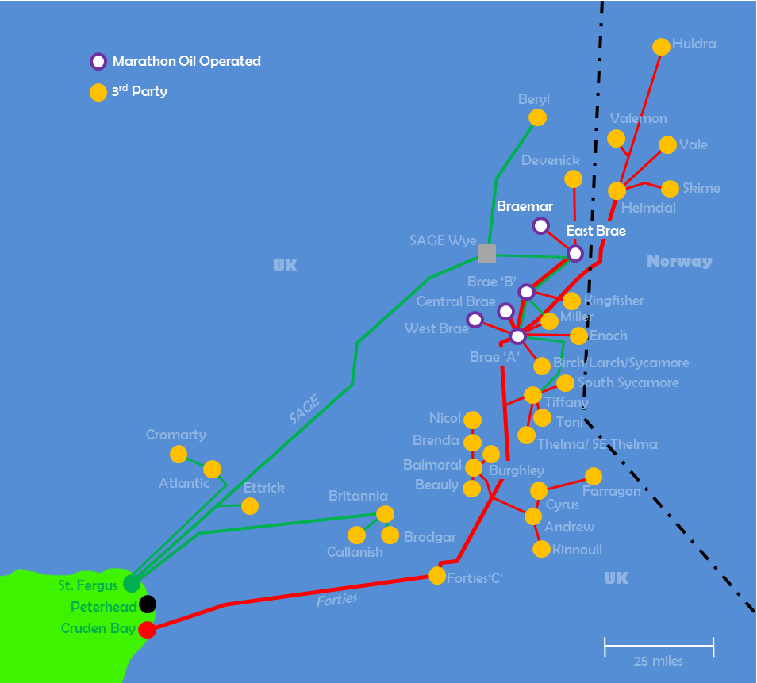

Fig 1. shows the Pipelines system at Peterhead.

1.2 Pipelines transmission system.
Pipeline transport for compressed gaseous hydrogen is likely to considered in general the most cost-effective approach of transporting large volumes of it by long distances. Furthermore, the transportation can be operated in pure form or be blended into natural gas above the limits or restrictions prescribed by policies regulations or contract regulations. However, certain factors should be considered in pipelines transportation.
- Velocity - this is where the volume flow rate associated with pressure and temperature is likely to be divided by section area.
- Gas pressure – the operation pressure inside the pipe.
1.3 Brittle fracture and environmental damage mechanisms.
Two main point has been considered: For internal corrosion.
- Hydrogen Gas Embrittlement (HGE) at ambient temperature
For external corrosion.
- Stress Corrosion Cracking (SCC) of line pipe materials in underground environments.

REFERENCE
- https://www.itmpower.com/images/NewsAndMedia/Reports/New_energy_value_chains_Hydrogen_as_an_energy_carrier_DNV-GL November_20.
- https://assets.publishing.service.gov.uk/government/uploads/system/uploads/attachment_data/file/866379/Phase_1_-_OGTC_-_Hydrogen_Offshore_Production.
- American Petroleum Institute, "Specification for Line Pipe, API Specification 5L," American Petroleum Institute, 41st Edition, April 1, 1995.
- https://www.energyvoice.com/oilandgas/north-sea/139693/marathon-oil-makes-north-sea-commitment-long/

