Balmenach Distillery Case Study

An Investigation of Energy Production from Distillery Co-Products for Balmenach Distillery, Speyside, Scotland

Sarah Allardyce
Eric Baster
Callum Kirk
Will Lamond

Contents

Contents 2
Abstract 4
Glossary 4
Introduction 5
Biofuel production 7
Biofuel Selection 7
Biogas Quality 9
By-products 9
Biofuel use 10
Electrical Demand Matching 11
Demand Matching Methodology 11
Results 12
Discussion 15
Assumptions & Sensitivity Analysis 16
Electrical Demand Data 16
Biofuel Production Rate 16
Merit Assumptions 17
Energy Price Variation 17
Conclusion & Recommendation 19
Appendices 20
Appendix A: RHI 20
Appendix B: Technical Considerations 20
Options A&B: Biogas Boiler 20
Options C&D: Power Generation 21
Option C: Export to grid possible 21
Option D: Export to grid not possible 21
Options E&F: Co-generation of Heat & Power 22
Option E: Low Grade Heat Recovery 22
Option F: High Grade Heat Recovery (Steam Regeneration) 22
Appendix C: Merit Calculations 23
Appendix D: Data & Assumptions 24

Abstract
This case study examines the potential for energy production from co-products at Balmenach Distillery near Cromdale in Speyside. A variety of technologies for biofuel production and generation of heat, power, or a combination of the two were considered in terms of economics and emissions. The impacts of government incentive schemes on the results were also examined. The most promising biofuel was found to be biogas from liquid co-products. The introduction of government Feed In Tariff for small scale renewable generation and the Renewable Heat Incentive tariff for renewable heat generation has improved the economic viability of small scale co-generation with steam regeneration; the tariffs help offset the high capital cost of solutions which were not previously viable at small scale, however this does not seem to have favoured CO₂ reduction in the case of Balmenach; in fact they appear to have had the opposite effect. An internal combustion engine generator with waste heat boiler generating steam was found to have the shortest payback period of options studied at 4.6 years with the potential to reduce CO₂ emissions of the distillery by 139 tonnes per year under 2010 conditions.

Glossary

AD: Anaerobic Digestion
CHP: Combined Heat and Power
COD: Chemical Oxygen Demand
Draff: Spent grain from the mash tuns; moisture content 70-80%
FIT: Feed In Tariff, available at 11.5 p/kWh electricity generated from AD. See project website for further discussion on tariffs.
Pot Ale: Liquid residue from the wash stills
RHI: Renewable Heat Incentive, available at 6p/kWh thermal energy from renewable sources. See project website for further discussion on tariffs.
SMP: Specific Methane Production Rate (m³ methane/tonne substrate)
Spent Lees: Liquid residue from the spirit stills

Introduction
Scotch Malt Whisky distilling is an energy intensive process utilising large volumes of steam in a two stage batch distillation process. The raw materials are limited to process water, yeast and barley. The co-products produced consist of the spent grain or ‘Draff’, the liquid residue from the wash still or ‘Pot Ale’ which contains spent yeast and dissolved solids, and the liquid residue from the spirit still or ‘Spent Lees’. Balmenach is a typical malt whisky distillery and will be the focus of this case study. Balmenach’s energy and co-product data for 2010 are illustrated in Figure 1 below:
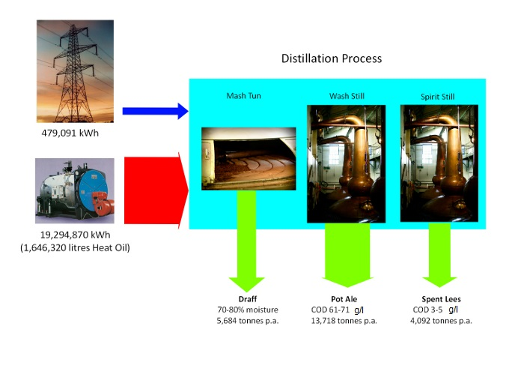
Fig. 1 Distillation Energy Demand and Co-Products
Key Points:
• Balmenach distillery is a traditional malt whisky distillery 1 mile from the village of Cromdale in Speyside producing around 2.3 million litres of alcohol per annum.
- The distillery is not connected to the mains gas grid, and process steam is currently raised in a 6,400kW rated oil fired boiler.
- Steam demand for the boiler is dependent on the batch distillation process.
- The distillery has 3 wash stills and 3 spirit stills which in 2010 were run on a batch basis in either 6 day or 7 day shifts, with some expectation to move to 7 day shifts only in the future.
- Cooling of the distillation products is by traditional ‘worm tub’ condensers with cooling water leaving at around 50°C, limiting heat recovery potential.
- Electrical distribution is at 132kV.
- The distillery is situated inland with a burn nearby and around ten houses in the immediate vicinity of the distillery.
- Both solid and liquid co-products are currently converted to animal feed at the Rothes Dark Grains Plant.
• Due to the demolition of redundant maltings there is significant space available on-site for development.

Existing Energy Supply:
- Steam for stills is supplied by single 6,400kW Cochran oil fired boiler installed 2 years ago; a biomass boiler was preferred but not available at the time of purchase. Steam leaves boiler at 8 bar g and is throttled to 3 bar g before stills. Annual oil demand for 2010 was 1,646,320 litres, at an average cost of 47.5p/l. Feed pre-heat via heat recovery from the distillation products
- Mains electricity supplies lighting, space heating, electric pumps and yeast refrigerators. Annual demand for 2010 was 479,091kWh at an average cost of 10.5p/kWh.
It was considered that there may be potential to produce useful amounts of heat, power, or both from the co-products of the distillery and the options available will be investigated in this report. Data and assumptions used are detailed in Appendix D.

Biofuel production
Research suggested three available technologies for production of biofuel from the draff:
- Biogas using Anaerobic Digestion: organic materials can be broken down by micro-organisms in the absence of oxygen to produce a gas mixture called biogas which consists mainly of methane and carbon dioxide. The process can be achieved at temperatures of around 38° C so has a comparatively low energy requirement, and the process is highly suitable for ‘wet’ biomass. AD is currently widely used in landfill, farm and MSW applications and benefits from specific Feed in Tariffs for energy production from the biogas produced.
- Bioethanol: hydrolysis by heat, acid, or enzymes can release sugars for yeast fermentation to alcohol which can then be distilled to provide bioethanol for fuel use.
- Drying: the draff can be dried to provide solid biomass fuel with a GVC of around 21MJ/kg
The liquid co-product mixture of Pot Ale and Spent Lees could also produce biogas through Anaerobic Digestion. These options were evaluated in the following section to examine their application to Balmenach.

Biofuel Selection
From the mass flowrate of co-product available and expected conversion rates (see Appendix D for data used) for the different processes, a comparison between energy inputs in MWh and outputs in terms of GCV of fuel can be made in Chart 1:
At this stage it was considered to discount bioethanol production on the basis of low yields available with current technology; breaking down lignocellulosic compounds to provide sugars for ethanol production is currently expensive, requiring either large amounts of heat or large volumes of acids or enzymes. Although production of fuel alcohol from distillery waste represents an interesting future opportunity, it was not thought viable at present as most of the available sugar for fermentation has been removed from the barley in the mash tuns.
Drying the draff has a number of drawbacks when compared to AD:
- The energy input required for drying is considerable due to the high moisture content of the solid co-product (70-80%). Steam drying of the co-product would require 3.3kg/kg, making the fuel conversion process energy intensive.
- The energy requirements of the AD plant are mainly low grade heat to maintain operating temperature at 38°C.
- To dry the draff from Balmenach would require an average of 2109.59kg/hr steam at 8bar g over the year, or over 14GWh of heat, possibly requiring an additional steam boiler whereas the low grade heat for the AD plant could be available as a by-product from a CHP unit.
- The conversion of gas and solid biofuel to heat and power can also be compared to show that biogas may be more efficiently converted to higher value energy; the best use of dried solid fuel would be in a biomass boiler to produce heat.
While it may be possible to dry draff economically in a large grain distillery operating continuous distillation where opportunities for process integration exist, this may be unsuitable for small scale distilleries with ‘worm tub’ condensers.
The next decision once Anaerobic Digestion was identified as the most promising currently available option for wet biomass was whether to process both draff and liquid co-products, or to focus only on liquid co-products. Draff and liquid co-product biogas production are shown in Table 2 below:
Table 2: Anaerobic Digestion of liquid and solid co-products
 | Feedrate (m3/day) | Retention Time (days) | Digester Volume (m3) | annual feed (t) | annual methane (m3)
Liquid Co-products | 50 | 3 | 150 | 20,000 | 300,000
Draff | 12 | 60 | 720 | 5,600 | 49,000
Draff conversion rate based on 25% organic dry matter (Tshiteya, M. 1985)
Liquid Co-products conversion rate based on 90% COD removal at 35g/l influent concentration

A comparison of the draff and liquid co-product biofuel potential suggests:
- Low degradability of draff in a digester due to lower dissolved solids and lignin requires long retention times up to 60 days.
- Draff requires 5 times greater digester volume (the product of retention time and feedrate); this will have a proportional effect on capital cost.
- Cost of pumping will be higher for draff.
- Liquid co-products will produce around 6 times as much biogas in a lower capital cost AD plant.

Biogas Quality
Interviews with existing technology providers and data available from research papers suggest the biogas produced from malt whisky distillery liquid co-products shall not contain harmful levels of H₂S or other contaminating compounds or moisture, and based on information available, a biogas analysis of 60% methane, 40% CO₂ has been assumed for this study.

By-products
The by-product from the AD digester is liquid with COD a tenth of the feedstock (i.e. around 3.5g/l). Options for disposal are as fertiliser where demand is available, by sea if agreed with SEPA, or to ground after tertiary treatment such as aerobic or membrane treatment. Best option will depend on the particular site. Balmenach is situated inland, surrounded by agricultural land so it is recommended that the best option would be to sell as fertiliser to local farmers.

Biofuel use
The biogas available can be combusted to provide heat, power, or a combination of the two as outlined in the following section. Some consideration was made of the equivalent value of heat and power. Chart 2 below outlines the relative economic benefits that can be gained per kWh from the biogas at 2010 energy prices with 6.5p/kWh RHI and 11.5p/kWh FIT, assuming the biogas can be burned in a boiler of equivalent efficiency to the existing fuel oil boiler and local electricity generation is at 30% efficiency.
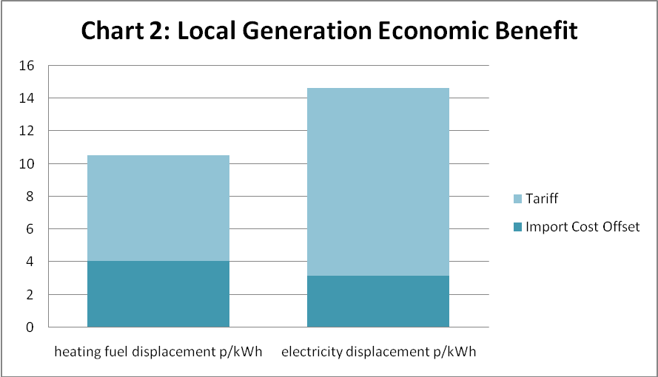
A number of options for fuel use were identified. Biogas production shall vary with the production profile of the distillery, and there is a lack of data available on expected Specific Methane Production rates due to a lack of pilot plant data, so each option was evaluated at a range of SMP’s from 10-15m³/tonne. The fuel use options are outlined below; for more detailed information on the options refer to Appendix B.
- Biogas boiler sized to use all biogas produced, generating steam in parallel with existing oil fired boiler; the boiler would be too large to qualify for RHI under the current scheme.
- Biogas boiler sized at 200kW in order to qualify for RHI, generating steam in parallel with existing oil fired boiler; this would not use all the biogas produced, and the excess would require to be flared off to avoid greenhouse gas emissions, or utilised elsewhere.
- Generator sized to use all biogas produced. More electricity would be generated than is required by the distillery, and so this option is reliant on the ability to export electricity to the grid.
- Generator sized for baseload electricity demand of 30kW. This option would be necessary if surplus electricity cannot be exported to the grid.
- Co-generation unit sized to use all biogas produced. This option would provide power for the distillery and export to the grid, and low-grade heat to meet the parasitic heat load for the AD plant.
- Co-generation unit with steam regeneration, sized to use all biogas produced. As well as providing power, a small amount of steam would be generated to offset oil use.
The co-generation units selected in cases E and F use the same size of prime mover (Internal combustion engine) and generator as in case C. Therefore for a particular biogas production rate, the same amount of electricity would be generated across all three cases. Capital costs were not available for option F, as steam regeneration is rarely economical at this scale; this option is included to illustrate the effect RHI may have on future feasibility of manufacture.

Electrical Demand Matching
Economic and emissions results for power generation will be dependent on whether the electricity is used on-site to offset grid electricity, or exported. The software program ‘Merit’ was used to simulate CHP and generator performance for Balmenach’s demand profile. The methodology is outlined below; further information on Merit is available on the project website.

Demand Matching Methodology
- Half hourly electrical demand profile for 2010 was constructed (for the limitations of half hourly data, see ‘Assumptions & Sensitivity Analysis’ section).
- Manufacturer’s datasheets were used to construct a database of biogas CHP units for use in Merit (for the limitations of this data, see ‘Assumptions & Sensitivity Analysis’ section).
- Corrected biogas data was constructed to take account of manufacturer’s assumed methane content.
- 6 day and 7 day production cycle demand profiles were identified.
- Part load efficiencies were calculated within Merit.
- Units were sized for 7 day cycles and run at part load for 6 day cycles.

Results
Table 2: Biogas Boiler Results
Option | SMP (Nm3/t) | boiler capacity (kW) | capital cost boiler (£) | offset fuel bill (£) | RHI income (£) | net income | Annual CO2 Reduction (t) | payback period (years)
A | 10 | 359 | 62500 | 94995 | 0 | 61870 | 647 | 10.7
A | 12.5 | 430 | 64000 | 114096 | 0 | 80896 | 777 | 8.2
A | 15 | 538 | 65000 | 142747 | 0 | 109497 | 971 | 6.1
B | RHI case | 200 | 61000 | 61901 | 80072 | 108923 | 423 | 6.1

Table 3: Generator Results
Option | SMP (Nm3/t) | required electrical capacity (kW) | cost of generator, installation (£) | electricity bill saving (£) | FIT income (£) | Export income (£) | net benefit (£) | Annual CO2 Reduction (t) | Payback period (years)
C | 10 | 190 | 125000 | 44967 | 70042 | 5424 | 84183 | 295.5 | 8.6
C | 12.5 | 233 | 165000 | 46095 | 95092.35 | 11636.7 | 114574 | 302.9 | 6.7
C | 15 | 260 | 170000 | 46095 | 111627.05 | 15950.1 | 135172 | 302.9 | 5.7
D | no export | 34 | 57500 | 22777 | 24950 | 0 | 44852 | 149.7 | 37.1

Table 4: Co-generation with Low Grade Heat Recovery
Option | SMP (Nm3/t) | required electrical capacity (kW) | cost of CHP, installation (£) | electricity bill saving (£) | FIT income (£) | Export income (£) | net benefit (£) | Annual CO2 Reduction (t) | Payback period (years)
E | 10 | 190 | 159000 | 44967 | 70042 | 5424 | 82483 | 295.5 | 9.2
E | 12.5 | 233 | 199000 | 46095 | 95092 | 11637 | 112874 | 302.9 | 7.1
E | 15 | 260 | 208000 | 46095 | 111627 | 15950 | 133272 | 302.9 | 6.1

Table 5: Co-generation with High Grade Heat Recovery
Option | SMP (Nm3/t) | Steam produced (kWh) | Cost of generator, installation (£) | Cost of whb (£) | Offset Oil Bill (£) | RHI income (£) | electricity bill saving (£) | FIT income (£) | Export income (£) | net benefit (£) | Annual CO2 red. (t) | payback period (years)
F | 10 | 302523 | 125000 | 43000 | 13189 | 16922 | 44967 | 70042 | 5424 | 112144 | 92.8 | 6.8
F | 12.5 | 377735 | 165000 | 45000 | 16580 | 21273 | 46095 | 95092 | 11637 | 150177 | 115.8 | 5.4
F | 15 | 453258 | 170000 | 47000 | 19985 | 25642 | 46095 | 111627 | 15950 | 178449 | 139.0 | 4.6

Chart 3 below shows the effect on emissions of the various investment options at the 15Nm3/tonne SMP rate:
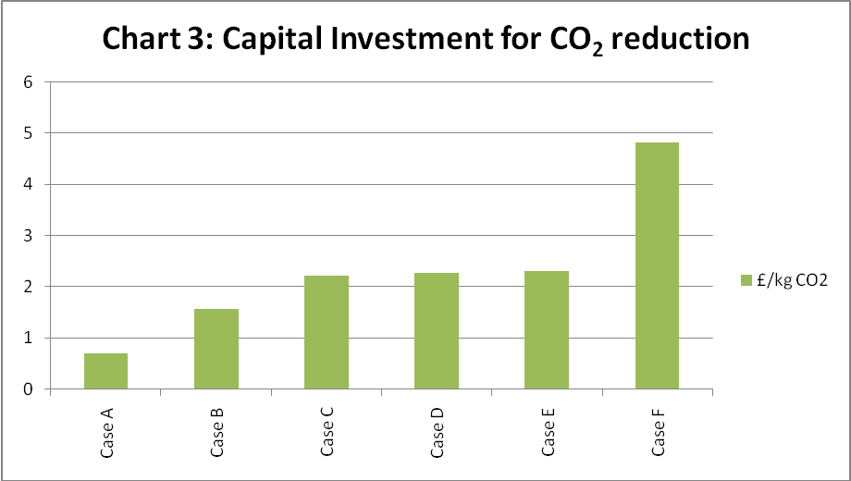

Payback period for each option under different fuel production scenarios is illustrated in Chart 4; note Option D offers a payback period greater than 15 years and is not shown to full scale for clarity:
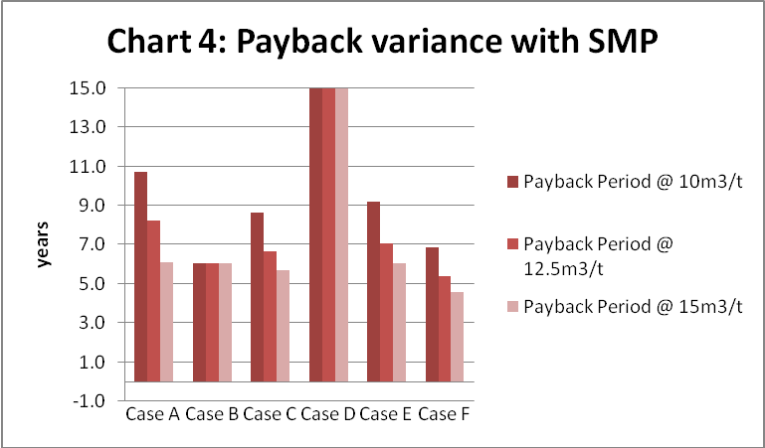

Chart 5 shows the relative payback periods of steam and electricity generation if no FIT or FHI tariffs were available.
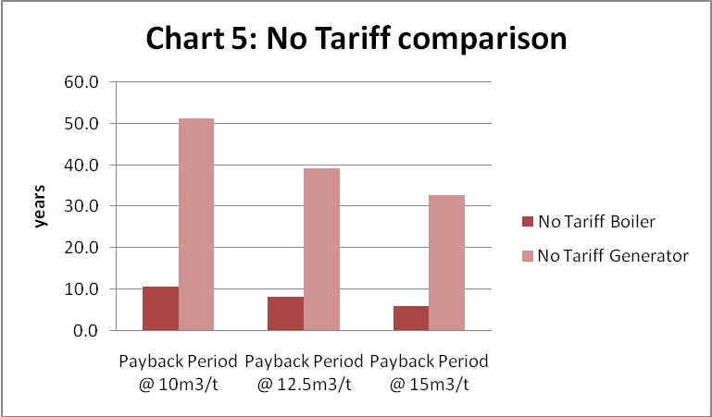

Discussion
In terms of gross energy conversion, burning biogas in a boiler with efficiency of around 80% would be preferable to generation of electricity at around 30% efficiency. Co-generation could approach 80% efficiency if a low grade heat demand is available, however if only the parasitic heat load of the AD plant need be supplied, then co-generation may only achieve around 60% efficiency (30% electricity, 30% heat), as co-generation would supply more heat than the AD plant requires. Alternative use of the heat available, either in a district heating system, space heating for agriculture such as for greenhouse heating, or for absorption chilling may be worth investigation. Evaluation based on gross energy conversion efficiency however does not take account of the difference in value between different grades of energy (i.e. electricity, steam or hot water). From the results it may be determined which grade of energy is most useful for Balmenach Distillery.
Due to the low biogas yield in comparison to demand for heating fuel, biogas burned in a steam boiler can at best be expected to offset around 23% of the distillery’s fuel oil use. The high price of fuel oil in comparison with mains gas may however make a reduction in fuel oil use worthwhile. At 2010 prices for fuel oil and grid electricity, steam raised in a biogas boiler may be the more economically valuable option, however the government incentives skew this result in favour of electricity generation due to the higher tariffs available for FITs from AD (See Chart 2). Chart 5 shows that co-generation with steam (Option F) provides the shortest payback period for all except the lowest SMP. At low biogas production rates, the lower capital cost of a 200kW boiler combined with RHI (Option B) presents the shortest payback period.
It is clear that without the FIT subsidy, the generation of electricity would be significantly less attractive. Were it not for FIT, the payback period across the range of biogas production rates examined would be greater than 20 years. Chart 4 shows the relative values in a ‘no tariffs’ scenario.
The effect of tariffs on the payback period of Option F means that waste heat boilers could become viable at a much smaller scale than has previously been the case. Raising steam in this way uses approximately 47% of the energy available in the biogas (35% for electricity generation plus 12.5% for waste heat boiler). The demand profile of steam use in a batch run distillery, which requires constant modulation, does not lend itself to a co-generation plant, however as with the biogas boiler scenario, the low volume of steam produced in comparison with peak demand means that the co-generation plant can offset baseload steam during production cycles whilst the oil fired boiler is modulated to meet peak demand as per normal operation.
In terms of reduction of CO₂ emissions, a 538kW biogas boiler would be the most cost effective option provided the AD plant can achieve a SMP of 15m³/tonne. This is also the best overall reduction in CO₂ of 971 tonnes of CO₂ per year. The effect of the RHI, shown in boiler results table, is however to give a 200kW boiler equivalent economic benefit at 2010 oil prices, despite having lower net benefit and lower CO₂ emissions reduction; if the purpose of the RHI is to reduce CO₂ emissions then this may be termed a ‘perverse incentive’ due to the 200kW sizing limitation. IF RHI is extended to above the 200kW limit in 2012 as has been suggested, this may change.
Overall, the tariffs contribute to Option F, with lowest CO₂ reduction potential and highest capital cost per CO₂ reduction, having the shortest payback period.

Assumptions & Sensitivity Analysis
Some areas of uncertainty in our analysis were identified, and the impacts of these along with general assumptions made are outlined below. Data and figures used are detailed in Appendix D.

Electrical Demand Data
The electrical demand data available for the distillery was on a half hourly basis. The results therefore cannot take account of sharp peaks in demand, so although the overall annual electrical demand may be met, there may still be some import of grid electricity to cover demand spikes, resulting in lower than expected economic & emission benefits from generation options. Reducing the amount of electricity generated used on-site by 15% (and adding this to the amount exported) added 3-6 months to the payback periods of electricity generating options.

Biofuel Production Rate
The AD plant is assumed to be able to provide a constant flow of biogas to run the CHP at the level we have recommended. This, however, may not be the case as they are a number of holiday periods when production drops off completely so the production of the biogas may drop significantly. If the level of biogas drops below the 50% load for the CHP then most of the time it will stop operating. If for some reason the methane production levels drop so there is less biogas then the CHP will have to operate at part load or could be set to follow the electric load as this requires less fuel. The best suited capacity and the respective part load percentages for 6 & 7 day operating cycles can be seen in the tables below.
Conversion rate of 10m³/t:
Prod-uction Cycle | Date from: | Date to: | Fuel Available m³ | Demand MWh | Capacity of Unit kWe | Percent-age Load | Fuel Req. m³ | Energy Delivered MWh | Surplus Energy MWh | Thermal Energy MWh
6 day week | 7/1 | 31/3 | 97191 | 124.7 | 160 | 62.1 | 97176 | 123.25 | 46.95 | 159.86
7 day week | 15/4 | 30/6 | 121450 | 114.5 | 160 | 88.3 | 121419 | 114.45 | 108.03 | 191.15
6 day week | 22/7 | 15/12 | 170083 | 199.95 | 160 | 62.1 | 170059 | 199.09 | 99.24 | 279.26

Conversion rate of 12.5m³/t:
Prod-uction Cycle | Date from: | Date to: | Fuel Available m³ | Demand MWh | Capacity of Unit kWe | Percent-age Load | Fuel Req. m³ | Energy Delivered MWh | Surplus Energy MWh | Thermal Energy MWh
6 day week | 7/1 | 31/3 | 121488 | 124.7 | 190 | 71.1 | 121350 | 124.64 | 336.58 | 147.53
7 day week | 15/4 | 30/6 | 151813 | 114.5 | 190 | 100 | 151574 | 114.45 | 479.32 | 174.58
6 day week | 22/7 | 15/12 | 212605 | 199.95 | 190 | 71.1 | 212354 | 199.91 | 606.27 | 258.19

Conversion rate of 15m³/t:
Prod-uction Cycle | Date from: | Date to: | Fuel Available m³ | Demand MWh | Capacity of Unit kWe | Percent-age Load | Fuel Req. m³ | Energy Delivered MWh | Surplus Energy MWh | Thermal Energy MWh
6 day week | 7/1 | 31/3 | 145786 | 124.7 | 233 | 67.5 | 145516 | 124.64 | 120.71 | 159.77
7 day week | 15/4 | 30/6 | 182175 | 114.5 | 233 | 97.4 | 182124 | 114.45 | 210.06 | 189.22
6 day week | 22/7 | 15/12 | 255126 | 199.95 | 233 | 67.5 | 254663 | 199.91 | 229.55 | 279.59

What is apparent in the tables above is that the unit can be sized over 150kWe and should always provide a surplus of electricity to be exported; the financial benefit of this can be found in the results section. This solution also means if the distillery decides to change their production cycle to only 7 day weeks (a possibility discussed with the distillery manager), then the CHP will be sized appropriately and electricity generation could scale accordingly.

Merit Assumptions
The demand matching calculations used to estimate income from electricity generation options uses manufacturer’s data for efficiencies due to a lack of pilot plant data. These are calculated under standard conditions according to each manufacturer and although some effort has been made to account for different reference conditions, these figures may be expected to over-estimate efficiency over the lifetime of the equipment.

Energy Price Variation
The effect of energy price deviation from the 2010 base case scenario is outlined in the table below:
 | Payback Period (Years)
 | Option A | Option C | Option E
2010 prices | 4.7 | 5.8 | 6
+ 10% fuel oil price | 4.2 | 5.8 | 6
+20% fuel oil price | 3.9 | 5.8 | 6
+10% electricity price | 4.7 | 5.6 | 5.8
+20% electricity price | 4.7 | 5.4 | 5.6

As we would expect, the boiler option (option A) is more sensitive to a rise in fuel prices than the generation options C & E are to electricity prices since a greater part of the benefit is from offsetting import costs as opposed to from tariffs.

Conclusion & Recommendation
The best economical option for Balmenach identified in this study was an anaerobic digestion plant producing biogas from liquid co-products combined with co-generation plant with steam regeneration.

Main features of this solution were:
- Liquid co-products (Pot Ale & Spent Lees) mixed and processed in Anaerobic Digestion (AD) plant with short retention time to minimise capital cost to produce biogas.
- Feeding liquid co-products to AD plant before their temperature drops below 38°C will remove the need to pre-heat.
- Biogas used to fuel an internal combustion engine generator with waste heat boiler recovering heat from exhaust to provide low grade heat and steam.
- FIT’s, electricity Export Tariffs and RHI earned for electricity and heat produced.
- Payback period of 4.6 years could be achieved for a plant with capital cost of £770,000 based on 2010 energy prices.
- Annual net benefit assuming maintenance and operating costs at 5% of capital cost was £178,449.
- Annual CO₂ emissions reduction of 139 tonnes.

Appendices

Appendix A: RHI
The biogas boiler may be sized to burn all biogas available, i.e. 359-538kW dependent on expected biogas available, however the recently introduced ‘Renewable Heat Incentive ‘(RHI) is available for boilers burning renewable fuel, but only up to 200kW installed capacity. A de-rated boiler is available at 200kW, and the economic and environmental impact of this option combined with the facility to flare off excess biogas (which would be a harmful greenhouse gas if emitted to atmosphere) was evaluated.
The government has only published a description of the RHI, and not the regulations themselves. However it appears there would be nothing to prevent Balmenach deliberately under-sizing the biogas boiler in order to qualify for the RHI. The remaining biogas could either be used to generate electricity, or a smaller AD system could be installed producing only the volume of biogas required for the boiler. The latter option would reduce capital costs of the whole system, and its financial implications are set out in the “RHI case” in the final row of Table 2. This approach appears to offer financial advantages, particularly if the actual biogas production rate achieved was to be at the lower end of the expected range. However it carries two risks:
• The estimated income available under the RHI case is sensitive to the proportion of the time that steam is required. If this is less than the 75% assumed (see “Methodology and assumptions”, below), the income available under the RHI case would shrink by a similar amount. In contrast, the income generated by the other options in the table is not affected by this percentage.
• The government is considering whether to extend RHI support to anaerobic digester gas boilers of more than 200kW in 2012. If this is done, the income available under the other options in the table would increase.

Appendix B: Technical Considerations

Options A&B: Biogas Boiler
A boiler supplier interviewed suggested that the cost of converting the existing boiler to dual fuel would be approximately £40,000, however this may require the biogas to be scrubbed of CO₂ to produce biomethane, and in any case the dual fuel option does not allow simultaneous firing of oil and gas; this suggests a buffer tank would be required sized to contain sufficient gas to meet peak demand. Given that annual biogas production is expected to meet 23% overall thermal demand at best, this was not considered a practical option. Running a biogas boiler in parallel with the existing oil fired boiler would represent a practical solution. The oil fired boiler could be modulated to meet demand as it is currently, with the biogas boiler burning the cheaper fuel meeting a baseload demand. Biogas boilers sized for expected biogas production rates (Option A) and the 200kW RHI limit (see Appendix A), Option B, were investigated.
It was assumed that the total amount of biogas produced under each production rate would be used to raise steam at an efficiency of 80%. This efficiency was based on discussions with biogas boiler suppliers.
It was assumed that steam produced in this way would displace steam generation by the current oil boiler. The volume of oil saved was calculated based on the assumption that this boiler also has an efficiency of 80%: analysis of Balmenach’s boiler log for February 2011 indicates that boiler efficiency varies, but reaches 80% when the boiler is operating well. The oil cost (£0.475/litre) and energy content (11.72 kWh/litre) used in calculations are the same as the figures used in Balmenach’s weekly production report for 2010.
To estimate the size of biogas boiler required, it is assumed that the boiler would be producing steam at full capacity whenever the distillery is operating. This assumption is thought reasonable as the peak steam production rate of the largest boiler above is less than the calculated demand of one still operating at full load, and at any point during operating hours it is rare for none of Balmenach’s six stills to be running. During 2010, the distillery operated round-the-clock 6 days a week for 33 weeks, and 7 days a week for 11 weeks. On this schedule, the distillery operates for 75% of the year.
Boiler cost estimates were for stand-alone containerised boilerhouse installed adjacent to existing boilerhouse, including: Boiler, SS Hot well tank, Blow down Vessel, Water softener, Chemical dosing set, all mechanical interconnecting pipework, all electrical wiring to a distribution board. Ex-Works Budget cost £46,000.00. £15,000.00 budgeted for connection to existing system for pipework, valves, supports and documentation. This gave total installed cost of £61,000 for a de-rated 200kW boiler and £62,500 for 359kW boiler.

Options C&D: Power Generation
As an alternative to the production of steam, the biogas could be used to generate electricity. At this scale, a number of companies supply internal combustion units, packaged either as generators or, with the addition of a heat recovery system, as CHP units. If no suitable use for the heat is available then the generator only option should be investigated as it will entail lower capital costs.
A key question in assessing the economic viability of electricity generation is whether or not surplus electricity can be exported to the grid. Enquiries were made to the District Network Operator; however an answer is not yet available. Two financial cases have therefore been examined. In one export to the grid is possible, in the other it is not.

Option C: Export to grid possible
Where grid export is possible, the generation/CHP unit can be run at constant load and surplus electricity sold back to the grid. Benefits arise in three ways: electricity purchased from the grid is reduced or eliminated; each kWh generated is subsidised through the Government’s Feed in Tariff (FIT) scheme; and surplus electricity can be sold to the grid. The results under each biogas production rate based on Balmenach’s electricity demand and production schedule during 2010 were investigated.

Option D: Export to grid not possible
Excluding holiday periods but not weekends, Balmenach’s baseload electricity demand varies from 20 kW during the warmer months to 30 kW during winter. Peak demand occasionally exceeds 100 kW, and regularly exceeds 80 kW. Under any of the biogas production rates considered, there is enough energy available to supply this demand. However the range between baseload and peak is too great for any of the CHP plants considered in this project to supply: none operate below 50% load. Additionally, large variations in load tend to lead to reduced reliability and increased maintenance costs.

Options E&F: Co-generation of Heat & Power
A number of companies supply packaged biogas CHP units at the scale likely to be required by Balmenach. These tend to use the same internal combustion engine and generator as the equivalent-sized generation units discussed in the previous section. Therefore at a given biogas production rate, the same electricity bill saving, FIT and export income as in the generation only case would be achieved. Heat recovery can provide either low grade heat (i.e. hot water for space heating, or to supply the parasitic heat load of the AD plant) or high grade heat by raising steam. Packaged CHP units producing steam do not appear to be available at this scale. However in theory, a bespoke steam CHP unit could be assembled by routing the exhaust gas from a generator unit through a waste heat boiler.

Option E: Low Grade Heat Recovery
Balmenach currently has little demand for low grade heat. Where it could be used – for example for heating the water used for mashing, or preheating the liquid in the stills to reduce the mass of steam required for distillation – heat tends to be recycled from the previous run. The AD system itself would require heat in order to maintain its temperature at 38°C, and this could be supplied by the CHP unit.

Option F: High Grade Heat Recovery (Steam Regeneration)
At the scale required by Balmenach, no packaged CHP units producing steam rather than low grade heat were identified. However it may be possible to construct a bespoke system by installing a generation unit and running the hot exhaust gas through a waste heat boiler (a heat exchanger which uses the heat in the exhaust gas to generate steam).
As with the steam boiler option, it is assumed that the output of the waste heat boiler can be used whenever the distillery is operating. As the distillery was operating on a six day per week schedule for part of 2010, and it is assumed that the generator (which acts as the heat source) is shut down during holiday periods, the total amount of steam use which could be offset has been reduced by a factor of 0.89.
The technical information obtained on generation units shows that an exhaust gas temperature of 500°C is typical. The amount of energy that is available for the production of steam depends on the temperature to which the exhaust gases can be cooled. The distillery requires steam at 180°C, and for this analysis a final exhaust gas temperature of 200°C is used.
Although a counter-flow arrangement or economiser could allow more energy to be extracted from the exhaust, further work on the implications of a lower exhaust temperature would be required before this can be recommended. Biogas produced through anaerobic digesters can contain corrosive compounds such as Hydrogen Sulphides. To reduce the risk of these compounds condensing and causing damage, the temperature of the exhaust gas is often maintained above 180°C. Most of the packaged CHP units available do not cool exhaust gas below 180°C, despite the fact they are only heating water to 90°C. None are designed to cool the exhaust gas below 100°C, which would enable the latent heat contained in water vapour to be captured.
In order to predict the energy available to the waste heat boiler, the mass flow rate of exhaust gas was also required. This was calculated from the flow rate of biogas fuel, and a typical value of 20% for the “excess air” drawn in by the engine (excess air is the proportion of air drawn in which is additional to that required for complete combustion). The specific heat capacity at constant pressure of biogas was assumed to be 0.96 kJ/kg.K. It was assumed that 98% of the available heat was transferred to the steam, and the rest lost to the surroundings.
Across the range of biogas production rates considered, the capacity of waste heat boiler required would fall within the 200 kW RHI threshold. Without the RHI, a waste heat boiler is unlikely to be worthwhile in financial terms. Even at a 15 Nm3/tonne SMP, the distillery’s total oil demand is reduced by only 2.5%.
Previously, waste heat boilers have not been available at such small scale, however, this analysis shows that the introduction of the RHI will make waste heat boilers viable at this scale.

Appendix C: Merit Calculations
Following the electrical load:
Capacity of Supply (kWe) | Total Supply (MWh) | Energy Delivered (MWh) | Energy Deficit (MWh) | Fuel Consumption (m³) | CO₂ emissions (ton)
30 | 192.8 | 192.79 | 286.27 | 166016.7 | 228.98
54 | 320.04 | 320.01 | 159.01 | 216535.75 | 298.71
65 | 368.85 | 368.8 | 110.18 | 293681.78 | 405.1
81 | 427.69 | 427.68 | 51.07 | 292869.31 | 403.95
101 | 467.68 | 467.64 | 11.18 | 341654.28 | 471.27
124 | 478.78 | 478.75 | 298.84 | 323514.38 | 446.26
160 | 479.09 | 479.06 | 0 | 322552.03 | 444.92
190 | 479.09 | 479.06 | 0 | 334744.16 | 461.75
233 | 479.09 | 479.06 | 0 | 346632.91 | 478.17

Running at a constant load:
Capacity of Supply (kWe) | Total Supply (MWh) | Energy Delivered (MWh) | Energy Deficit (MWh) | Energy Surplus (MWh) | Fuel Consumption (m³) | CO₂ emissions (ton)
30 | 195.5 | 192.79 | 286.22 | 2.67 | 168206.83 | 232
54 | 351.96 | 320.01 | 158.74 | 31.73 | 236520 | 326.28
65 | 423.68 | 368.8 | 109.81 | 54.41 | 328500 | 453.12
81 | 527.86 | 427.68 | 50 | 99.19 | 362695.47 | 500.21
101 | 658.26 | 467.64 | 9.84 | 188.72 | 435241.94 | 600.3
124 | 808.12 | 478.75 | 0.21 | 329.03 | 499320 | 688.76
160 | 1050 | 479.06 | 0 | 574.82 | 641175.19 | 884.6
190 | 1250 | 479.06 | 0 | 772.42 | 718479.19 | 991.01
233 | 1530 | 479.06 | 0 | 1060 | 883079.25 | 1218.02

Appendix D: Data & Assumptions

Parameter | Value | Source
Methane conversion of liquid co-product (COD 35g/l) | 10-15 m3/tonne
Methane conversion of draff | 34 m3/tonne | Ezeonu & Okaka, 1996; Tshiteya, M., 1985
Bioethanol conversion from draff | 109 kg/ dry tonne | Xiros C., and Christakopoulos, P., 2009
Steam drying requirement for draff | 3.3kg/kg | Perry’s Chemical Engineering
GCV of draff | 21 MJ/kg
Biogas Analysis | 60-66% methane, 34-40% CO2 | Boopathy, R., Larsen, V. F., Senior, E., 1988; Biowayste UK
Biogas NCV | 21.5 MJ/Nm3 | 60% methane, 0C 1atm
Cost of grid electricity, 2010 | 10.5 p/kWh | DECC figures 2010
Cost of fuel oil, 2010 | 47.5 p/litre | DECC figures 2010
GCV of fuel oil | 11.72 kWh/litre | DECC figures 2010
Carbon intensity of grid electricity | 0.69 kg CO2/kWh | DECC figures 2010
Carbon intensity of fuel oil | 3.22 kg CO2/litre | DECC figures 2010
AD Plant Capital Cost | £600,000 | Manufacturer interviews
Plant Operating & Maintenance Costs | 5% of capital cost
Cost of Grid Connection | £20,000

