Power Curve Performance Report
- The initial problem

The wind farm is located in the northern part of UK. It has 15 wind turbines, each rating 850kW. Cut-in, cut-out and rated speed of turbine is 4m/s, 25m/s and 16m/s respectively. Its expected energy out put in 2007 was below designed value. During the winter “January, February and March” 2007 several turbines’ output was dramatically low. It is also observed that it happened, when turbines were operating at high wind speed. The economical loss was approximately £100.000. This energy and economical loss reached a peak in March 2007.

The energy plot (Power-time plot) below shows the turbine X performance, during 01/03/07 to 07/03/07. The real performance of the wind turbine is represented in blue and power expected is red. The power expected is related with turbine X. The losses are represented in yellow colour. Losses are the difference between the power output and the expected power.

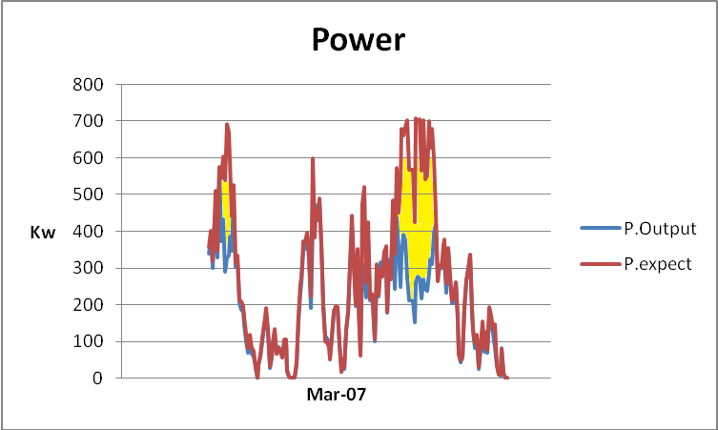

In this plot, it is possible to see that the difference between expected and output power reaches a maximum value of 500 kW. The average energy loss is around 20% and 40% from the rated figure at high wind speed.

To understand these energy gaps, it is necessary to follow the wind speed data sheet, look at the different winds speed and also the alarm codes. To understand unexpected performance, it is necessary to look into climate conditions, such as ice in the blades, jamming of anemometer, or any other problem during the winter time. Hence it is important to understand the extreme temperatures and also high temperatures during this period.

The plot below shows the turbine X energy performance. The trend in based in the power output and the wind speed.

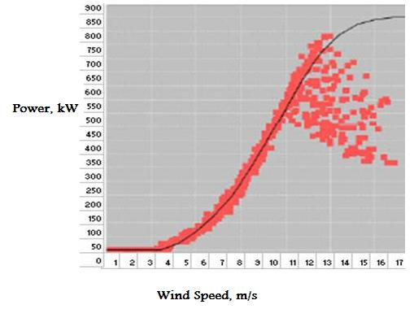
In this graph is possible to see the energy losses. It drops when the wind speed reaches above 10 m/s.

Wind direction data

We have a wind data from the most closed met station. Furthermore we do not have wind direction data from the wind farm site due to data logging issues. So we could not compare it with the met office data.

The analysis of wind direction from the met office shows that wind direction is not the culprit for poor performance of wind farm.

The analysis was based in three different parts.

1. - Discover the annual wind direction

2. - Discovered the monthly wind direction

3. - Discovered weekly wind direction

During the research the most common wind direction to the 3 different levels were:

The most common degrees for the wind direction during 2007 were 241 to 270 in the three different levels, yearly, monthly and weekly.

181 | 55 | 73 | 75 | 130 | 167 | 232 | 333 | 412 | 132 | 202 | 192
0 | 31 | 61 | 91 | 121 | 151 | 181 | 211 | 241 | 271 | 301 | 331
30 | 60 | 90 | 120 | 150 | 180 | 210 | 240 | 270 | 300 | 330 | 360

Without the wind direction for the site, we are not sure that wind direction did not affect the energy production.

Wind Speed data

Wind speed data from the wind farm site was at the interval of 10 min from whereas the met site data was hourly. Hence it was impossible to compare between two different winds speed.

During the period where turbine X had the higher losses, some of the other turbines were showing expected performance.

The conclusion about wind speed is that it is also not the culprit for wind farm poor performance.

Actual power output and expected power.

In March 2006 the turbine X was showing good performance in medium wind speed 6-9 m/s. Also turbine X creates an excess energy during March 2006 at the same wind speed range. However in 2007, it resulted in low energy output.

Identification Output problem

During winter 2007 turbine X was showing poor energy performance. This situation changes during the summer & spring 2007, where it did an expected performance.

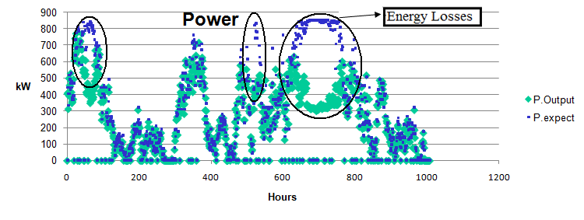
Winter 2007
In the winter 2007, it is possible to see three times when the energy was lower than the expected with a peak of 500kW.
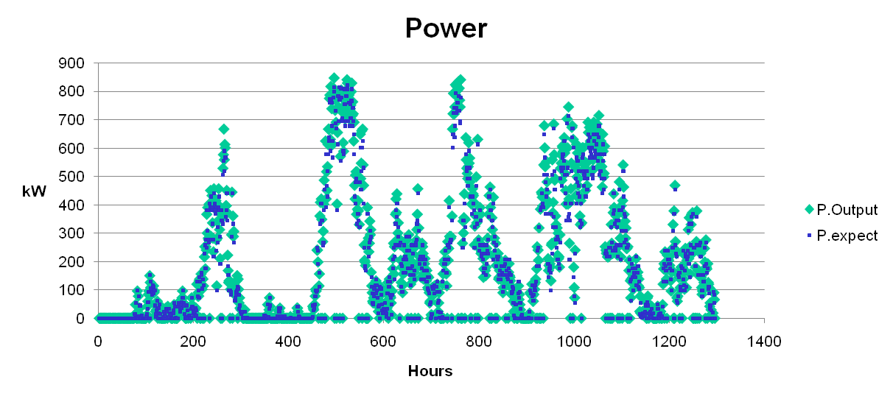
Summer & spring 2007
In summer and spring 2007 graph, the turbine x did expected performance.
During the second week of March 2006, the energy output from turbine X was higher than the expected. The energy losses started in medium wind between 6-9 m/s

During the third week in March 2006, the energy output was higher than the expected. The higher winds speed does not produce less energy than the expected.
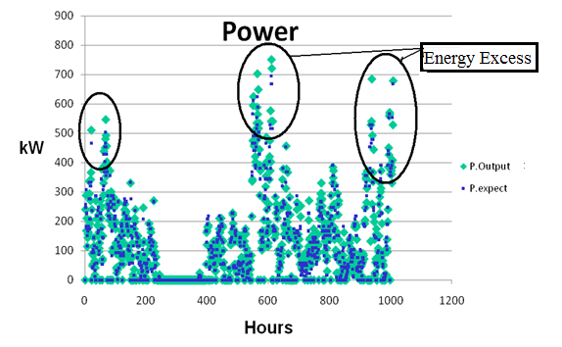

In contrast with the third week of March 2006, this turbine did the highest energy production.
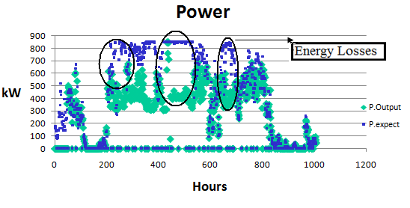
In contrast with 2007 when the energy output was much lower than the expected.

The same energy circumstances happened for the previous turbine-X. During winter 2006, turbine-Y did a higher energy production and winter 2007. However it did a lower energy production.

Turbine Y:

Third week March 2006
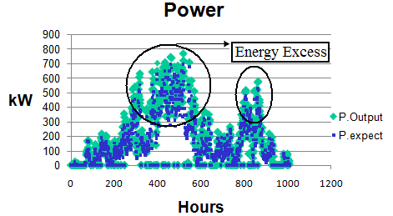

Third week March 2007

