CARBON NEUTRAL COMMUNITY QUESTIONNAIRE
University of Strathclyde

This questionnaire is produced by MSc students of University of Strathclyde to complement the Carbon Footprint Survey distributed by the Going Carbon Neutral group. The information obtained from this questionnaire will then be used as an input to our simulation tools. Using these tools, we can further refine domestic CO₂ emissions, as first determined by the GCNR footprint survey. The results from this survey could also be used to help identify energy efficiency measure, which could ultimately lead to a reduction in your energy bills.

BUILDING TYPE

1. Building Period

- Victorian
- 1900 - 1945
- 1946 -1983
- 1984 – 1997
- 1998-2000
- Post 2000
- Others (please specify)

2. Property Type

- Single Storey Terrace (Middle/Corner )
- Double Storey Terrace (Middle/Corner )
- Flat / Tenement (Top Floor/Middle Floor/Ground Floor)
- Semi Detached
- Detached
- Others (please specify)

3. Number of rooms
Single size : (please specify)
Double size : (please specify)
Living room : (please specify)

4. Size of bedrooms
- Compact (single bedroom)
- Average sized (double bedroom)
- Large sized

5. Ceiling height Normal/High

6. Has the attic been converted to a useable room? Yes/No/ Not applicable

.
7. Building Fabric
7.1 Window Glazing Type
- Single glazed
- Mixed single-double glazed
- Double glazed
- Double glazed + external doors

7.2 Ventilation (please tick whichever relevant)
- Window opening
- Kitchen extract fan
- Bathroom extract fan
- Mechanical ventilation system

7.3 Building Fabric Improvements (please tick whichever relevant)

Improvements | Done
Loft insulation 100mm
Loft insulation 250mm
Ground floor insulation
External insulation
Cavity insulation
Internal insulation
Draught-proofing (windows, doors, loft access)
Refurbishment of floor area

HOUSEHOLD TYPE

1. No of household members
- 1
- 2
- 3
- 4
- 5
- 6
- 7
- 8
- Others (please specify)

2. Age Group

Age Group (Years) | No of Occupants
<6
6-11
12-18
19-30
31-55
>55

CONSUMPTION PATTERN

1. Quarterly Consumption (If available)

Winter bills (January - March)

Electricity Consumption : (kWh)
Gas Consumption : (kWh)

Spring bills (April - June)

Electricity Consumption : (kWh)
Gas Consumption : (kWh)

Summer bills (July - September)

Electricity Consumption : (kWh)
Gas Consumption : (kWh)

Autumn bills (October - December)

Electricity Consumption : (kWh)
Gas Consumption : (kWh)

Or

Annual bill
Electricity Consumption : (kWh)
Gas Consumption : (kWh)

3. Lighting

No of light bulbs : (please specify)
How many of them is energy saving?
- All
- More than half
- Half
- Some
- None

Usage Time (e.g. 5pm-11 pm and 5 am to 9 am)
Winter .
Other seasons .

4. Heating/Cooling

4.1 Main Heating Fuel
- Gas
- Electricity
- Oil
- Coal
- Wood
- Others (please specify)

4.2 Main Heating System Type
- Fireplace
- Storage heaters
- Standard boiler
- Combi Boiler
- Condensing Boiler
- Condensing Combi Boiler
- In house CHP
- Others (please specify)

4.3 Water heating system type
- Same as the rest of heating system
- Gas instant heater
- Electric Immerser
- Electric instant heater
- Others (please specify)

4.4 Other heating data
When was the heating system installed? .
When was the current boiler installed? .
When was the boiler last maintained? .
When was the water heating system installed? .
When was the current hot water tank installed (if any)? .
Heater Set Temperature (if applicable) .
Usage Time (e.g. 5pm-11 pm and 5 am to 9 am)
Winter .
Other seasons .

4.5 Air conditioning
Air conditioning installed? Yes/No
Usage Time in summer (e.g. 5pm-11 pm and 5 am to 9 am) .

5. Domestic Appliances

Appliances | No of Appliance | Energy Saving (Rating A&B)  (Yes/No)
Toaster (T)
Microwave (M)
Oven (O)
Hob (B)
Kettle (K)
Refrigerator (R)
Freezer (F)
Dishwasher (D)
Television (V)
Computer/Laptop (C)
Radio/Hi-fi (H)
Electric Water Heater (W)

6. Domestic Appliances Usage Pattern

Please tick for when the domestic appliances are used daily on weekdays

Time | T | M | O | B | K | R | F | D | V | C | H | W
1-2
2-3
3-4
4-5
5-6
6-7
7-8
8-9
9-10
10-11
11-12
12-13
13-14
14-15
15-16
16-17
17-18
18-19
19-20
21-22
22-23
23-24

Please tick for when the domestic appliances are used daily on weekends

Time | T | M | O | B | K | R | F | D | V | C | H | W
1-2
2-3
3-4
4-5
5-6
6-7
7-8
8-9
9-10
10-11
11-12
12-13
13-14
14-15
15-16
16-17
17-18
18-19
19-20
21-22
22-23
23-24

-------------------------------------------------------------------------------------------------------

ENERGY EFFICIENT APPLIANCES AWARENESS

EU Energy Labels and Energy Efficient Recommended Logo

- Are you aware of the existence of EU Energy Labels?
Yes/No 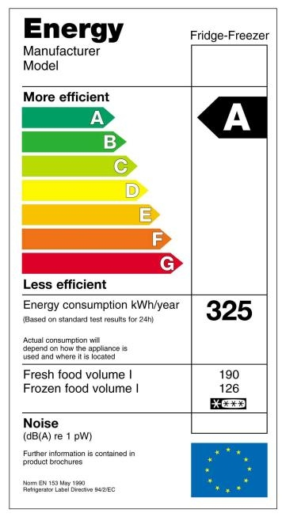

- Do you check the EU Energy labels and ratings before purchasing an appliance?
Yes/No

- Are you aware of the existence Energy Efficient Recommended Logo?
Yes/No 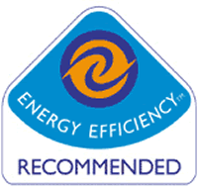

- Does the Energy Efficient Recommended Logo influence your purchase of appliances?
Yes/No

- How important is it for the appliance to have the energy efficient recommended logo when you are purchasing the appliance?
  - Very Important
  - Important
  - Does not matter
  - Did not look for the logo

- What is the turn off for you when buying energy efficient appliances?
- The cost
- The styling
- The brand

Best Practices

Cooking

- Do you normally keep the saucepan lids on while cooking?
Yes/No

- Do you know that keeping the saucepan lids on while cooking reduces condensation and energy?
Yes/No

- Do you know that boiling water using a pan uses more energy compared to a kettle?
Yes/No

Washing

- At what temperature setting do you usually use for your washing machine?

- Do you know that a 40°C washing cycle use a third less electricity rather than a 60°C cycle?
Yes/No

- Do you use economy setting or half load setting when you are washing small quantity of clothes?
Yes/No

- Do you know that the economy setting or the half load setting for small quantity of washing consumes less energy compared to full load setting?
Yes/No

Other electrical appliances

- Do you know that equipment left on standby consume energy?
Yes/No

- Do you normally leave your electrical appliances on standby mode whenever you are not using them?
Yes/No

General

- How often do you check your electricity and gas meter?
- Daily
- Weekly
- Monthly
- Every quarter of year
- Annually
  - Others (please specify)
- Would you like to learn more about energy efficiency
Yes/No

- How would you like to receive further information on best practises?
  - Brochures
  - Emails
  - Talks
  - Others (please specify)

