Case 1 Case 2
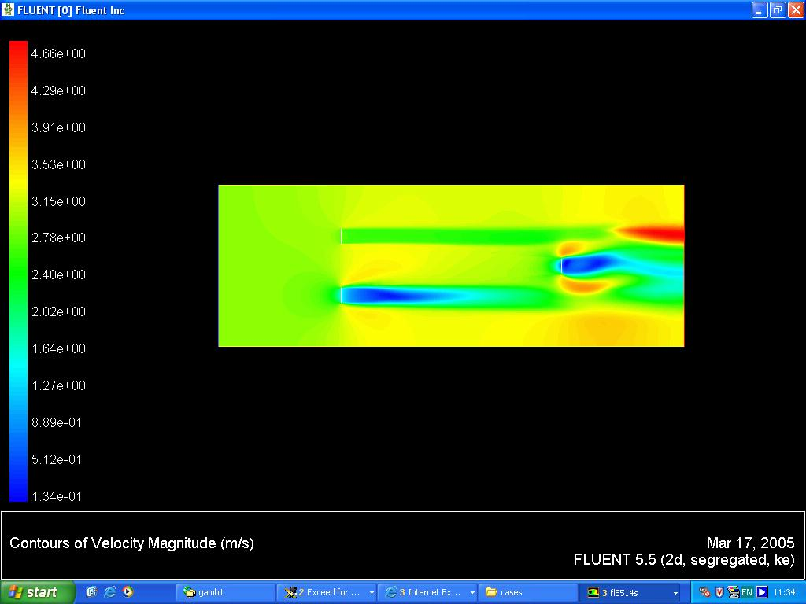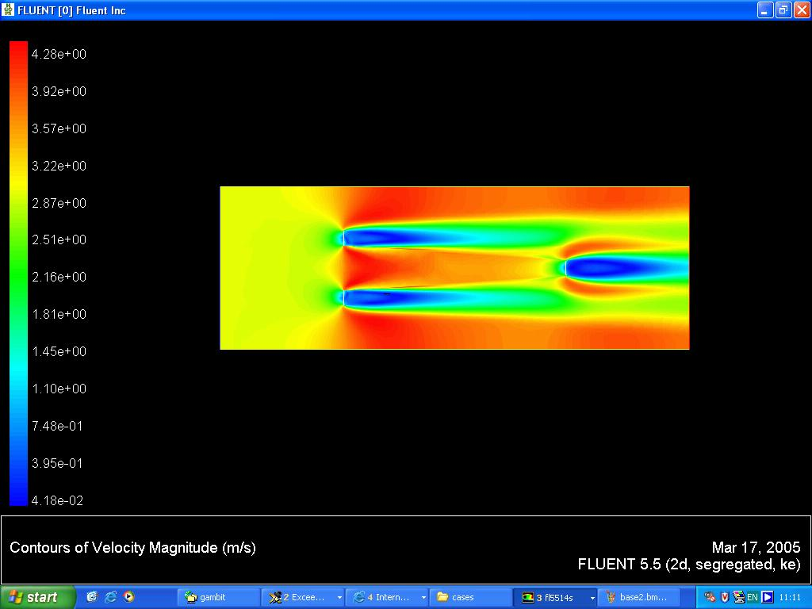
Case 3 Case 4
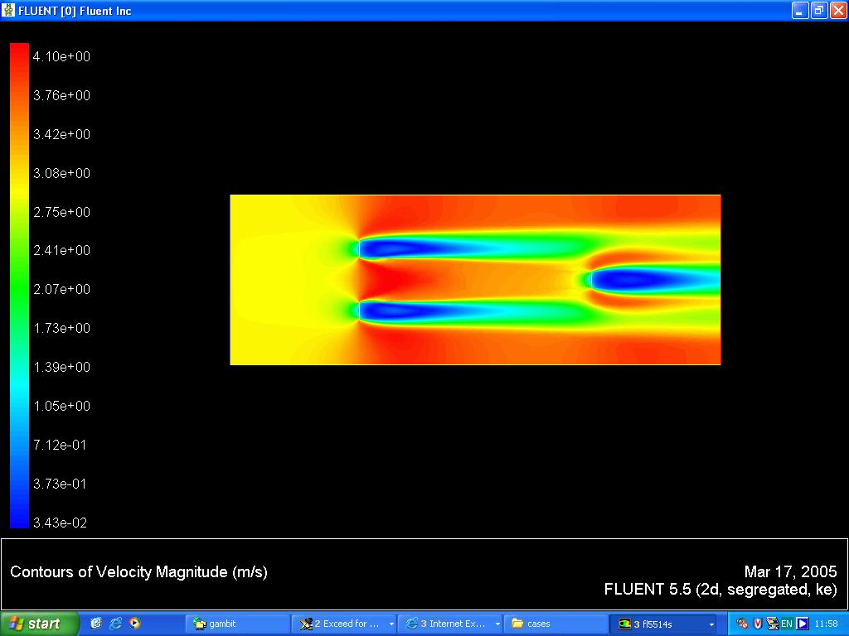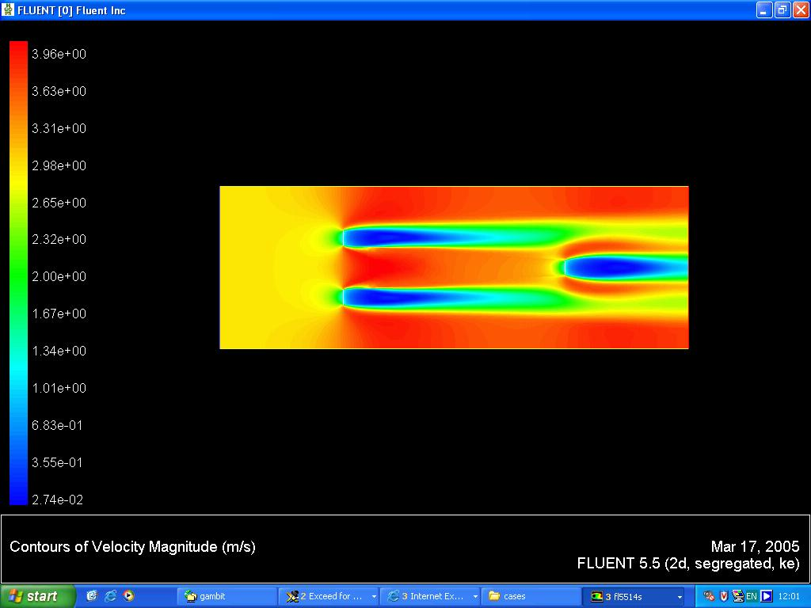
Case 5
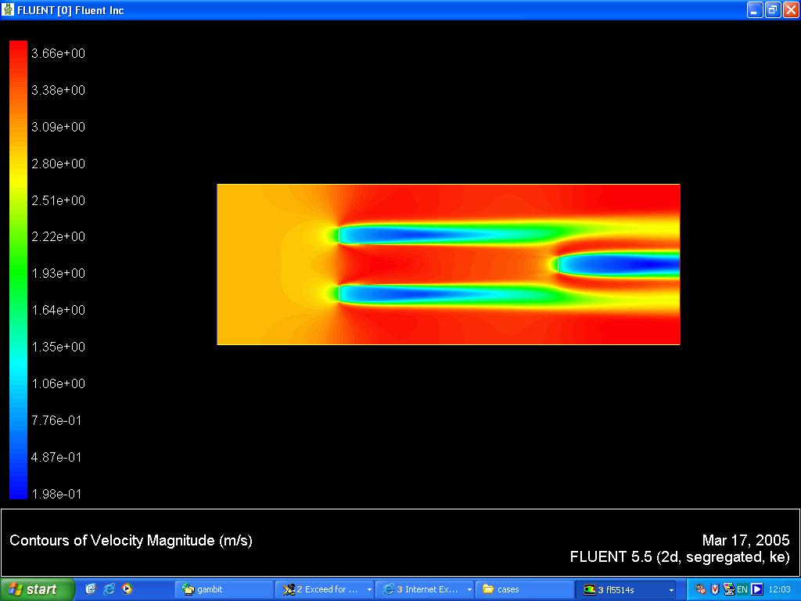

Sensitivity Analysis of C2 Value

Case | C2 Value | Delta m | Convergence | Iterations
Case1
MCT 1 | 1 | 0.5 | 1e-5 | 1000
MCT 2 | 10 | 0.5 | 1e-5 | 1000
MCT 3 | 100 | 0.5 | 1e-5 | 1000
Case2
MCT 1 | 100 | 0.5 | 1e-5 | 300
MCT 2 | 100 | 0.5 | 1e-5 | 300
MCT 3 | 100 | 0.5 | 1e-5 | 300
Case 3
MCT 1 | 50 | 0.5 | 1e-5 | 300
MCT 2 | 50 | 0.5 | 1e-5 | 300
MCT 3 | 50 | 0.5 | 1e-5 | 300
Case 4
MCT 1 | 25 | 0.5 | 1e-5 | 300
MCT 2 | 25 | 0.5 | 1e-5 | 300
MCT 3 | 25 | 0.5 | 1e-5 | 300
Case 5
MCT 1 | 10 | 0.5 | 1e-5 | 300
MCT 2 | 10 | 0.5 | 1e-5 | 300
MCT 3 | 10 | 0.5 | 1e-5 | 300

