Introduction to the tool

The “Retrofit Tool” was developed to display the project’s modelling results and findings in a user-friendly manner, while providing three different and independent mechanisms of obtaining results.
The first element of the tool is the Retrofit Main Tool; in this interface, the user can select any of the project retrofit levels and obtain the outcome data for applying that retrofit level, to either the entire residential building stock, a particular building type, or a particular age band; moreover, the user has the facility to generate the results obtained to a *.CSV report.
The second tool interface is the “Scenario Tool”; here the user can select four retrofit levels and explore the impact of applying them by different percentages to the entire building stock. As in the “Retrofit Tool”, the user can also print the results into a *.CSV file.
Finally, the “Graph Tool” interface allows navigating through several charts representing both the large scale and individual building impacts, of all the project retrofit levels; this tool provides a printing feature where the selected graph can be sent to the default printer, or printed as PDF, upon pressing a print button.

The interface

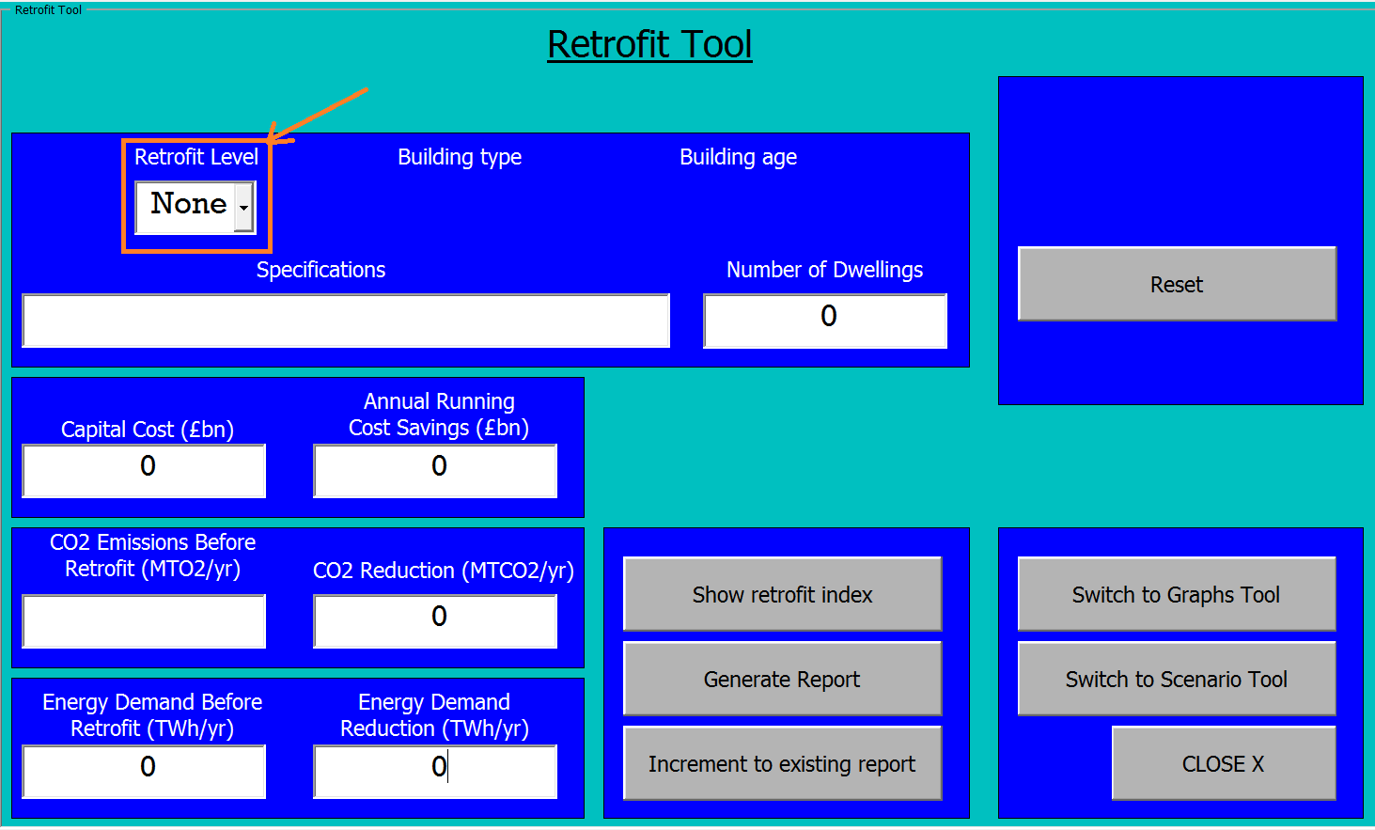
Figure 1 – Initial screen

(Figure 1) represents the initial page of the tool. There is only one selection available for the user which is the retrofit level.
Upon selecting the retrofit level, the rest of the selections are enabled (Figure 2).

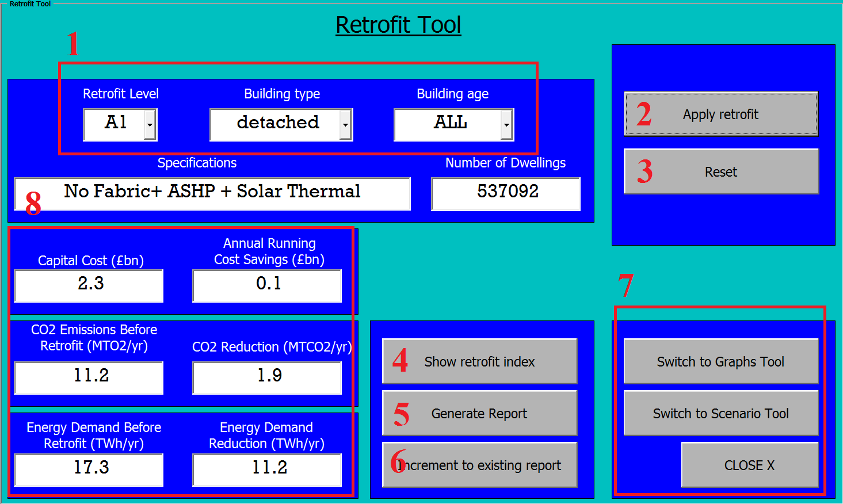
Figure 2 – Retrofit Tool features

- Retrofit selections
These are the main inputs required from the user to allow obtaining the retrofit outcome results using the main project categorizing criteria, which are building type, age, or both. The user can obtain the results for the entire residential building stock by selecting “ALL” for both selections.
- Apply retrofit command
The button runs the code to pick the results from the data tables based on the selections; it should be pressed after the user has made his/her selections. The button is only available if any selections are made; otherwise it is hidden.
- Reset
The reset button initializes the page and all selections and fields providing a clean start.
- Show Retrofit index
Calls the retrofit levels specifications table (Figure 3).
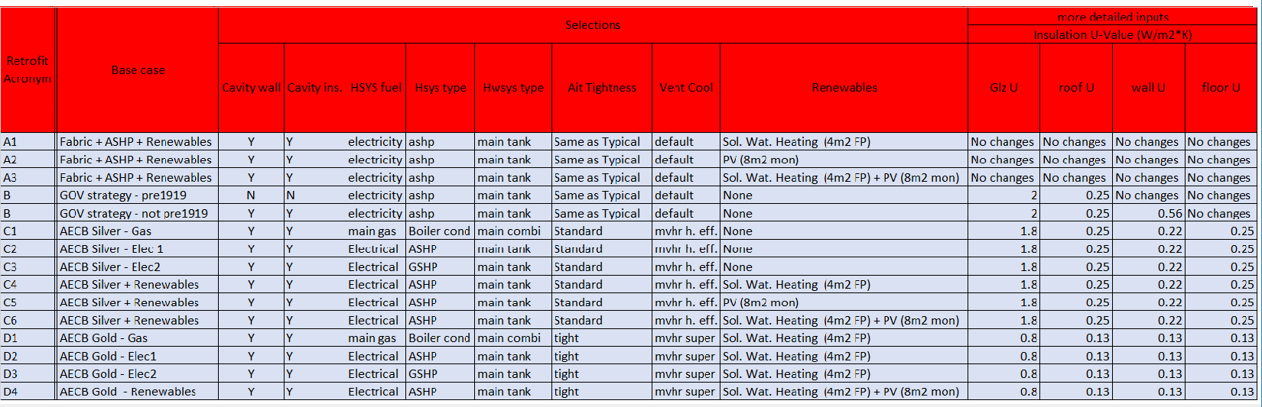
Figure 3 – Retrofit Levels Specifications

- Generate Report
Export results to *.CSV file; the user is prompted to browse for the directory to save the file.
Note: The file name is generated automatically to reflect the exact action time and date, in addition to the selections made.

- Increment to existing file
This button has been developed for the user may wish to build his own results table for further analysis; the user can browse and select a previous report and inserting other results in the following row; every time the user generates different results he/she can add them in the following row.

- Navigation buttons
These buttons are the only means of switching between the three tool interfaces.

- Results indicators
Where output results are displayed.

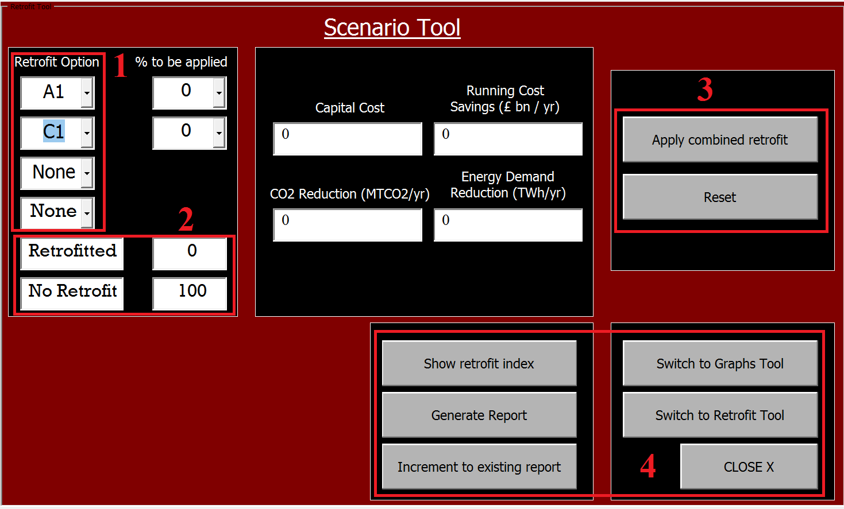
Figure 4 – Scenario Tool Interface

The second interface is the scenario tool, the tool allows the user to mix between up to four different retrofit levels and examine their outcome impact.
- Retrofit Selections
As in the Retrofit Main Tool, the “% to be applied” cells are hidden until a corresponding retrofit level is selected. Once the user has selected the desired retrofit option, the corresponding percentage entry becomes visible, as well as the “Apply Combined Retrofit” button. At least one retrofit % needs to be selected to enable the running of the tool.
Note: the user cannot select two of the same retrofit options at once, nor can they
select a total value of more than 100% of the buildings to be retrofitted.

- Total percentage dynamic Indicators
The dynamic indicators in figure 4 (Box 2) display the percentage of the selected and non-selected buildings for retrofit.

- Apply combined retrofit button
Runs the code to execute the requested calculations and returns the results to the adjacent field indicators.

- Navigation buttons
The navigation buttons have the exact same functionalities as the main retrofit interface described earlier.

The final interface is the Graph tool. That tool is intended to provide a variety of charts demonstrating the key impacts of all retrofit levels.

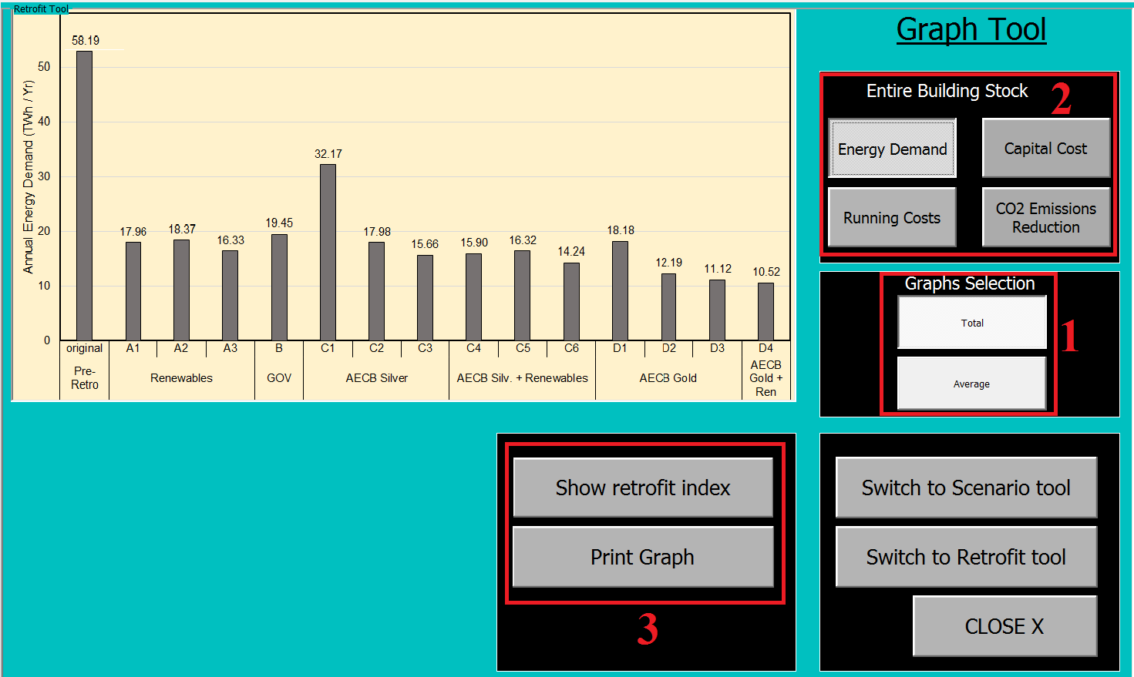
Figure 5 – Graph Interface Tool

- Main selection buttons
Only one of the two buttons can be selected at once; depending on which one is selected, the buttons in box 2 show different graphs.
- Key buttons
Each of the key buttons displays a different chart; only one can be selected at a time. The chart displayed depends on the main selection buttons mentioned in point 1. If the “Total” button is pressed, the charts displayed will represent the entire building stock, while if the “Average” button is selected, the charts displayed will represent average results per individual building of a certain type.
- Print Graph
The Print graph button prints the file into the default selected printer on the computer. If a .pdf creator is selected as default, the selected chart will be printed into a .pdf file. The charts have been designed to fit into a normal A4 scaling without the need of applying extra settings.

