Department of Mechanical and Aerospace Engineering

**Project**

**Studies of Three Configurations of Buses Powered by Hydrogen in Three Environmental Conditions Using MATLAB Tool**

Author: Nichapond Paisalvichitnuth

Supervisor: Dr Cameron Johnstone

A thesis submitted in partial fulfilment for the requirement of a degree in

Master of Science in

*Sustainable Engineering: Renewable Energy Systems and the Environment*

2023

**Copyright Declaration**

This thesis is the result of the author’s original research. It has been composed by the author and has not been previously submitted for examination, which has led to the award of a degree.

The copyright of this thesis belongs to the author under the terms of the United Kingdom Copyright Acts as qualified by the University of Strathclyde Regulation 3.50. Due acknowledgement must always be made of the use of any material contained in, or derived from this thesis.

Signed: Nichapond Paisalvichitnuth Date: 31 October 2023

**Abstract**

The transportation industry contributes substantially to global CO2 emissions. It relies heavily on fossil fuels, necessitating a shift towards sustainable energy sources. Hydrogen fuel is an interesting alternative energy, presenting a promising solution. Notably, buses, though not the primary contributors to emissions, play an essential role in public transport. Their transition to eco-friendly fuel sources can have wide-reaching environmental impacts.

This research utilises MATLAB to investigate and compare three configurations of hydrogen-powered buses: Hydrogen Internal Combustion Engine (HICE) buses, Fuel Cell (FC) buses, and Fuel Cell Electric (FCE) buses. This research aims to observe and assess their operational behaviours and fuel consumption across the determined simulated situations: long haul, regional, and urban driving simulations.

**Keywords:** Hydrogen Internal Combustion Engine (HICE) buses, Fuel Cell (FC) buses, and Fuel Cell Electric (FCE) buses.

**Acknowledgements**

This research project has been successfully completed with the assistance and advice from Dr Cameron Johnstone, the research project advisor on this study.

Additionally, I would like to thank my brother, Klahan; despite the 6-hour time zone difference, he has always been there to assist me. I am also thankful to my partner, Mild, who never hesitates to answer my calls every morning. Special thanks to the individual who has supported and guided me since 2019, helping me navigate challenging times.

I would also like to thank myself. I have learned to persevere and find beauty in the world through every twist and turn.

**Table of Contents**

1.0 Introduction 1

1.1 Problem Definition 1

1.2 Aim 2

1.3 Outline of Methodology 3

1.4 Structure of the Dissertation 3

2.0 Literature Review 5

2.1 Hydrogen 5

2.1.1 Hydrogen Characteristics 5

2.1.2 Hydrogen-fueled Mobile Application 5

2.2 Vehicle Fundamentals 7

2.2.1 Vehicle Movement Force 7

2.2.2 Propulsion Power Vehicle 9

2.2.3 The Fuel Consumption 10

2.3 Driving Simulations 10

2.3.1 Long-haul Simulation 10

2.3.2 Regional Simulation 12

2.3.3 Urban Simulation 14

2.4 Hydrogen Internal-Combustion Engine Vehicles (HICEVs) 15

2.4.1 The Internal Combustion Engine (ICE) Review 16

2.4.2 Hydrogen Internal Combustion Engine (H2-ICE) 16

2.4.3 Clutch 17

2.4.4 Transmission load 17

2.5 Fuel Cell Vehicles (FCVs) 18

2.5.1 PEM Fuel Cell 18

2.5.2 A DC-DC Converter 20

2.5.3 An AC Inverter 20

2.5.4 An Electric Motor 21

2.6 Fuel Cell Electric Vehicles (FCEVs) 21

2.6.1 Energy Management System (EMS) 21

2.6.1 Lithium-ion (Li-ion) battery 22

2.6.2 The State of Charge (SOC) 22

2.6.3 Operational Battery 23

3.0 Methodology 25

3.1 Part A: MATLAB Tool Development 25

3.2 Part B: MATLAB Tool Validation 27

3.3 Part C: MATLAB Tool Application 29

3.3.1 Bus Model Description 29

3.3.2 MATLAB tool for HICE Bus 30

3.3.3 MATLAB tool for FC and FCE Bus 30

4.0 Result 33

4.1 Hydrogen Internal Combustion Engine (HICE) Bus Result 33

4.1.1 Powertrain Result 33

4.1.2 Fuel Consumption Analysis 35

4.2 Fuel Cell (FC) Bus Result 35

4.2.1 Powertrain Analysis 35

4.2.2 Fuel Consumption Analysis 37

4.3 Fuel Cell Electric (FCE) Bus Result 37

4.3.1 Powertrain Analysis 37

4.3.2 Power Contribution Analysis 40

4.3.3 The State of Charge (SOC) Analysis 42

4.3.4 The Fuel Consumption Analysis 43

5.0 Discussion 44

5.1 Comparison of the Powertrain 44

5.2 Comparison of the Fuel Consumption 45

6.0 Conclusion 46

6.1 Future Work 46

7.0 References 47

**List of Figures**

**Figure 1.** The share of EU greenhouse gas emission in 2019 by sector [6]. 1

**Figure 2.** Type I, II, III, and IV cylinders for Hydrogen storage [23]. 7

**Figure 3.** The forces component for the moving vehicle [25]. 7

[**Figure 4.** The Long-Haul Simulation, where (a) velocity in km/h, (b) acceleration in m/s2, and (c) gradient road in % [28]. 11](https://d.docs.live.net/04a6059516b99b61/Documents/EF900%20Thesis%20-%202.docx#_Toc149640812)

[**Figure 5.** The Regional Simulation, where (a) velocity in km/h, (b) acceleration in m/s2, and (c) gradient road in % [28]. 13](https://d.docs.live.net/04a6059516b99b61/Documents/EF900%20Thesis%20-%202.docx#_Toc149640813)

**Figure 6.** The Urban Simulation, where (a) velocity in km/h, (b) acceleration in m/s2, and (c) gradient road in % [29]. 15

**Figure 7.** The HICEVs structure [13]. 16

**Figure 8**. The FCVs Structure [13]. 18

[**Figure 9.** The PEM fuel cell model [35]. 19](https://d.docs.live.net/04a6059516b99b61/Documents/EF900%20Thesis%20-%202.docx#_Toc149640817)

**Figure 10.** The FCEVs structure [13]. 21

**Figure 11.** Energy movement direction in the standard mode [43]. 23

**Figure 12.** Energy movement direction in the charging mode when low power [43]. 24

[**Figure 13.** Energy movement direction in the low-power mode when during braking [43]. 24](https://d.docs.live.net/04a6059516b99b61/Documents/EF900%20Thesis%20-%202.docx#_Toc149640821)

[**Figure 14.** Energy movement direction in the discharging mode [43]. 24](https://d.docs.live.net/04a6059516b99b61/Documents/EF900%20Thesis%20-%202.docx#_Toc149640822)

[**Figure 15.** MATLAB tool diagram 26](https://d.docs.live.net/04a6059516b99b61/Documents/EF900%20Thesis%20-%202.docx#_Toc149640823)

[**Figure 16**.The MATLAB interfaces. 27](https://d.docs.live.net/04a6059516b99b61/Documents/EF900%20Thesis%20-%202.docx#_Toc149640824)

[**Figure 17.** The flowchart of the FCE bus. 31](https://d.docs.live.net/04a6059516b99b61/Documents/EF900%20Thesis%20-%202.docx#_Toc149640825)

[**Figure 18.** HICE bus results of simulation tests, where (a) Long-haul profile; (b) Regional profile; (c) Urban profile. 34](https://d.docs.live.net/04a6059516b99b61/Documents/EF900%20Thesis%20-%202.docx#_Toc149640826)

[**Figure 19.** Fuel consumption analysis in the three driving profiles: HICE bus. 35](https://d.docs.live.net/04a6059516b99b61/Documents/EF900%20Thesis%20-%202.docx#_Toc149640827)

[**Figure 20.** FC bus results of simulation tests, where (a) Long-haul profile; (b) Regional profile; (c) Urban profile. 36](https://d.docs.live.net/04a6059516b99b61/Documents/EF900%20Thesis%20-%202.docx#_Toc149640828)

[**Figure 21.** Fuel consumption analysis in the three driving profiles: FC bus. 37](https://d.docs.live.net/04a6059516b99b61/Documents/EF900%20Thesis%20-%202.docx#_Toc149640829)

[**Figure 22.**  FCE bus results of simulation tests, where (a) Long-haul profile; (b) Regional profile; (c) Urban profile. 39](https://d.docs.live.net/04a6059516b99b61/Documents/EF900%20Thesis%20-%202.docx#_Toc149640830)

[**Figure 23.** The power contribution: FCE bus, where (a) Long-haul profile; (b) Regional profile; (c) Urban profile. 41](https://d.docs.live.net/04a6059516b99b61/Documents/EF900%20Thesis%20-%202.docx#_Toc149640831)

[**Figure 24.** The percentage of the power contribution: FCE bus. 41](https://d.docs.live.net/04a6059516b99b61/Documents/EF900%20Thesis%20-%202.docx#_Toc149640832)

[**Figure 25.** The State of Charge (SOC) analysis in the three driving profiles: FCE bus. 42](https://d.docs.live.net/04a6059516b99b61/Documents/EF900%20Thesis%20-%202.docx#_Toc149640833)

[**Figure 26.** The fuel consumption analysis of the three driving profiles: FCE bus. 43](https://d.docs.live.net/04a6059516b99b61/Documents/EF900%20Thesis%20-%202.docx#_Toc149640834)

[**Figure 27.** Comparison of powertrain in the three buses. 44](https://d.docs.live.net/04a6059516b99b61/Documents/EF900%20Thesis%20-%202.docx#_Toc149640835)

[**Figure 28.** Comparison of fuel consumption in the three buses. 45](https://d.docs.live.net/04a6059516b99b61/Documents/EF900%20Thesis%20-%202.docx#_Toc149640836)

**List of Tables**

**Table 1.** Hydrogen properties at STD [3] [9] [14] [15] [16]. 5

**Table 2.** The Hydrogen and other traditional fuels [3] [9] [15] [16] [18]. 6

**Table 3.** The Long-Haul Simulation [27]. 11

**Table 4.** The Regional Delivery Features [27] 13

**Table 5.** The Urban Delivery Features [27]. 15

**Table 6.** Baseline vehicle [44]. 28

**Table 7**. MATLAB tool validation: 1st 28

**Table 8.** MATLAB tool validation: 2nd 29

**Table 9**. Bus model in the MATLAB tool [8] [44] [45] [46] [47] [48]. 30

**Table 10.** Parameters used in the HICE bus [8] [10] [49]. 30

**Table 11.** Parameters used in the FC and FCE bus [8] [10] [49] [50]. 30

**Table 12.** Battery parameters used in the FCE bus. 32

**Table 13.** The summarised results of the net power: HICE bus. 33

**Table 14**. The summarised results of the net power: FC bus. 35

**Table 15.** The summarised results of the powertrain: FCE bus. 38

**Table 16.** State of Charge (SOC): FCE bus. 42

**Nomenclature**

|  |  |  |
| --- | --- | --- |
| **Symbol** | **Description** | **Units** |
| Ft  Fr  Faero  Fg  m  mi  v  a  g $grad$   Jwheel  JM  gr  rw  Cr  Caero  Af    ICE  H2-ICE  CGH2  UDC  PFI  DI  HICEVs  FCVS  FCHEVs  EVs  HDV  LDV  VECTO  EMS | Traction force  Rolling friction force  Air friction force  Gravity force  Mass of the vehicle  Mass from the rotating inertia force  Velocity  Acceleration  Gravity acceleration  Gradient road  Wheel inertia  Engine inertia  Gear ratio  wheel radius  Rolling resistance coefficient  Aerodynamic drag coefficient  Wind-facing area  Air density  Internal combustion engine  Hydrogen internal combustion engine  Compressed Gas Hydrogen  Unidirectional DC-DC converter  Port fuel injection  Direct injection  Hydrogen internal-combustion engine vehicles  Fuel cell vehicles  Fuel cell electric vehicles  Electric vehicles  Heavy-duty vehicle  Light-duty vehicle  Vehicle energy consumption calculation tool Energy management system | N  N  N  m/s2  kg  kg  km/h or m/s  m/s2  m/s2  %  kg.m2  kg.m2  -  m  -  -  M  kg/m2  -  -  -  -  -  -  -  -  -  -  -  -  -  - |

# 

# Introduction

## Problem Definition

There has been a notable shift towards sustainable energy in the transport sector, with its attempt to adopt growing because transportation mostly depends on fossil fuels, up to 95% [1].

The high consumption raises concerns about future energy security. According to the BP Statistical Review of World Energy Report in 2021, at the current rate of production, crude oil reserves are anticipated to last for just about 50 more years [2]. Despite the global push for sustainability, practical data reveals a contrasting trend: worldwide oil consumption has surged from 3,928 million tonnes to 5,300 million tonnes from 2008 to 2021 [3]. This situation emphasises the need for the transport sector to switch to more sustainable power.

In addition, global transportation ranks fifth for emitters of CO2, with 6.9 gigatonnes of carbon dioxide (GtCO2) emissions in 2020. This is a statement that the transport sector is experiencing a growing impact on fuel usage and greenhouse gas emissions, which is of significant concern [4]. It also leads to an increase underscores the urgency of international agreements like the Paris Agreement, targeting a restriction on global temperature increase to 1.5°C before the end of the 21st century [3, 5].

Like the European Union (EU), In 2019, the EU recorded emission volumes exceeding 744.5 million metric tonnes of carbon dioxide (CO2) [6]. The energy sector led the way within the emission profile, accounting for 27.8%. The transport sector closely followed this at 22.3% and the industry sector at 20.7%. Upon further examination of the emissions within the transport sector, it has been determined that road transport was the leading contributor, accounting for 78.9% of the total emissions. Passenger vehicles were the most significant emitters in this category, accounting for 87.2%, while buses at 5.6%, as is displayed in Figure 1.

**Figure 1.** The share of EU greenhouse gas emission in 2019 by sector [6].

Although the bus is not ranked first, its importance is highlighted by its substantial weight, which includes passengers and cargo and its propensity for longer journeys. As a result, it also considerably affects oil consumption and emissions [4]. The bus is considered an essential option of public transportation that plays a vital role in supporting the overall well-being of humans, as evidenced by the European Union's reliance on buses. In the EU, buses are the primary mode of public transportation, serving both cities and the countryside. With 684,285 buses, the transport system of the EU underscores the importance of buses in ensuring mobility and connectivity [7]. While buses offer an eco-friendly alternative to cars—potentially replacing the emissions of automobiles with a singular bus —it is notable that 99% of operational buses continue to rely on conventional fuel sources [7]. This fact underscores the need to advocate for bus usage as a green transportation solution, especially in densely populated urban areas where congestion and air pollution are significant concerns.

Based on the information mentioned above, it can be observed that alternative fuel is currently undergoing a phase of energy transition [8, 1, 5]. One of the sustainable energy sources is Hydrogen fuel, which has garnered significant attention, leading to efforts to promote its growth in terms of production [1]. Hydrogen production can be generated by renewable energy sources, primarily through water electrolysis, known as green hydrogen [9]. Moreover, hydrogen fuel is clean burning, producing less harmful emissions and pollutants than conventional fuel emitting carbon molecules [10]. In the context of vehicles, the bus has an advantage regarding its physical dimensions. The bus has a higher capacity than a Light-Duty Vehicle (LDV) in supporting hydrogen systems, such as fuel cells, energy storage, and hydrogen storage systems [11]. The benefit of hydrogen-fueled vehicles is also shorter refuelling time than battery electric vehicles [12].

Therefore, hydrogen technologies in automobiles have been developed to apply hydrogen as an alternative fuel. There are three main options for hydrogen-powered vehicles: hydrogen internal combustion engine (HICE) vehicles, fuel cell (FC) vehicles, and fuel cell electric (FCE) vehicles, which present unique challenges and characteristics regarding fuel consumption and efficiency [13].

Numerous studies have investigated the development of hydrogen use in buses. Hydrogen is an attractive option as the transportation sector seeks sustainable alternatives to traditional fuels. It is the potential to reduce fossil fuel consumption and carbon emissions, as well as its compatibility with the operational requirements of buses, capture the interest of researchers and industry professionals [11, 12, 8, 1, 3, 5]. This study is aware of the significance of this technology. It intends to research and investigate the three configurations of hydrogen-powered buses to analyse their operation and fuel consumption under various driving test cycles: long haul, regional, and urban conditions. To assist in analysing the data from these tests, this study will specifically use a tool developed by MATLAB.

## Aim

This research uses the MATLAB tool to observe the behaviour of operational and fuel consumption in three hydrogen configurations among the three driving profiles. The three configurations of hydrogen-powered vehicles are the hydrogen internal combustion engine (HICE) bus, the fuel cell (FC) bus, and the fuel cell electric (FCE) bus. The three driving profiles are long-haul, regional, and urban profiles, and a comparative analysis will be created among them.

## Outline of Methodology

To achieve the aim, the outline of the methodology is arranged in detail in the bullets:

* *Research problem, question, and design:* The study starts with the research problem and question. It seeks reliable and related documents, including the knowledge background, to gather quantitative data to plan the research design.
* *Foundational knowledge field:* To gain a comprehensive understanding of hydrogen technology in automobiles, the author fundamental aspects of conventional vehicles. This included studying essential components and the forces required for vehicle propulsion.
* *MATLAB tool development:* After that, the study developed the tool in MATLAB. The analysis will be separated into model and road variables, driving cycle variables and specialised section variables. These segments collaboratively function to produce the outcomes.
* *MATLAB tool validation:* To ensure the precision of the MATLAB tool, its outputs will be compared with referenced study from traditional-fueled heavy-duty vehicles. The percentage difference between the results from the MATLAB tool and the reference data will be computed to measure the accuracy of the tool.
* *MATLAB tool application:* When the result from the MATLAB tool is acceptable. The tool will be enhanced to incorporate three main configurations: the hydrogen internal combustion engine (HICE) bus, the fuel cell (FC) bus, and the fuel cell electric (FCE) bus, to analyse their operation and fuel consumption.
* *Result and discussion:* It presents the outputs obtained from MATLAB and discusses these outcomes, then does the comparative analysis.
* *Summary and Future work:* This section summarises the results, emphasising key insights on hydrogen-fueled vehicle simulations and suggesting future work.

## Structure of the Dissertation

The content in this study consists of five chapters, detailed in the following;

|  |  |
| --- | --- |
| *-* | *Chapter 1: Introduction* – This chapter introduces the general information about the statement for the reader to comprehend the topic and issue under discussion. It also delineates the aims of this study. |
| *-* | *Chapter 2: Literature Review* -This chapter involves researching and studying various past and present works related to this study, in which essential points are analysed, organised, and interconnected to clarify further and emphasise the topic. |
| *-* | *Chapter 3: Methodology –* This chapter will mention the method of this study, focusing on three main stages: the MATLAB tool development, the MATLAB tool validation, and the MATLAB simulation. |
| *-* | *Chapter 4: Result*- This chapter delineates the findings and outcomes derived from the methodologies employed in Chapter 3. |
| *-* | *Chapter 5: Discussion* - This chapter will bring results from Chapter 4 to a comparative analysis of three model buses: the hydrogen internal combustion engine (HICE) bus, the fuel cell (FC) bus, and the fuel cell electric (FCE) bus and three driving simulations: long-haul, regional, and urban simulations. |
| *-* | *Chapter 6: Conclusion -*This chapter addresses the findings of this study, presenting them concisely. |

# Literature Review

## Hydrogen

This section will mention about the general information for hydrogen, such as typical characteristics, then will describe hydrogen as the alternative fuel for vehicles.

### Hydrogen Characteristics

Hydrogen is the lightest element, denoted as H2, with a low atomic weight of 2.016 g/mol [14]. Besides, hydrogen has a lower density than air at 0.0898 g/l, whereas the density of air is 1.19 g/l. Its molecular size also gives it a high diffusion rate of 0.61 cm2/s. Consequently, hydrogen gas exhibits a lighter weight than air [14].

|  |  |
| --- | --- |
| Properties | Hydrogen |
| Name, Atomic Number | H,1 |
| Density at STD | 0.0898 g/l |
| Molecular weight | 2.016 g/mol |
| Energy per weight (MJ/kg) | 120 MJ/kg |
| Energy per volume (MJ/l) | 0.0107 |
| Diffusion (cm2/s) | 0.61 |
| Flammability rang in the air | 4-75 vol % |
| Energy-related to ignition(mJ) | 0.017 |
| Flame velocity (m/s) | 3.06 |

Regarding energy content, hydrogen contributes a high gravimetric energy density of 120 MJ/kg. However, hydrogen presents notable storage difficulties due to its low volumetric energy density at 0.0107 MJ/l, under standard temperature and pressure (STD) conditions [15].

**Table 1.** Hydrogen properties at STD [3] [9] [14] [15] [16].

Furthermore, hydrogen illustrates a broad range of flammability in the presence of air, spanning from 4% to 75% in terms of volume. This substance tends to create combustible combinations under different circumstances [3]. Hydrogen also behaves with a low ignition energy of 0.017 mJ with flame velocity at 3.06 m/s, indicating that the combustion of a hydrogen-air blend sensitive to ignition [15]. Then, it necessitates special care, especially when it is in gas. Table 1 shows the hydrogen properties at 25°C at 1 atm.

### Hydrogen-fueled Mobile Application

Hydrogen, a primary component of nature, is widely acknowledged for its potential as an environmentally friendly alternative to traditional fossil fuels. It can be extracted from various compounds, such as water, which is abundantly available. One promising method for producing hydrogen from water involves the use of renewable energy sources, such as solar and wind power [9]. While fossil fuel combustion releases carbon compounds that contribute significantly to environmental concerns, hydrogen combustion does not emit carbon-based molecules due to its unique chemical composition [15]. As a result, hydrogen offers a cleaner energy solution in comparison to fossil fuels.

One advantage of hydrogen is its high gravimetric energy density, especially when compared to gasoline. Hydrogen has more than three times more specific energy than gasoline [17]. This provides more energy than other fuels. However, its advantage diminishes when considering volumetric energy density due to its lower volumetric energy content. For instance, gasoline has an energy density of 34.2 MJ/l, while hydrogen has 0.0107 MJ/l [15]. This indicates that a significant gap in volume requires a larger quantity of gaseous hydrogen to store the same energy content as other fuels. A comprehensive comparison of hydrogen with gasoline and diesel is shown in Table 2; this comparative analysis at 25°C and 1 atm pressure.

|  |  |  |  |
| --- | --- | --- | --- |
| Property | Hydrogen | Gasoline | Diesel |
| Molar mass (g/mol) | 2.015 | 110 | 170 |
| Density (kg/m3) | 0.08 | 692 | 830 |
| Quenching the gap (cm) | 0.06 | 0.2 | - |
| Mass diffusivity in the air (cm2/s) | 0.61 | 0.05 | - |
| Energy per weight (MJ/kg) | 120 | 46.4 | 45.4 |
| Energy per liter (MJ/l) | 0.0107 | 34.2 | 34.6 |
| Minimise ignition energy (mJ) | 0.017 | 0.24 | 20 |
| Flammability limits in the air (vol%) | 4.1–75 | 1.5–7.6 | 0.6-5.5 |
| Carbohydrate mass content (%) | 0 | 84 | 86 |

**Table 2.** The Hydrogen and other traditional fuels [3] [9] [15] [16] [18].

#### Hydrogen Storage

As mentioned above, the hydrogen characteristic leads to the challenge of storing hydrogen due to its unique characteristics. The most suitable for hydrogen storage is Compressed Gas Hydrogen (CGH2) [19].

Compressed Gas Hydrogen (CGH2) is the current standard for storing hydrogen onboard vehicles [20]. It is typically designed to operate and hold at nominal working pressures of 35 to 70 MPa. There are various types of hydrogen containers: Type I, Type II, Type III, and Type IV. The material determines the classification of each type utilises and its operating pressure [21]. Type I is constructed entirely from metal, while Type II consists of a metal core surrounded by fibre with a polymer layer. Due to their weight and relatively low hydrogen storage capacity concerning their mass, they are impractical for automotive applications [21]. In contrast, Type III is composite cylinders with a metal liner, and Type IV is composite cylinders with no metal-based liners. These configurations enable Type III and IV cylinders to withstand the elevated pressures required for hydrogen storage while maintaining a comparatively lower mass [21]. Consequently, Type III and Type IV are commonly applied owing to their strong mechanical properties and low-weight characteristics, which make them more suitable for vehicular use [22, 23]. The image of each type is demonstrated in

Figure ***2***.

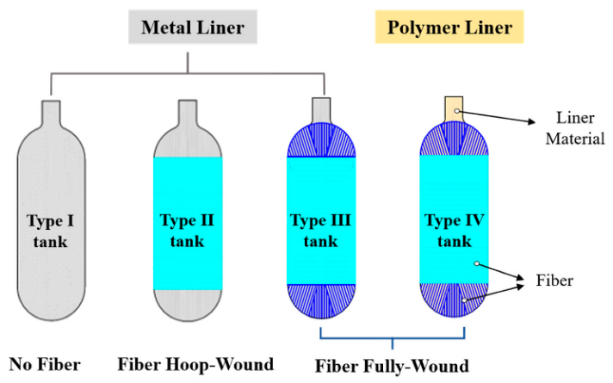

**Figure 2.** Type I, II, III, and IV cylinders for Hydrogen storage [23].

## Vehicle Fundamentals

This section describes a comprehensive overview of the fundamental knowledge of an automobile, including the principal components and calculations related to driving power, considering various forces.

### Vehicle Movement Force

According to Newton's second law, the force acting on an object is directly proportional to its acceleration and mass [24]. Similarly, in the context of a vehicle, propulsion power is essential for movement across distances related to the mass and acceleration. While in motion, a vehicle encounters three additional challenge forces: rolling drag force, aerodynamic force, and gravitational force, which is linked to the centre of gravity [25, 24, 26], as shown in , collectively determine the driving force of the vehicle, commonly referred to as the traction force. Figure 3, collectively determine the driving force of the vehicle, commonly referred to as the traction force.

**Figure 3.** The forces component for the moving vehicle [25].

#### Traction Force

The traction force indicates how much propulsion power propels the vehicle, which respects the overall kinetic energy that offsets the opposing party due to airflow friction, tire friction, and acceleration due to gravity.

However, when a vehicle is in motion, the wheels experience a phenomenon known as rotational inertia. This is the tendency for wheels to resist changes in their rotational motion. This resistance must be considered in order to match the kinetic energy of the vehicle. The equation is in Equation 2.1 [25, 24].

|  |  |
| --- | --- |
| $$F_{t}=(m+m_{i})a+F_{r}+F_{aero}+F_{g}$$ | 2.1 |

Where,

Ft is the traction force in the Newton unit.

Fr is the rolling friction force in Newton unit.

Faero is the air friction force in Newton unit.

Fg is the gravity force in m/s2.

m is the mass of the vehicle in kilograms.

mi is the mass from the rotating inertia force in kilograms.

a is the acceleration in m/s2.

The mi, mass of the inertia force, can be written in Equation 2.2.

|  |  |
| --- | --- |
| $$m_{i}=\frac{J_{wheel}+(J_{M}*{(g_{r})}^{2})}{{r_{w}}^{2}}$$ | 2.2 |

Where,

Jwheel is the wheel inertia in kg.m2.

JM is the engine inertia in kg.m2.

gr is the gear ratio.

rw is the wheel radius in meters.

#### Rolling Drag Force

The rolling drag force is commonly known as the rolling resistance force. This force is essential in automotive power and refers to the friction of the wheel vehicle with the road surface. All these factors influence this force directly, contributing to its coefficient of resistance, as in Equation 2.3 [25, 24].

|  |  |
| --- | --- |
| $$F_{r}=C_{r}*m*gcos(grad)$$ | 2.3 |

Where,

Fr is the rolling drag force in the Newton unit.

Cr is the coefficient due to rolling resistance.

m is the mass of the vehicle in kilograms.

g is the gravitational force in m/s2.

is the slope of the road in percentage.

#### Aerodynamic Drag Force

The movement of air is the main factor affecting the driving force. Therefore, examining the wind friction through the moving vehicle is necessary. It is recognised as an aerodynamic force. This force is opposed to the wind flow when the vehicle moves forward. This force also varies according to the shape and size of the vehicle, including the speed of motion. It can find out the value as following Equation 2.4 [25, 24].

|  |  |
| --- | --- |
| $$F_{aero}=\frac{1}{2}(A_{f}*C_{aero}*ρ*v^{2})$$ | 2.4 |

Where,

Faero is the aerodynamic drag force in the Newton unit.

Af is the wind-facing area of the vehicle in the meter units.

Caero is the aerodynamic drag coefficient.

$ρ$ is the air density in kg/m2 unit.

v is the velocity of the vehicle in m/s2 unit.

#### Gravitational Force

The variation in the gradient road (incline or decline) affects the force. Thus, it requires an analysis of the angle of the sloping road, including the weight of the vehicle and gravity. It also cites the centre of gravity (CG) of the vehicle body according to the stability and balance when movement happens. It is shown in Equation 2.5 [25, 24].

|  |  |
| --- | --- |
| $$F_{g}= m*gsin(grad)$$ | 2.5 |

Where,

Fg is the force due to gravity in the Newton unit.

m is the mass of the vehicle in kilograms.

g is the gravitational force in m/s2.

is the slope of the road in percentage.

### Propulsion Power Vehicle

The power to drive the automobile is ably calculated from the tractive force from Equation 2.1, with the distance varying over time as follows in Equation 2.6 [25, 24].

|  |  |
| --- | --- |
| $$P_{t}=F_{t}*\frac{Distance }{time}=F_{t}*velocity in m/s$$ | 2.6 |

Where,

Pt is the propulsion power in the watt unit.

Ft is the tractive force in the Newton unit.

The equation mentioned above represents the necessary power for the vehicle movement. However, it requires to consider the auxiliary power ($P_{aux}$), for example, heating and air condition power, ventilation power, and lighting power [8]. Taking these into consideration, the final power (P) is given in Equation 2.7.

|  |  |
| --- | --- |
| $$P=P_{t}+P_{aux}$$ | 2.7 |

### The Fuel Consumption

Given the required energy and the energy density of fuel used in the vehicle, the fuel usage during the journey was determined using Equation 2.8. Energy is the final propulsion power (P) throughout the whole over-cycle period in the Joule unit. Energy density can be in weight or volume depending on the desired unit of measure [25, 24]. For example, diesel fuel consumption would be 34.6 MJ/l due to diesel being commonly measured in volume while considering its consumption in terms of weight, giving it an energy density of 120 MJ/kg.

|  |  |
| --- | --- |
| $$Fuel consumption=\frac{Energy }{Energy density }$$ | 2.8 |

## Driving Simulations

A driving simulation is a profile that depicts a velocity over a duration, considering variations in road gradient. It evaluates fuel efficiency, emissions, and other relevant performance parameters. While there is a difference in driving profile patterns, each choice is contingent upon the type of vehicle and its operating environment. There are three driving simulations, namely, the long haul, regional delivery, and urban delivery profiles. These profiles are available from the VECTO (Vehicle Energy Consumption calculation Tool) programme provided by the European Commission. Each profile represents different driving conditions and vehicle speed, as outlined by VECTO version 3.2.1.1054:

### Long-haul Simulation

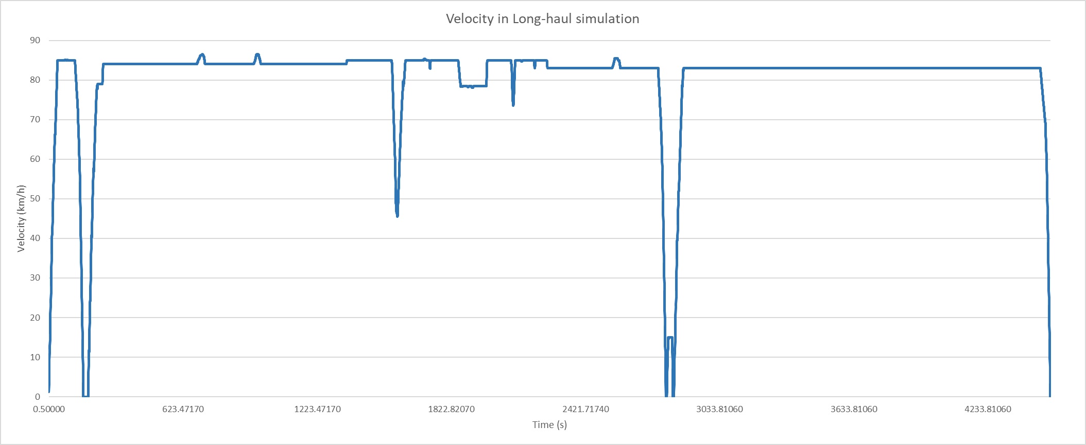The long-haul simulation reflects the conditions of a motorway environment, characterised by long distances of 100 kilometres, infrequent stops averaging 67 seconds, and an overall average speed of 80.55 km/h for the entire journey. There are velocity, acceleration, and gradient roads over the periods, as shown in Figure 4(a), (b), and (c).

(a)

*Cont.*

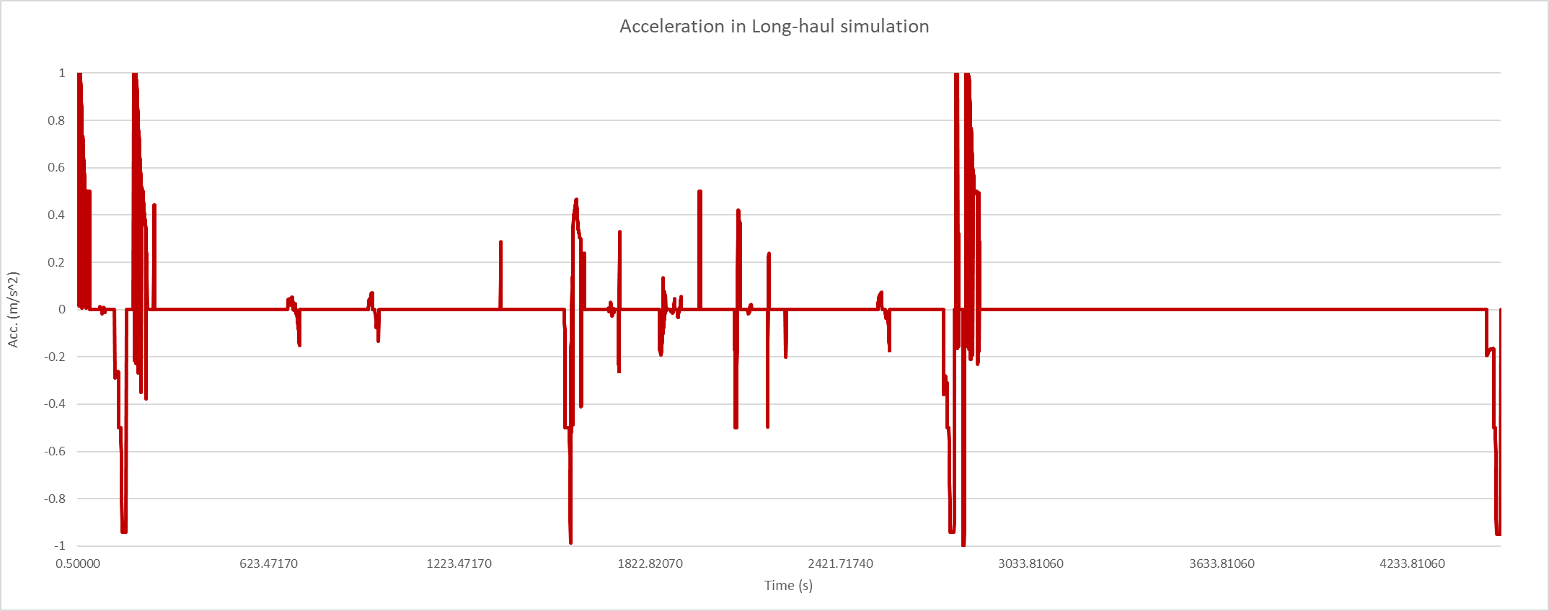(b)

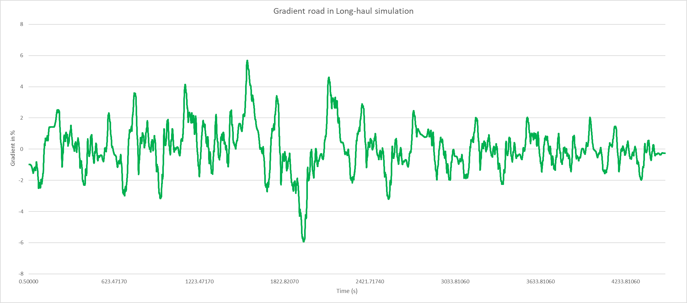(c)

**Figure 4.** The Long-Haul Simulation, where (a) velocity in km/h, (b) acceleration in m/s2, and (c) gradient road in % [28].

There is summarised information of this driving simulation in Table 3.

|  |  |
| --- | --- |
| Parameter | Value |
| Duration (s) | 4,515.45 |
| Distance (km) | 100 |
| Maximum velocity (km/h) | 86.5 |
| Minimum velocity (km/h) | 1.27 |
| Average velocity (km/h) | 80.55 |
| Stop time (s) | 67 |
| Number of braking events | 539 |

**Table 3.** The Long-Haul Simulation [27].

### Regional Simulation

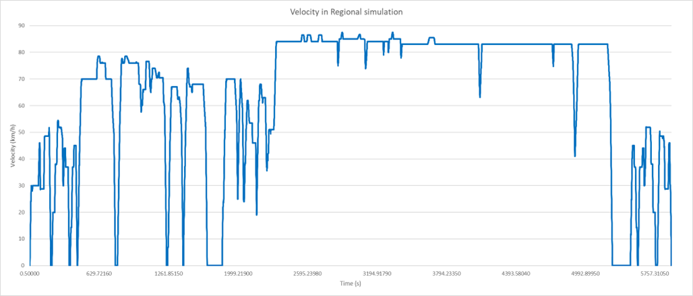The Regional Delivery driving cycle models the vehicle in the suburb, featuring distances of 100 kilometres, with stops lasting 746 seconds, and an overall average speed of 65.02 km/h, as shown in Figure 5(a), (b), and (c).

(a)

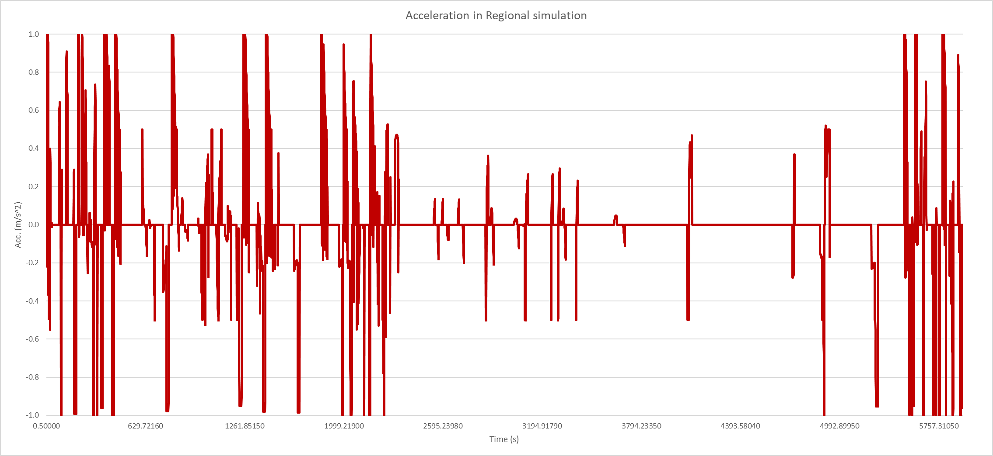(b)

*Cont.*

(c)

**Figure 5.** The Regional Simulation, where (a) velocity in km/h, (b) acceleration in m/s2, and (c) gradient road in % [28].

There is summarised information of this driving simulation in Table 4.

|  |  |
| --- | --- |
| Parameter | Value |
| Duration (s) | 5,922.58 |
| Distance (km) | 100 |
| Maximum velocity (km/h) | 87.5 |
| Minimum velocity (km/h) | 1.27 |
| Average velocity (km/h) | 65.02 |
| Stop time (s) | 746 |
| Number of braking events | 1,419 |

**Table 4.** The Regional Delivery Features [27]

### Urban Simulation

The urban simulation resembles the operation of vehicles within metropolitan area, necessitating frequent operation at lower mean speeds of 30.22 km/h, interrupted by extended durations of stoppage. There are velocity, acceleration, and gradient roads over the periods, as shown in Figure **6**(a), (b), and (c).

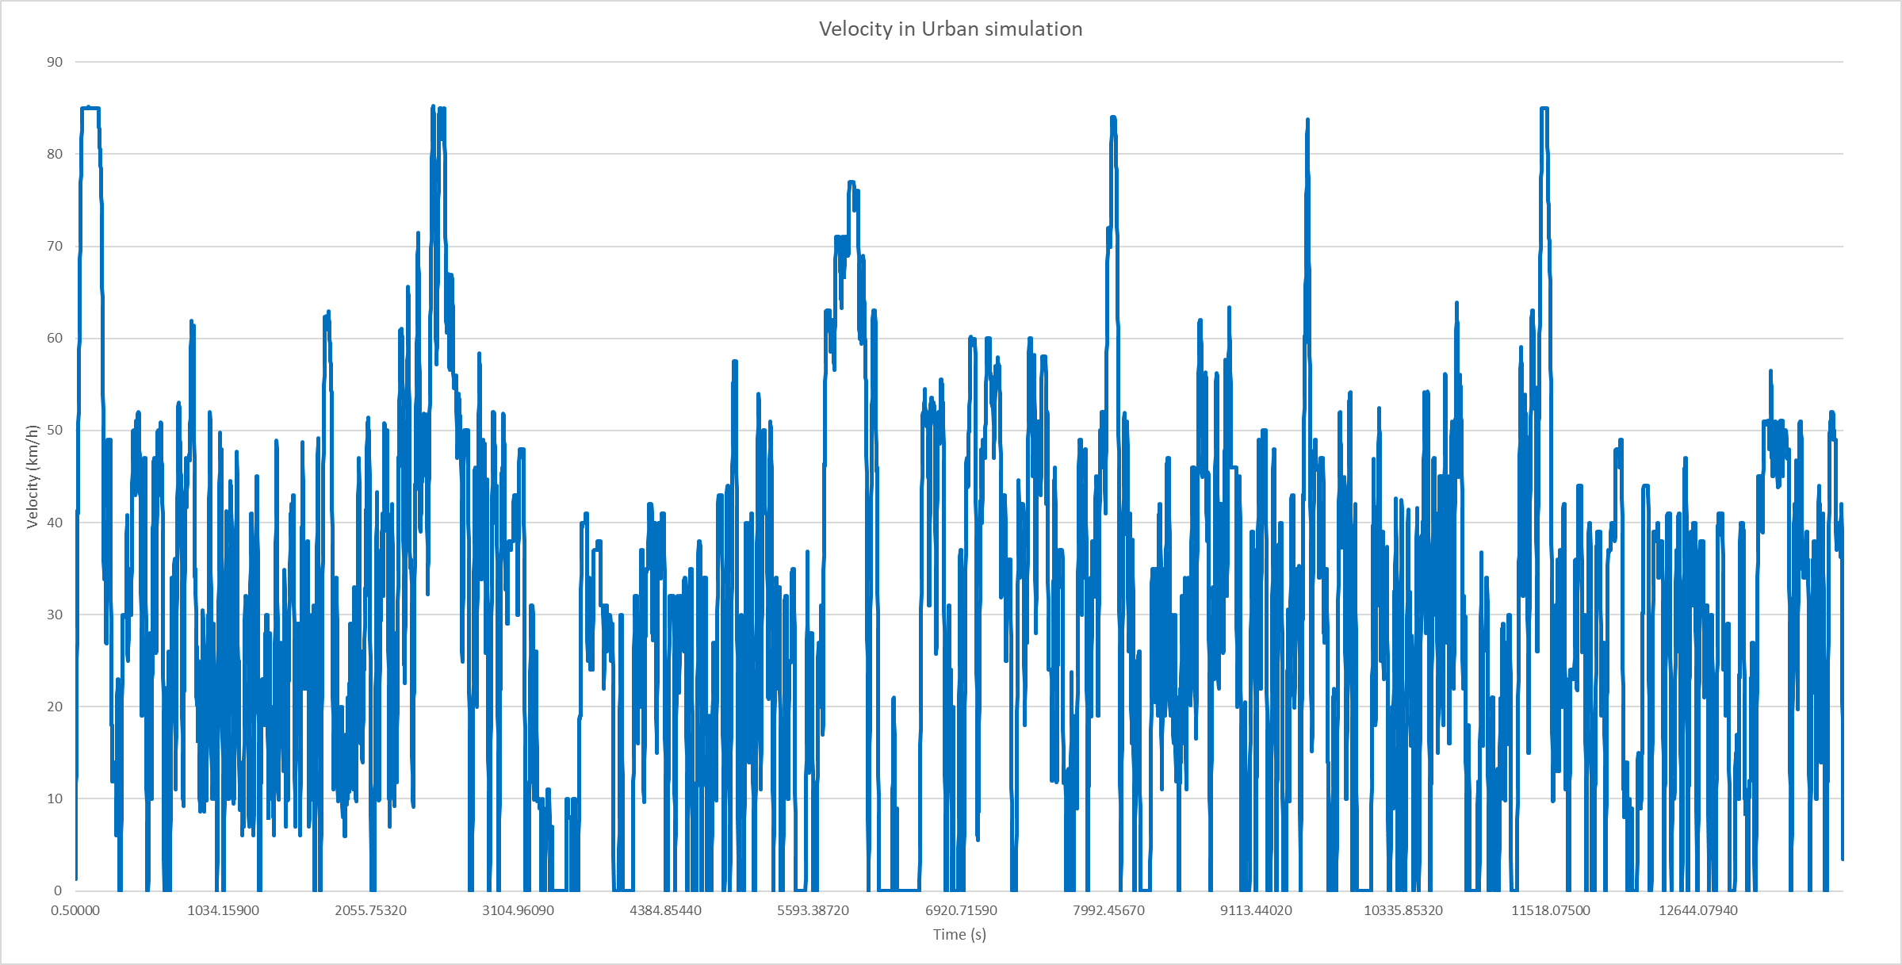(a)

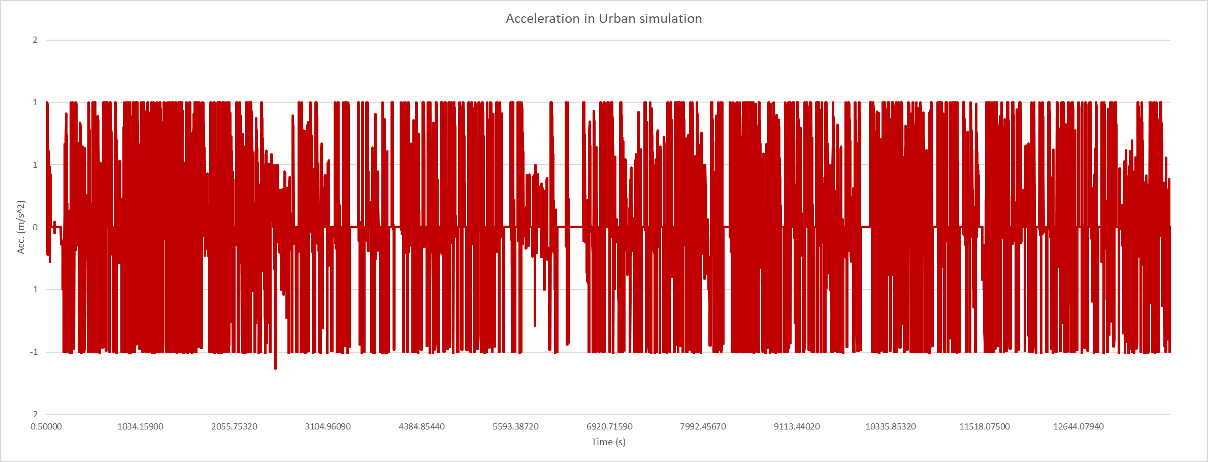

(b)

*Cont.*

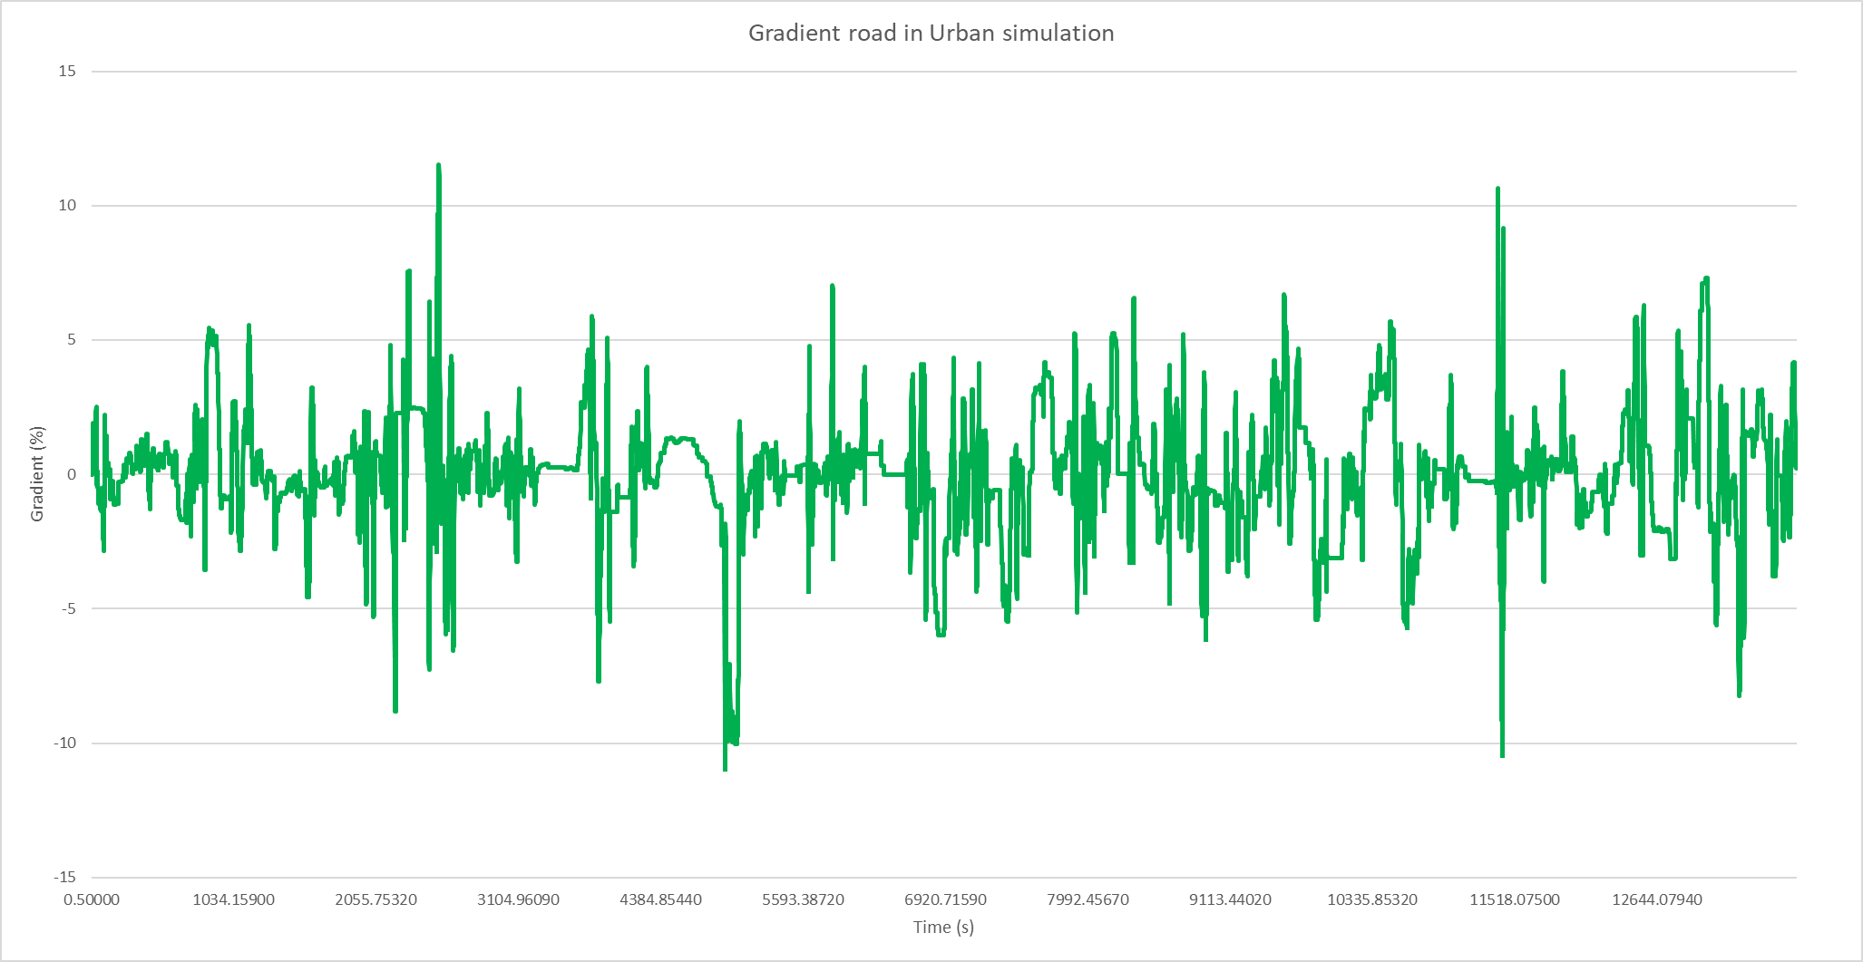(c)

**Figure 6.** The Urban Simulation, where (a) velocity in km/h, (b) acceleration in m/s2, and (c) gradient road in % [29].

There is summarised information of this driving simulation in Table 5.

|  |  |
| --- | --- |
| Parameter | Value |
| Duration (s) | 13,731.27 |
| Distance (km) | 100 |
| Maximum velocity (km/h) | 85.26 |
| Minimum velocity (km/h) | 1.27 |
| Average velocity (km/h) | 30.22 |
| Stop time (s) | 1,674.5 |
| Number of braking events | 6,344 |

**Table 5.** The Urban Delivery Features [27].

## Hydrogen Internal-Combustion Engine Vehicles (HICEVs)

HICEVs stand for hydrogen internal combustion engine vehicles, meaning hydrogen is the primary fuel utilised by HICEVs, as opposed to conventional vehicles that use internal combustion engines (ICE) powered by fossil fuels. HICEVs operate based on the same thermodynamic principles as ICEVs. However, they exhibit characteristics different from conventionally designed engines. Therefore, this content will begin with an overview of ICE and then delve into the hydrogen Internal Combustion Engine (H2-ICE). The figuration of the HICEVs consists of a hydrogen internal combustion engine (HICE), clutch, and transmission, which is displayed in Figure 7.

.

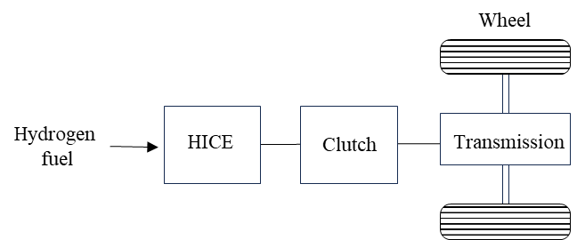

**Figure 7.** The HICEVs structure [13].

### The Internal Combustion Engine (ICE) Review

To clarify the concept of H2-ICE, it is imperative to commence with a foundational understanding of conventional internal combustion engines.

#### The Engine Function

The mechanical operation engine can be generally divided into four-stroke and two-stroke movements. The four-stroke has intake, compression, combustion, and exhaust processes. Firstly, the piston descends as the inlet valve allows the air-fuel mixture to enter the cylinder, which is the intake stroke (1st stroke). After that the compression stroke (2nd stroke) compresses this mixture with both the intake and exhaust valves closed. Then the spark plug ignites the mixture- known as the combustion stroke (3rd stroke). The result of combustion force is caused by the piston lowering again. This power transfers to the crankshaft and then drives the wheels. Finally, in the exhaust stroke (4th stroke), the piston expels the burned gas out through the outlet valve. Conversely, the two-stroke engine gathers the intake and compression phases into one and the combustion and exhaust phases into another [24].

### Hydrogen Internal Combustion Engine (H2-ICE)

The hydrogen engine is adjusted to be more suitable and prevent the risk of abnormal combustion processes such as (1) preignition- the combustion situation starts before the spark plug fires, (2) backfires- the situation when a spark happens in the intake manifold instead of the cylinder, and (3) knocking- the situation when combustion is too early, opposing the momentum of the engine [28, 29, 18]. Accordingly, H2-ICE requires an inspection into three parts: the combustion section, the delivered fuel system, and the thermal spot [28, 16].

#### Combustion Section

The combustion stroke is related to spark plug types. The spark plug is an electric device to ignite the air and fuel in the combustor. The sparking plug material affects the hydrogen fuel, so the platinum in spark plug electrodes should be avoided because it has the potential to act as a catalyst for hydrogen oxidation, which may increase the possibility of combustion abnormalities. Additionally, there are hot and cold spark plugs, which refer to the operating temperature range of the spark plug. The recommended spark plug is a cold attribute spark plug due to the specific characteristics of hydrogen, such as lower ignition energy and a more comprehensive range of flammability. Using a cold spark plug reduces the risk of pre-ignition by minimising the formation of carbon deposits [28, 29, 16, 18].

#### The Delivered Fuel System

Hydrogen engines can consider two designs of the delivery system: Direct Injection (DI) and Port Fuel Injection (PFI). The DI process directly introduces hydrogen into the cylinder throughout the compression stroke, avoiding undesired combustion conditions. PFI is the injection method that feeds fuel into the intake manifold. This method causes the ratio of hydrogen to air (A/F ratio) to decrease from the ideal stoichiometric ratio, which is related to the higher ignition energy [18]. This characteristic is an advantage because it can mitigate the risk of autoignition. However, it may backfire instead; thus, PFI necessitates a good injection timing program [28] to protect the time inadequate for hydrogen when approaching the combustion chamber [16].

#### Thermal spot

The thermal point can cause uncommon burning in the combustor due to uneven combustion. Enhanced and uniform mixing of air and fuel in the combustion chamber helps mitigate this issue. Utilising multi-valve configurations is also one of the techniques to reduce this risk [28, 16].

Each power in the HICEVs component can be calculated from the ‘backward’ through the powertrain by using the previous power to consider its power. Likewise, the power from the hydrogen engine can be found in Equation 2.9.

|  |  |
| --- | --- |
| $$P_{eng}=\frac{P_{out}}{η_{e}}$$ | 2.9 |

Where,

$P_{eng}$ is the engine power in watt unit.

$P_{out}$ is the output power from the previous load (clutch) in watt unit.

ηe is the efficiency of the hydrogen engine.

### Clutch

The clutch is an essential component that is installed between the engine and the transmission system. Its function is to connect and disconnect the power transmission from the engine to the gearbox, allowing the driver to change gears at different speeds, thus the clutch power is in Equation 2.10.

|  |  |
| --- | --- |
| $$P_{clutch}=\frac{P_{out}}{η_{clutch}}$$ | 2.10 |

Where,

$P_{clutch}$ is the clutch power in watt unit.

$P_{out}$ is the output power from the previous load (Transmission load) in watt unit.

$η_{clutch}$ is the efficiency of the clutch.

### Transmission load

The primary role of the transmission is to convert the power generated by the engine into kinetic energy and then transfer it to the wheels. The gear is central to this transmission system, which adjusts the amount of power and speed to match the requirements of the vehicle. It can find the needed power for transmission as Equation 2.11.

|  |  |
| --- | --- |
| $$P_{trans}=\frac{P}{η_{trans}}$$ | 2.11 |

Where,

$P_{trans}$ is the transmission power in watt unit.

$P$ is the final propulsion power in watt unit that can be found in Equation 2.7.

ηtrans is the efficiency of the transmission.

## Fuel Cell Vehicles (FCVs)

Besides the H2-ICE, hydrogen can also convert from chemical form to electrical form using a fuel cell, which is known as an electrochemical process.

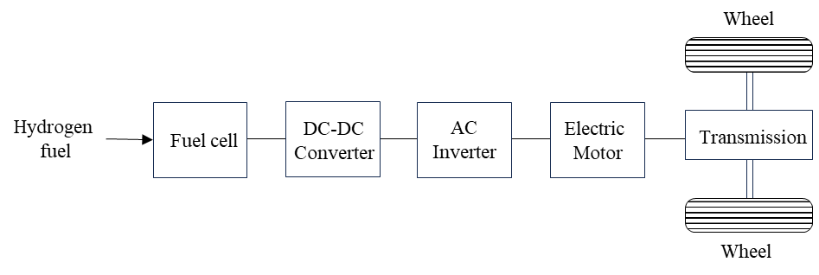FCVs drive with electric power instead of mechanical power, composed of a fuel cell stack, a DC-DC converter, an AC inverter, and an electric motor. The fuel cells are the place to produce the electricity from hydrogen fuel, which is then delivered to a DC-DC converter, an AC inverter, and an electric motor, respectively, as demonstrated in Figure 8.

**Figure 8**. The FCVs Structure [13].

### PEM Fuel Cell

Through the utilisation of an electrochemical reaction, a fuel cell produces direct current (DC) electrical energy. The average single fuel cell offers a low voltage output within the 0.4 to 0.9V and a high current ranging from 0.5 to 1 A/cm2. To increase the power output, multiple fuel cells are combined into a fuel cell stack [30]. Each fuel cell within stack consists of three main sections: a cathode, an anode, and an electrolyte. The electrolyte serves as a catalyst membrane positioned between the anode and the cathode [31, 32].

Different fuel cell types are based on the electrolyte, including solid membrane, liquid phase, and ceramic materials [31]. The one fuel cell type is widely known is the PEM fuel cell. It stands for proton exchange membrane. This membrane is a solid phase made from platinum [32].

Firstly, the working process of a PEM fuel cell starts with hydrogen (H2) entering the anode. Then, it undergoes splitting into two protons and two electrons. Then, these electrons move along an external circuit, facilitating the flow of electric current [31, 32].

The anode reaction:

|  |  |
| --- | --- |
| $$H_{2}→ {2H}^{+}+ {2e}^{-}$$ | 2.12 |

Secondly, the electrolyte membrane allows only H+ ions to pass towards the cathode. At the same time, the oxidising agent or oxygen (O2) enters the cathode side. It leads to oxygen molecules split up into oxygen atoms. These oxygen atoms combine with H+ ions and electrons to form water molecules [31, 32].

The cathode reaction:

|  |  |
| --- | --- |
| $$\frac{1}{2}O_{2}+2H^{+}+2e^{-}→H_{2}O$$ | 2.13 |

Thirdly, according to the chemical reaction, the by-product of the whole process is water and heat [31, 33, 32]. The heat is generated for several reasons, such as the entropic heat reaction, losses associated with hydrogen transfer, resistances along the proton and electron pathways, and hydrogen transport to the anode. Thus, the fuel cell requires thermal insulation protection [34]. Additionally, maintaining the membrane at optimal hydration levels is crucial. Due to insufficient hydration can harm the performance of fuel cell, underscoring the importance of adequately managing water within the system [35] .

The overall reaction:

|  |  |
| --- | --- |
| $$H_{2}+\frac{1}{2}O_{2}→H_{2}O+ heat$$ | 2.12 |

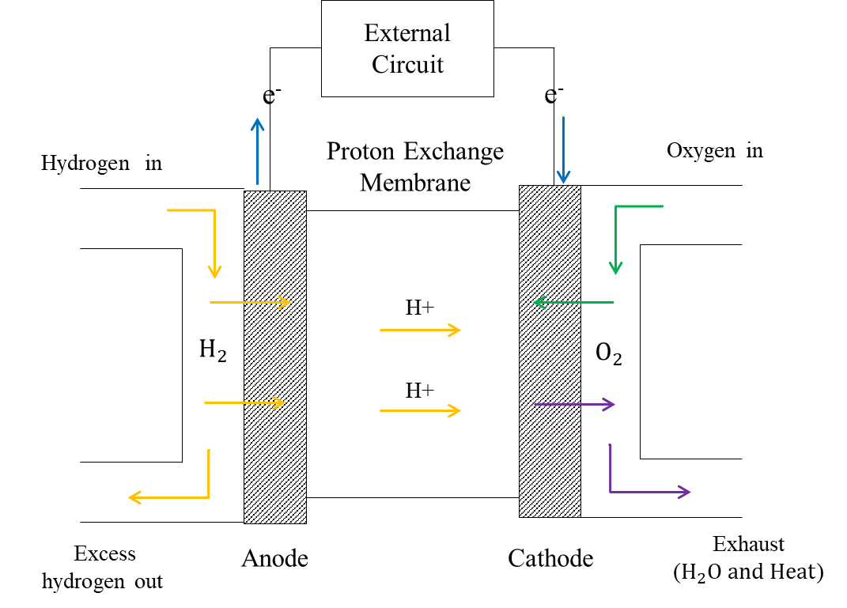Numerous scholarly articles and studies [31, 33, 32, 35] have referenced that the working temperature of PEM is lower at 100°C, with a high electrical efficiency is around 60%. It is generally understood that PEMFCs are fast responses at low temperatures. It is the most suitable for automotive utilisation due to the vehicle not requiring high-temperature ranges [32]. Moreover, electrolyte leakage is impossible due to the electrolyte type being a solid state. The operation process of the PEM fuel cell is demonstrated in Figure 9.

**Figure 9.** The PEM fuel cell model [35].

To determine the power for each component of the FCV, it can be thought of from the ‘backward’ calculation method as same as the HICEs power calculation. Therefore, the power by fuel cell system is Equation 2.14.

|  |  |
| --- | --- |
| $$P_{fc}=\frac{P_{out}}{η_{fc}}$$ | 2.14 |

Where,

Pfc is the fuel cell system power in watt unit.

Pout is the output power from the previous load (DC-DC converter) in watt unit.

ηfc is the efficiency of the fuel cell system.

### A DC-DC Converter

It is an electronic component that assists in adjusting the input voltage in the fuel cell stack to a more appropriate output voltage level to match the device requirement in the system [12, 36]. There is a bidirectional converter for dual-fuel vehicles and a unidirectional converter (UDC) for FCVs. The UDC has various configurations for FCVs, aiming to optimise efficiency, reduce voltage ripple, effectively manage power transfer, and prolong the lifetime of the component. The buck-boost converter is commonly used due to its straightforward structure, consisting of a switch, a diode, a capacitor, and an inductor [37]. The appliance is understood to have a power loss, which can be calculated from its efficiency, as shown in Equation 2.15.

|  |  |
| --- | --- |
| $$P_{conv}=\frac{P_{out}}{η_{conv}}$$ | 2.15 |

Where,

Pconv is the boost converter power in watt unit.

Pout is the output power from the previous load (AC inverter) in watt unit.

ηconv is the efficiency of the boost converter.

### An AC Inverter

An inverter is necessary to convert the DC power generated by the fuel cell system to AC, catering to components that operate on AC power. It is also essential for effectively controlling various parameters of the electric motor, including speed, torque, acceleration, and rotational direction [37]. In addition, it assists power control and management, which is essential for ensuring safety operations [37]. The efficiency equation is represented by Equation 2.16.

|  |  |
| --- | --- |
| $$P_{inv}=\frac{P_{out}}{η_{inv}}$$ | 2.16 |

Where,

Pinv is the AC inverter power in watt unit.

Pout is the output power from the previous load (electric motor) in watt unit.

ηinv is the efficiency of the AC inverter.

### An Electric Motor

The main roleplay of the electric motor is transferring the electric power into the machine power to drive the wheels.

Additionally, the electric motor can also work in a dual role: propulsion and regenerative braking. In the propulsion mode, the electric motor acts as a motor to convert electrical energy from the fuel cell or the battery to create mechanical energy that turns the wheels. In this mode, if there is the battery, which is in discharging state [38]. Opposite to regenerative braking, it operates when deacceleration or braking- the electric motor functions in reverse as a generator. The mechanical energy from the braking wheel is delivered as converted kinetic energy into electric energy to the battery during the vehicle braking. The electrical energy is subsequently utilised to reinforce the battery, known as the state of charging [38].

The required power for the electric motor can be calculated as Equation 2.17 [39].

|  |  |
| --- | --- |
| $$P_{motor}=\frac{P_{out}}{η_{motor}}$$ | 2.17 |

Where,

Pmotor is the motor power in watt unit.

Pout is the output power from the previous load (transmission load) in watt unit.

ηmotor is the efficiency of the motor.

## Fuel Cell Electric Vehicles (FCEVs)

The significant format in Fuel Cell Electric Vehicles (FCEVs) aligns similarly with those encountered in FC vehicles, with the addition of a battery component, as shown in Figure 10. Therefore, the propulsion power is delivered from two energy sources: a fuel cell stack and a battery. The fuel cell efficiently converts hydrogen fuel into electricity, which is then used to directly or indirectly drive the electric motor, depending on the current charge level of the battery during a given operational period [13].

**Figure 10.** The FCEVs structure [13].

### Energy Management System (EMS)

Energy management is a critical section of the FCEVs because there are two energy sources. It is necessary to intelligently control and distribute from the sources to a load to use the energy effectively to reduce fuel consumption. The EMS has two main strategies: simple logic strategy and predictive mode strategy. The simple logic strategy is known as the Rule-based control strategy. This strategy works based on predefined motion conditions (i.e., moving or idleing, going uphill or going downhill) and inputs (i.e., state of charge (SOC), speed vehicle). Its functioning can be visualized as a flowchart, responding to set criteria. While Model Predictive Control (MPC) is a form of predictive mode strategy. It uses both past and current data, combined with a system model, to anticipate future behaviour and determine optimal control actions that align closely with real-world conditions [40].

### Lithium-ion (Li-ion) battery

The general categories of batteries are primary batteries and secondary batteries. A primary battery is designed for single use and cannot be refilled. On the other hand, a secondary battery is a rechargeable device, a Lithium-ion (Li-ion) battery in a group of this category. Therefore, it can store electrical energy through charging and release it on demand load through discharging. Due to the material used in the Li-ion battery is Meta lithium, which leads to its great energy density, which can reach up to 160 Wh/kg and operate the dynamic cycle of over 600 times [36] . This is commonly acknowledged that a Li-ion battery provides high performance and long-span life [41, 33]. Its energy management design is also adaptable to adjust the capacity size according to the vehicle [42]. In these factors, a Li-ion battery is use-widely in the electric vehicles (EVs) [41, 33, 42] and it also applied in hydrogen-fueled vehicles. The power from the battery can be calculated as Equation 2.18.

|  |  |
| --- | --- |
| $$P_{b}=\left(η_{dch}*P_{dch}\right)+(η_{ch}*P_{ch})$$ | 2.18 |

The discharging power and charging power can be found as Equation 2.19 and 2.20 considering the final propulsion power (P).

|  |  |
| --- | --- |
| $$P_{dch}=\frac{P-P_{fc}}{η_{dch}}$$ | 2.19 |

And

|  |  |
| --- | --- |
| $$P_{ch}=\frac{P-P_{fc}}{η_{ch}}$$ | 2.20 |

Where,

P is the final propulsion power in watt units that can be found in Equation 2.7.

Pb is the battery power in watt unit.

$P_{dch}$ is the discharging power in watt unit.

$P_{ch}$ is the charging power in watt unit.

$η_{dch}$ is the efficiency of the discharging power.

$η_{ch}$ is the efficiency of the charging power.

### The State of Charge (SOC)

The state of charge (SOC) measures the electric quantity contained within a battery, expressed as a percentage. It is an important metric for energy management, as it controls when the battery is drawn upon. Determining the SOC at specific time intervals ($∆t$) based on charge and discharge states, as represented in Equation 2.21.

|  |  |
| --- | --- |
| $$SOC\left(t+1\right)=SOC\left(t\right)- \frac{P_{dch}}{Q_{b}}∆t- \frac{P_{ch}}{Q_{b}}∆t$$ | 2.21 |

Where,

$SOC\left(t+1\right)$ represents the charge level at the subsequent time interval.

$SOC\left(t\right)$ is the current state of charge.

$P_{dch}$ is the discharge battery power in watt unit.

$P_{ch}$ is the charge battery power in watt unit.

$Q_{b}$ is the capacity of the battery kW-hour unit.

### Operational Battery

FCEVs use a hydrogen fuel cell and a Li-ion battery as power sources. The system requires distributing the power correctly and determining a certain setpoint. The system intelligently switches between these modes based on the driver power demanded and the state of charge (SOC) of the battery. There is main three modes [43]:

#### Standard Power Mode

In this mode, the fuel cell is the only power provider to the electric motor when the fuel cell power can manage its operations effectively and independently, such as, in normal driving conditions, as displayed in

Figure ***11***.

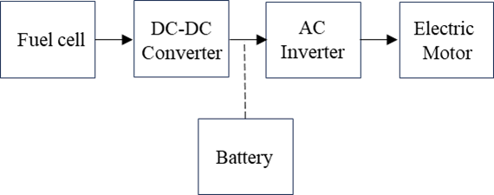

**Figure 11.** Energy movement direction in the standard mode [43].

#### Charging mode

The battery can enter charging mode in two scenarios. First, when the vehicle needs low-demand power, but the fuel cell produces more power than required, therefore the surplus energy will be charged into the battery, as displayed in Figure 12. Second, during vehicle braking, the energy is recuperated through regenerative braking, which also charges the battery, as displayed in Figure 13.

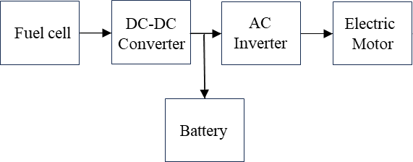**Figure 12.** Energy movement direction in the charging mode when low power [43].

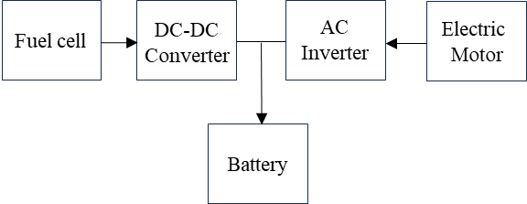

**Figure 13.** Energy movement direction in the low-power mode when during braking [43].

#### Discharging Mode

This mode is activated when the driver requires more power than the fuel cell alone can provide, such as during rapid acceleration or steep hill climbing. In this mode, the battery contributes additional power to meet the high demand, as displayed in Figure 14.

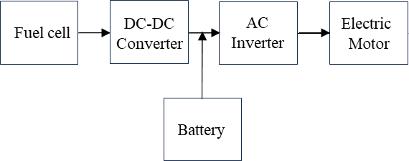

**Figure 14.** Energy movement direction in the discharging mode [43].

# 

# Methodology

Building upon the foundation principles and technologies outlined in Chapter 2: Literature Review, this chapter delves into the comprehensive methodology and detailed steps used to develop and analyse simulations for the three hydrogen-powered vehicle models using the MATLAB tool. The framework utilised in this chapter aims to achieve the aim of the study as follows:

1. Selection of Hydrogen-powered Vehicles: Identify three hydrogen technologies for vehicles, primarily differentiated by their components, to evaluate their powertrain and fuel consumption attributes.
2. Selection of Driving profiles: Choose three reliable driving profiles representing different conditions, ensuring a comprehensive powertrain and fuel consumption assessment across varied scenarios.
3. MATLAB Analysis: With the selected vehicles and driving profiles in place, utilise the MATLAB tool for simulation and analysis. There are separated into three main parts:
   * *Part A:* *MATLAB Tool Development*- The author will develop a tool to simulate and analyse the fuel consumption in the buses to be a foundation tool in this study.
   * *Part B: MATLAB Tool Validation-* The author will validate and refine a MATLAB-based tool by benchmarking its results against a study by Delgado et al. (2017). They studied and simulated the diesel fuel rate in heavy-duty vehicle (HDV) using VECTO, the fuel consumption estimation programme provided by the European Commission.
   * *Part C: MATLAB Tool Application-* After the refinement of the MATLAB tool, the author will use this developed tool to simulate the three hydrogen bus configurations: hydrogen internal combustion engine (HICE) bus, fuel cell (FC) bus, and fuel cell electric (FCE) bus across three driving routes: long -haul, regional, and urban routes.

## Part A: MATLAB Tool Development

In this part, the author will develop the MATLAB tool, which serves as the foundation for subsequent analyses involving three buses: hydrogen internal combustion engine (HICE) bus, fuel cell (FC) bus, and fuel cell electric (FCE) bus. The operation of MATLAB can be categorised into 11 key sections, as outlined below:

*Section 1: Vehicle Model Identify*- gathering fundamental vehicle parameters, such as the curb weight, seating capacity, estimated percentage of passengers who might use the service, and the average weight of the passengers. These variables affect the propulsion power. The details will be mentioned in subtopic 3.3.1.

*Section 2: Driving Simulations Determination -* defining three driving profiles: long-haul, regional, and urban. Each contains different velocity, acceleration, gradient road, and time over the period. Data corresponding to these profiles is accessible online via VECTO. This can export this data into an Excel file and then import it into the tool.

*Section 3: Aerodynamic Drag Force Calculation*- computing the air resistance force, as represented in Equation 2.4.

*Section 4: Rolling Drag Force Calculation-* computing the wheel resistance force as represented in Equation 2.3.

*Section 5: Gradient Force Calculation-* computing the gravitational force component acting along the slop as represented in Equation 2.5.

*Section 6: Traction Force Calculation-* combining all forces from the previous sections to compute the traction force acting on the driving vehicle as represented in Equation 2.1.

*Section 7: Traction Power Calculation-* Convert the calculated traction force into power in watt unit, as represented in Equation 2.6.

*Section 8: Calculation of Power Requirements for Individual Components-* assessing the power needs (P) for each component in each unique configuration of the vehicle. This section will feed the essential input related to the those vehicles.

*Section 9: Calculation of Total Power Required for the Vehicle* – merge and assess the total amount of power that the automobile necessitates for its operation.

*Section 10: Energy across the Journey Calculation-* integrating final power values over time to determine total energy consumption, as represented in Equation 2.7.

*Section 11: Fuel Consumption-* this section estimates the fuel consumption for the chosen driving cycle, as represented in Equation 2.8.

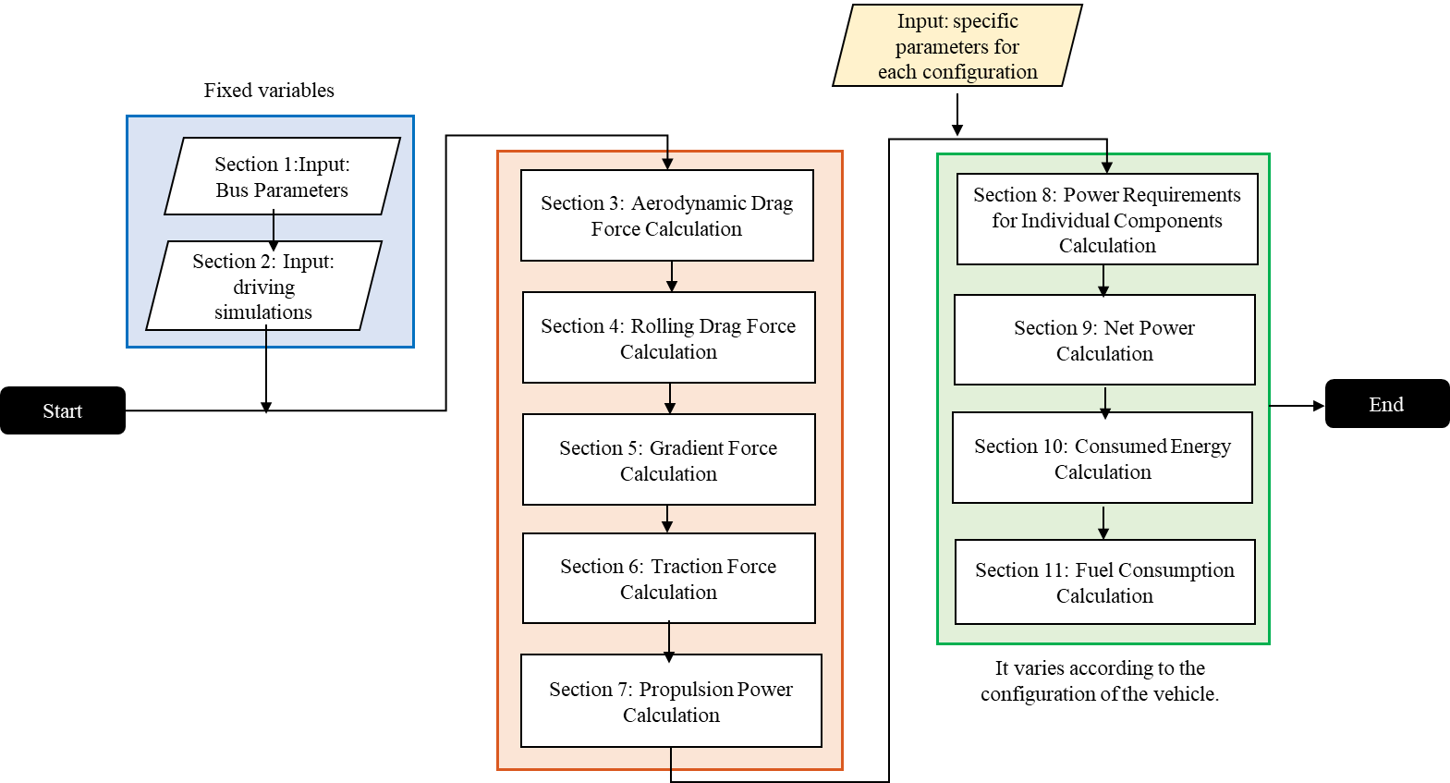The diagram of the MATLAB tool operation is displayed in Figure 15.

**Figure 15.** MATLAB tool diagram

Figure 16 shows the interface of the MATLAB tool, where the user can fill the parameter into the box according to the ‘Bus Model Vehicle’ and ‘Air’ tabs. The user can also select the types of buses to simulate and drive profiles.

**Figure 16**.The MATLAB interfaces.

## Part B: MATLAB Tool Validation

Delgado et al. (2017) study was a benchmark to validate the MATLAB tool. They studied the results of diesel consumption measurements on Heavy-duty vehicles (HDVs) over the EU sample driving cycles using VECTO software. Their experiments encompassed two HDV categories: rigid trucks and trailers. However, the focus of this paper is on bus fuel consumption. The author will select the vehicle type most similar to a bus based on weight considerations. Notably, they used VECTO version 3.1.2.748 to research their data, while this study uses VERTO version 3.2.1.1054, the latest updated version. The notable difference between the two versions is the reformation of the Urban delivery profile. Hence, the comparative analysis of this study will be limited to the long-haul and regional profiles. The benchmark vehicle from Delgado et al. (2017) study, a rigid truck, is detailed in Table 6.

|  |  |
| --- | --- |
| Baseline vehicle: Rigid Truck | |
| Definition | Value |
| Curb vehicle weight (kg) | 6,500 |
| Maximum load (kg) | 5,500 |
| Practical load (kg) | 3,000 |
| Front area (m2) | 5.28 |
| Wheel radius (m) | 0.43 |
| Gear ratio | 6:1 |
| Rolling resistance coefficient (Cr) | 0.01 |
| Air drag coefficient (Cd) | 0.6 |
| Diesel engine efficiency (%) | 42 |
| Auxiliary power (kW) | 3.63 |

**Table 6.** Baseline vehicle [44].

To find the final propulsion power (P) for a diesel-powered vehicle, the components taken into consideration are similar to those in a HICE bus. The power associated with each component—transmission, clutch, and engine—is provided in Equation 2.9, 2.10, and 2.11, respectively. Thus, the input parameter before *Section 8* will relate to those components. In *Section 11* for fuel consumption calculation, the diesel energy density for fuel consumption calculation is 34.6MJ/l.

The tool validates with Delgado et al. (2017) study, which is the diesel-powered truck carrying 12 tonnes and 9.5 tonnes under long-haul and regional driving profiles, respectively, with covering 100 kilometres. The comparison of the tools is detailed in Table 7.

|  |  |  |  |  |
| --- | --- | --- | --- | --- |
| The fuel consumption in litres per 100 kilometres. | | | | |
| Condition | Driving cycle | Delgado et al. (2017) [44] | MATLAB Tool | Differences (1st) |
| Full load (12 t) | Long-haul | 26.3 | 24.06 | 8.89% |
| Regional | 22.2 | 22.64 | 1.96% |
| Typical load (9.5 t) | Long-haul | 24.9 | 21.14 | 7.33% |
| Regional | 20 | 19.03 | 4.97% |

**Table 7**. MATLAB tool validation: 1st

Since the author did not initially consider this inertia force variable, its inclusion was later introduced to the tool to enhance its precision and accuracy, as detailed in Equation 2.2 from Chapter 2: Literature Review. When the inertia force is integrated, the results show the improvement after accounting for this force in the tool, as shown in Table 8. It becomes evident that the inertia force is closely related to the acceleration and deceleration of wheel motion, affecting the overall required propulsion power.

|  |  |  |  |  |
| --- | --- | --- | --- | --- |
| The fuel consumption in litres per 100 kilometres. | | | | |
| Condition | Driving cycle | Delgado et al. (2017) [44] | MATLAB Tool | Differences (2nd) |
| Full load (12 t) | Long-haul | 26.3 | 24.6 | 6.67% |
| Regional | 22.2 | 22.1 | 0.45% |
| Typical load (9.5 t) | Long-haul | 24.9 | 23.2 | 7.06% |
| Regional | 20 | 19.1 | 4.6% |

**Table 8.** MATLAB tool validation: 2nd

However, the percentage difference was relatively small. It should be noted that the VECTO program version used by Delgado et al. (2017) study differs from the one utilized in this study. Delgado et al. (2017) study employed an earlier version, specifically 3.1.2.748, while the present study implemented the most recent version, 3.2.1.1054. This variation in software versions might account for the observed differences in values.

## Part C: MATLAB Tool Application

Following the enhancements to the MATLAB tool, the verified tool in Part A now stands as the cornerstone for the following work. This section will describe the characteristics of the buses that will be investigated within the tool. This includes a deeper analysis of three hydrogen-used vehicle configurations: the hydrogen internal combustion engine (HICE) bus, fuel cell (FC) bus, and fuel cell electric (FCE) bus. Some sections will be refined to each design for a comprehensive examination.

### Bus Model Description

The gross weight of the tested bus combines the average weight of the passengers, which is 68 kg [8]. The number of passengers assumes 75% of the seating capacity. Therefore, the gross weight of the bus is ascertained by summing the aggregate weight of the passengers with the curb weight of the bus, as follows as Equation 3.1 [8].

|  |  |
| --- | --- |
| $$m=(n)(sc)(w_{avg})+ m_{c}$$ | 3.1 |

Given that *n* denotes the service user percentage, *sc* defines the number of seats, *wavg* signifies the mean weight of an individual, and *mp* represents the combined physical weight of the bus, factoring in both the empty hydrogen tanks and the additional weight when these tanks are filled with hydrogen. The bus factors are shown in Table 9, including the surrounding elements. All variables are fixed valves in three bus models.

|  |  |
| --- | --- |
| Bus Parameters | Value |
| Physical vehicle weight ($m_{p}$) in kg | 12,700 |
| Gross vehicle weight ($m$) in kg | 16,780 |
| Passenger capacity ( $sc)$ | 80 |
| Service user percentage (n) | 75% |
| Average weight of the passengers in kg | 68 |
| Front area in m2 | 8.7 |
| Wheel radius in m | 0.43 |
| Gear ratio | 6:1 |
| Rolling resistance coefficient (Cr) | 0.01 |
| Auxiliary power in kW | 3.63 |
| Number of hydrogen tank | 8 |
| Hydrogen stored (kg) | 27.2 |
| Air Parameters | Value |
| Aerodynamic drag coefficient (Cd) | 0.7 |
| Air density at 25°C in kg/m2 | 1.184 |

**Table 9**. Bus model in the MATLAB tool [8] [44] [45] [46] [47] [48].

### MATLAB tool for HICE Bus

HICE operate similarly to fossil fuel-powered vehicles, except only for the engine efficiency. The hydrogen engine efficiency is estimated at 40-50% [10]. Other components (transmission and clutch sections) remain consistent with those of traditional vehicles, including the use of the same operational section as diesel-powered vehicles. The detailed in Table 10.

|  |  |
| --- | --- |
| Parameter | Value |
| Transmission efficiency (%) | 90 |
| Power steering efficiency (%) | 90 |
| H2-ICE efficiency (%) | 40 |

**Table 10.** Parameters used in the HICE bus [8] [10] [49].

### MATLAB tool for FC and FCE Bus

Due to the FC and FCE buses have the same components, except the battery, therefore *Section 8* for both buses will be refined to evaluate the components of the FC and FCE buses: the transmission, fuel cell, converter, inverter, and electric motor. The power output for each component is determined based on their respective efficiencies, as described in Equations 2.11, 2.14, 2.15, 2.16, and 2.17 from Chapter 2: Literature Review. This collective assessment calculates the total power needed for the FC and FCE bus, as detailed in Table 11.

|  |  |
| --- | --- |
| Parameter | Value |
| Transmission efficiency (%) | 90 |
| Electric motor efficiency (%) | 90 |
| AC inverter efficiency (%) | 90 |
| DC converter efficiency (%) | 90 |
| PEM fuel cell efficiency (%) | 55 |

**Table 11.** Parameters used in the FC and FCE bus [8] [10] [49] [50].

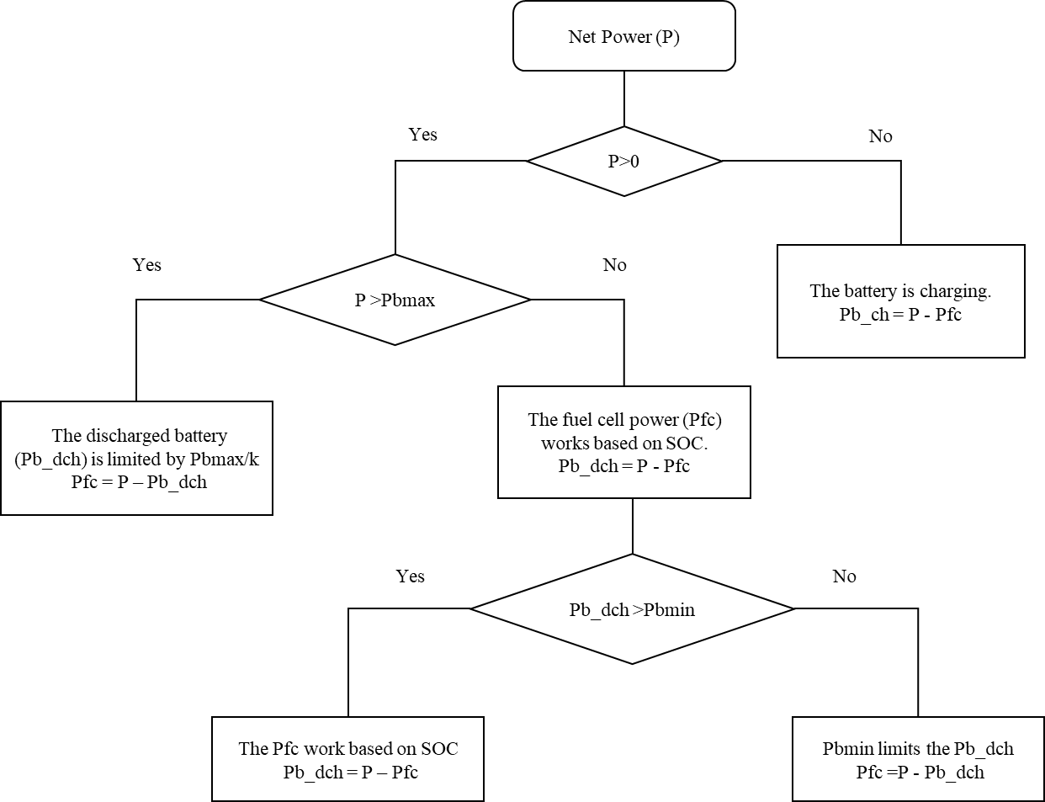However, there is additional section of the FCE bus due to the battery in the system. Therefore, the refined section must consider the battery characteristics and the energy management system. The study will incorporate the Rule-based control strategy into the MATLAB tool in *Section 8*. The strategy uses an ‘if-else’ statement and loops with conditions. Figure 17 shows the flowchart of this strategy to be more understanding.

**Figure 17.** The flowchart of the FCE bus.

The flowchart separates the analysis into discharging and charge states, considering whether the final propulsion power by vehicle (P) is positive or negative. When examining the P, if it is positive, the fuel cell system works with the assistance of the battery. The discharging power battery, denoted as Pb_dch, has an upper limit imposed by Pbmax. This maximum discharging power is not directly applied as Pbmax but is diminished by a factor of k. This k factor is the parameter that allows the total discharging capacity of the battery; thus, it would be Pbmax divided by k.

However, if the P is less than Pbmax, the fuel cell power is decided based on its SOC, and the battery discharges exactly the power difference between P and the fuel cell power as Pfc. If the desired discharge power is below this limit, it is adjusted to be precisely Pbmin, with the fuel cell compensating for the rest. However, if the discharge power remains above Pbmin, the discharged power is the difference between P and Pfc.

If P is negative, the battery enters charging mode. The power from the fuel cell system (Pfc) remains at its minimum. The excess power, which is the difference between P and Pfc, is used to charge the battery. This difference is denoted as the charging power, Pb_ch. The parameters and values are in Table 12.

|  |  |
| --- | --- |
| Battery Parameter | Value |
| Battery type | Li-ion |
| Minimum SOC (%) | 10 |
| Maximum SOC (%) | 90 |
| Optimal SOC (%) | 50 |
| Initial SOC (%) | 50 |
| Maximum battery power (kW) | 150 |
| Minimum battery power (kW) | -45 |
| Resistance battery (Ω) | 0.1 |
| Capacity battery (kWh) | 200 |
| Discharging battery efficiency (%) | 97 |
| Charging battery efficiency (%) | 97 |
| K factor | 1.692 |

**Table 12.** Battery parameters used in the FCE bus.

# Result

This chapter will detail the results obtained from verified MATLAB tool. There are results of the three hydrogen-powered types of buses: hydrogen internal combustion engine (HICE) bus, fuel cell (FC) bus, and fuel cell electric (FCE) bus. Each bus will be subjected to simulations under long-haul, regional, and urban driving conditions.

## Hydrogen Internal Combustion Engine (HICE) Bus Result

This section delves into a detailed analysis, presenting the outcomes related to the powertrain performance and fuel consumption patterns observed in the HICE bus.

### Powertrain Result

Table 13 shows that the total power of the HICE bus responds differently under various driving conditions. The average of the required power is highest for long-haul conditions at 249 kW, followed by regional conditions at 188.2 kW and urban conditions at 67.03 kW. The negative values in the minimum traction power across all profiles indicate braking events.

|  |  |  |  |
| --- | --- | --- | --- |
| Net power (P) in kW: HICE Bus | | | |
| Driving Profile | Maximum | Average | Minimum |
| Long-haul | 893.02 | 249 | -626.92 |
| Regional | 887.5 | 188.2 | -837.5 |
| Urban | 890.15 | 67.03 | -1,151.34 |

**Table 13.** The summarised results of the net power: HICE bus.

Figure 18 (a), (b), and (c) plot the needed power (P) in the kW compared to the velocity in km/h and acceleration in m/s2 to notice their relationship. It is observed that the power (P) in all three conditions varied with changes in velocity and acceleration. Specifically, higher velocity and acceleration resulted in greater power, corresponding to Chapter 2: Literature Review.

Figure 18 (a) shows that P mostly stays in the positive quadrant, corresponding to the long-haul environment, which refers to longer distances and the constant velocity with fewer deceleration periods. Meanwhile, P in Figure 18(b) is in the more negative quadrant of the long-haul cycle. The negative P means the braking period according to the regional setting. Unlike P in Figure 18(c), there is a constant fluctuation between positive and negative power, presenting urban driving conditions with frequent stops.

(a)

(b)

(c)

**Figure 18.** HICE bus results of simulation tests, where (a) Long-haul profile; (b) Regional profile; (c) Urban profile.

### Fuel Consumption Analysis

Figure 19 shows the comparison of the hydrogen used throughout the entirety of each profile. The long-haul driving profile is the highest consumer at 9.35 kg, followed by the regional condition at 8.69 kg. The urban environment is the least at 6.4 kg. This data suggests that vehicles with long-haul and regional profiles, which typically involve higher speeds, tend to consume more fuel than those with urban profiles, where slower speeds are influenced by city traffic and stops.

**Figure 19.** Fuel consumption analysis in the three driving profiles: HICE bus.

## Fuel Cell (FC) Bus Result

This section provides the powertrain and hydrogen fuel consumption result of the FC bus.

### Powertrain Analysis

Table 14 shows the numerical results. Similar to the HICE bus analysis section, the varying total needed power for each profile corresponds to the varying velocity. Long-haul conditions have the highest average net power at 223.95 kW, followed by regional conditions with 169.35 kW and urban conditions with 60.33 kW.

|  |  |  |  |
| --- | --- | --- | --- |
| Net power (P) in kW: FC Bus | | | |
| Driving Profile | Maximum | Average | Minimum |
| Long-haul | 802.18 | 223.95 | -562.52 |
| Regional | 797.23 | 169.35 | -751.6 |
| Urban | 799.61 | 60.33 | -1,033.38 |

**Table 14**. The summarised results of the net power: FC bus.

Figure 20 (a), (b), and (c) show the simulation result through the driving cycles. The graphs have similar characteristics to the HICE bus.

(a)

(b)

(c)

**Figure 20.** FC bus results of simulation tests, where (a) Long-haul profile; (b) Regional profile; (c) Urban profile.

### Fuel Consumption Analysis

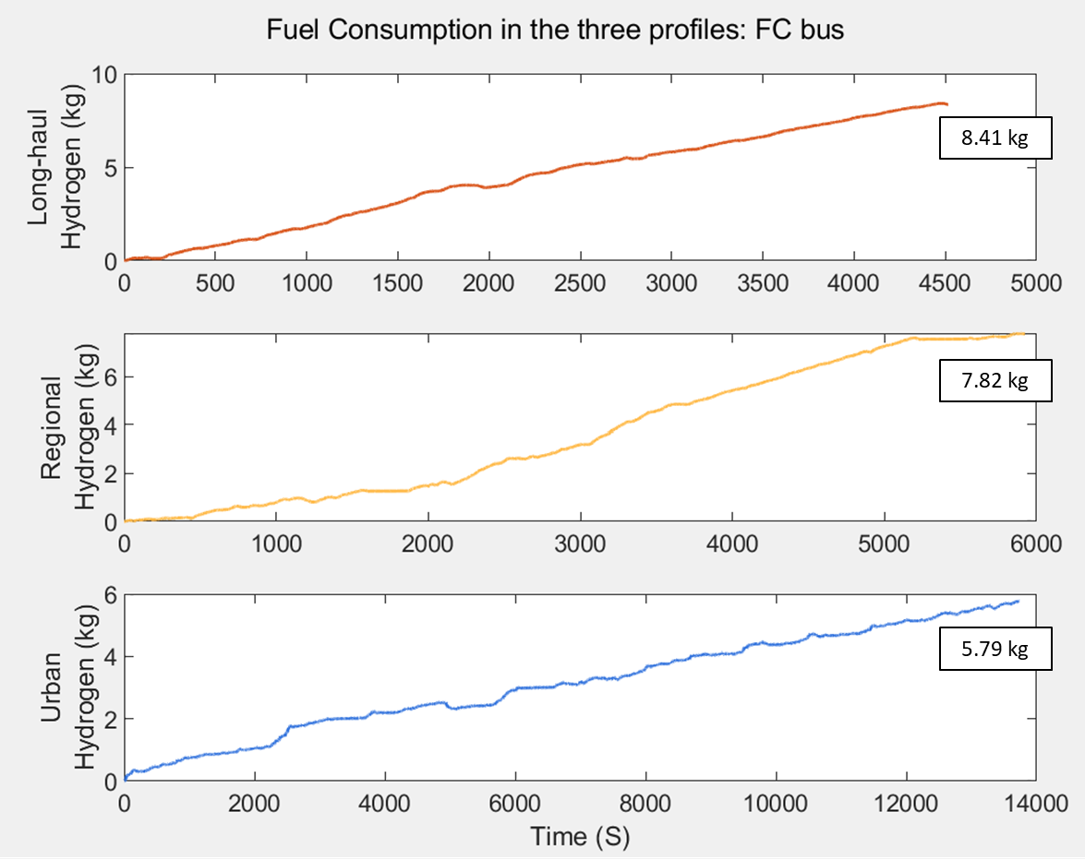Figure21 shows the hydrogen consumption of the FC bus across all profiles. The graphs have a similar trend to the HICE bus consumption because the long haul ranks first in hydrogen fuel consumption at 8.41 kg, followed by the regional profile at 7.82 kg, and the urban profile is the least, consuming 5.79 kg.

**Figure 21.** Fuel consumption analysis in the three driving profiles: FC bus.

## Fuel Cell Electric (FCE) Bus Result

This section provides the operation and fuel consumption results of the FCE bus. These results are beneficial for examining the interaction between the fuel cell and the battery system, particularly concerning propulsion and energy recovery. It consists of four areas: the powertrain, power contribution, the state of charge (SOC) of the battery, and the hydrogen fuel consumption analysis.

### Powertrain Analysis

The powertrain of the FCE bus consists of three components: the net power (P), the fuel cell power (Pfc), the discharging battery power (Pdch)- it is determined as a positive value and the charging battery power (Pch)-it is determined as a negative value which provides energy storage and additional power when needed. These components show the results in Table 15.

|  |  |  |  |
| --- | --- | --- | --- |
| Powertrain Result: FCE Bus | | | |
| Driving Profile | Long-haul | | |
|  | Maximum | Average | Minimum |
| Net power (P) in kW | 798.56 | 220.32 | -23.65 |
| Fuel cell power (Pfc) in kW | 768.38 | 153.78 | 20 |
| Discharging battery power (Pdch) in kW | 85.99 | 61.7 | 0 |
| Charging battery power (Pch) in kW | 0 | -11.85 | -43.65 |
| Driving Profile | Regional | | |
|  | Maximum | Average | Minimum |
| Net power (P) in kW | 793.61 | 165.73 | -23.65 |
| Fuel cell power (Pfc) in kW | 707.62 | 132.95 | 20 |
| Discharging battery power (Pdch) in kW | 85.99 | 49.56 | 0 |
| Charging battery power (Pch) in kW | 0 | -17.65 | -43.65 |
| Driving Profile | Urban | | |
|  | Maximum | Average | Minimum |
| Net power (P) in kW | 795.98 | 56.94 | -23.65 |
| Fuel cell power (Pfc) in kW | 709.99 | 114.56 | 20 |
| Discharging battery power (Pdch) in kW | 85.99 | 24.95 | 0 |
| Charging battery power (Pch) in kW | 0 | -30.72 | -43.65 |

**Table 15.** The summarised results of the powertrain: FCE bus.

According to Table 15, the power from each component is related to the selected driving cycle. It is evident that across all driving simulations, the fuel cell emerges as the dominant energy source, catering to the net power demands of the vehicle. The battery offers auxiliary energy support, reducing the load on the fuel cell. Importantly, the battery discharges power in compliance with the specific power output boundaries detailed in Table 12 in Chapter 3: Methodology. As a consequence, the negative net power, resulting from the braking process, is partially offset (to a consistent minimum of -23.65 kW across all profiles) to ensure alignment with battery specifications and overall system balance.

Moreover, there is an observation during urban driving simulations: the vehicle encounters the speed limitations and frequent stops characteristic of city environments. Due to these limitations, the fuel cell produces power exceeding the vehicle requirements. This surplus power is then charged into the battery for storage. This also corresponds to charged power in the urban condition, which is the highest power at -30.72 kW. Conversely, the log-haul condition has the lowest charged power, which is -11.85 kW, due to fewer braking events. A thorough examination of these observations will follow in the next section.

Figure 22(a), (b), and (c), the net power (P), fuel cell power (Pfc), and battery power (Pb) are illustrated, showcasing their operations across varying periods in each environment.

(a)

(b)

(c)

**Figure 22.**  FCE bus results of simulation tests, where (a) Long-haul profile; (b) Regional profile; (c) Urban profile.

### Power Contribution Analysis

Considering the FCE bus utilises two energy sources—the fuel cell and battery—it is essential to analyse the respective contributions of each power source to comprehend their interaction. Figure 23(a), (b), and (c) display the three powers: net power (P), fuel cell power (Pfc), and battery power (Pb).

As previously mentioned, the net power (P) is influenced by the storage capacity of the battery. Therefore, it can be observed negative quadrant of the net power is capped at -23.65 kW, as displayed in Figure 23(a), (b), and (c). Moreover, it is important to note that the battery is discharged (represented in the positive quadrants) and charged (represented in the negative quadrants) power to and from the vehicle, respectively, based on its designated capacity.

(a)

(b)

*Cont.*

(c)

**Figure 23.** The power contribution: FCE bus, where (a) Long-haul profile; (b) Regional profile; (c) Urban profile.

The integrated operation of the system has been decomposed into percentages, as depicted in Figure 24, to enhance comprehension. Figure 24 provides insights into the distribution of power contribution in FCE buses across three different types of scenarios: long-haul, regional, and urban. It can be noticed that the fuel cell is the primary energy power for all three scenarios, supplying 69.87% for long-haul, 67.93% for regional, and 66.56% for urban scenarios.

For the battery section, the power can be categorised into two activities: discharging the power to the motor and charging from regenerative braking. Observing the long-haul scenario, 25.93% of the power is discharged from the battery. On the other hand, charging power through regenerative braking accounts for only 4.2%. This lower charging percentage can be attributed to fewer braking events in highway settings compared to others.

At the same time, there is more braking period in the regional scenario than in the long-haul scenario, so there is an increase in charged power of 8.88%, causing discharged power to decrease by 23.19%. Similar to urban scenarios, frequent braking events increase energy charging, accounting for 17.98% of the power. Moreover, the lower velocities in this scenario reduce the total energy consumption. This results in excess energy from the fuel cell, which is then stored in the battery. Consequently, the power that would typically be discharged to the motor decreases to 15.46%.

**Figure 24.** The percentage of the power contribution: FCE bus.

### The State of Charge (SOC) Analysis

The charge and discharge cycles of the battery correspond to the acceleration and braking events during various driving profiles—the battery charges during the braking phases of the bus. Table 16 shows that urban driving conditions is the highest average state of charge (SOC), 52.66%. This is followed by the regional and long-haul driving profiles, which exhibit a SOC of 38.87% and 33.89%, respectively.

|  |  |  |  |
| --- | --- | --- | --- |
| State of Charge (SOC) in percentage: HICE Bus | | | |
| Driving Profile | Maximum | Average | Minimum |
| Long-haul | 50.26% | 33.89% | 16.78% |
| Regional | 50.79% | 38.87% | 22.22% |
| Urban | 57.32% | 52.66% | 48.32% |

**Table 16.** State of Charge (SOC): FCE bus.

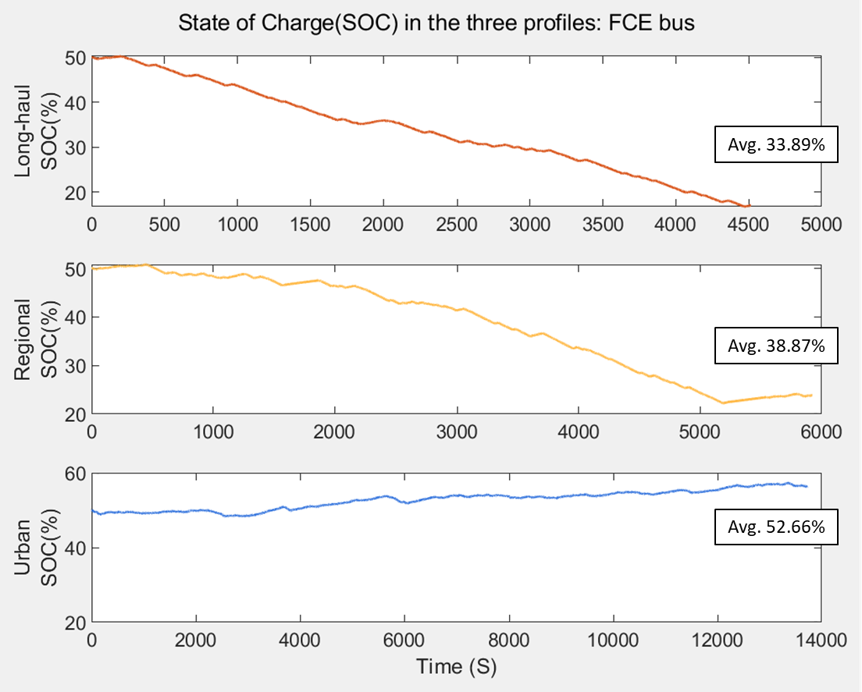In the urban driving simulation, which lasts longer than the other two profiles, the FCE bus maintains a higher SOC. This suggests that in urban conditions, characterised by frequent stops and starts, the net power usage of the FCE bus might be lower. Additionally, the presence of regenerative mechanisms could be contributing to the improved performance of the battery, as shown in Figure 25.

**Figure 25.** The State of Charge (SOC) analysis in the three driving profiles: FCE bus.

### The Fuel Consumption Analysis

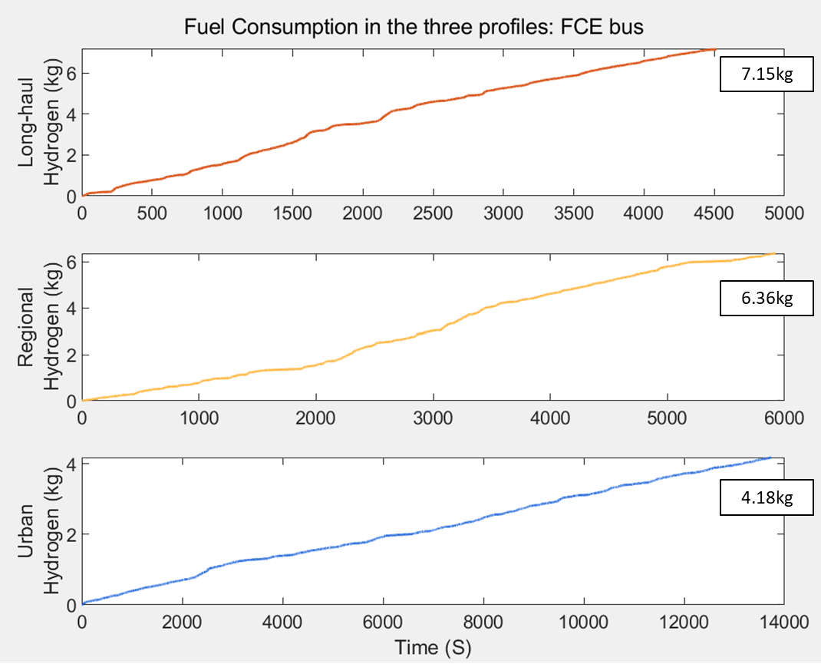Figure 26 demonstrates the total hydrogen fuel consumption during the driving simulation, the highest hydrogen consumer is the long-haul profile at 7.15 kg, while the regional and urban values are 6.36 kg and 4.18 kg, respectively. The trend is similar to fuel consumption analysis graphs of the HICE and FC buses (Figure 19 and Figure 21).

**Figure 26.** The fuel consumption analysis of the three driving profiles: FCE bus.

# Discussion

This chapter will bring the results mentioned in the previous chapter to discuss by comparing the three buses, namely, hydrogen internal combustion engine (HICE) bus, fuel cell (FC) bus, and fuel cell electric (FCE) bus, in long-haul, regional, and urban driving conditions to see the differences in terms of the powertrain and fuel consumption.

## Comparison of the Powertrain

Figure 27 compares the average of the net power (P) in kW units of the three configurations of the buses among the three simulations. It can be observed that the three buses in the long-haul profile have the highest average net power output, followed by regional and urban profiles, which correspond to unique and varied driving profiles.

It is evident from the three driving simulations that the HICE bus consistently exhibits the highest net power (P). In contrast, the FC and FCE buses display comparable values. This distinction arises because the HICE bus is equipped with unique components (transmission, clutch, and hydrogen engine). In contrast, the FC and FCE buses share similar components (transmission, fuel cell, DC converter, AC inverter, and electric motor), leading to their analogous power outputs.

However, the data exhibits significant similarity in the urban profile. This trend can likely be attributed to the lower average velocities and increased frequency of braking events in the profile. As a result, discernible differences are muted when contrasted with the more diverse velocities inherent in the long-haul and regional profiles.

**Figure 27.** Comparison of powertrain in the three buses.

## Comparison of the Fuel Consumption

According to Figure 28, the HICE bus exhibits the highest hydrogen consumption among the three bus types. This higher consumption can be attributed to the efficiency characteristics of the hydrogen engine. As explored in Chapter 2: Literature Review, the hydrogen engine operates similarly to traditional internal combustion engines, relying on the combustion process to ignite hydrogen and drive the wheels. Although the hydrogen engine is applied to be more suitable for hydrogen, the combustion in the thermodynamic process is generally less efficient compared to the electrochemical process in a fuel cell. As a result, the HICE bus consumes more hydrogen in all driving profiles.

At the same time, FC and FCE buses display reduced hydrogen consumption across all driving profiles due to the implementation of fuel cell technology. In particular, FCE buses stand out from the battery assistance, contributing to the lowest hydrogen consumption. As discussed in Chapter 2: Literature Review and Chapter 4: Results, the battery is supplementary by providing additional power to capture all net power of the bus. Conversely, surplus power from the fuel cell recharges the battery when the demand is low and during the braking period, ensuring an energy balance. This optimises fuel consumption.

High and mostly constant speeds characterise the long-haul condition over a shorter duration, while the other profiles exhibit varied velocities and span longer timeframes. As a result, it can be noted that the long-haul condition displays the highest hydrogen consumption compared to the other conditions, followed by the regional and urban profiles. Moreover, it can be observed that the FCE bus displays a decreasing trend in hydrogen consumption across the three driving simulations, especially in the urban simulation, which is declining by 27.81%. This might be attributed to the increasing number of braking events in each profile, leading to an increase in energy storage in the battery through regenerative braking, thereby reducing hydrogen consumption. It can be inferred that environmental settings play a significant role in determining the optimal type of hydrogen-based powertrain for vehicles.

**Figure 28.** Comparison of fuel consumption in the three buses.

# Conclusion

This study studies the operational performance and fuel consumption of three buses utilising different hydrogen technologies: the hydrogen internal combustion engine (HICE) bus, the fuel cell (FC) bus, and the fuel cell electric (FCE) bus. These buses are examined under long-haul, regional, and urban profiles using MATLAB as an analytical tool for this study. The key findings of this study are following:

Powertrain Observations

* HICE bus displayed the highest net power across all driving profiles.
* FC and FCE buses exhibited similar power outputs due to similar components like the transmission, fuel cell, DC converter, AC inverter, and electric motor.

Fuel Consumption Observations

* HICE bus shows the highest hydrogen consumption across all driving scenarios due to the combustion-based mechanism.
* FC and FCE buses demonstrate reduced hydrogen consumption across all driving profiles due to the implementation of fuel cell technology.
* FCE bus stands out due to battery assistance, leading to the lowest hydrogen consumption.

Driving Profile Observations

* Environmental settings play a significant role in determining the optimal type of hydrogen-based powertrain for vehicles.

The findings of the study emphasis the possible advantages of battery-assisted hydrogen systems in terms of fuel efficiency. Nevertheless, while exhibiting distinct characteristics, both HICE and FC buses present their benefits, can be developed, and become more feasible in the future. The accessibility of these diverse hydrogen technologies may play a crucial role in expediting the transition of the transportation sector to alternative energy solutions.

## Future Work

Future research should enhance the MATLAB tool used in this study, emphasising a more detailed analysis of each hydrogen technology within the vehicle framework. It would be beneficial to integrate real-time data (i.e., air velocity) might produce results that mirror actual scenarios more closely. Beyond hydrogen technology, delving into the economic and environmental facets can enrich the study, offering a more understanding of the topic.

# References

|  |  |
| --- | --- |
| [1] | IRENA, “World Energy Transitions Outlook 2023,” International Renewable Energy Agency, Abu Dhabi, 2023. |
| [2] | BP, “Statistical Review of World Energy,” 2021. [Online]. Available: https://www.bp.com/content/dam/bp/business-sites/en/global/corporate/pdfs/energy-economics/statistical-review/bp-stats-review-2021-oil.pdf. [Accessed 22 9 2023]. |
| [3] | B. Shadidi, G. Najafi and T. Yusaf, “A Review of Hydrogen as a Fuel in Internal Combustion Engines,” *Energies,* vol. 14, no. 19, p. 6209, 2021. |
| [4] | B. Sharpe and R. Muncrief, “Literature review: real-world Fuel Consumption of heavy-duty Vehicles in the United states, china, and the European Union,” 2015. [Online]. Available: https://theicct.org/sites/default/files/publications/ICCT_HDV_FC_lit-review_20150209.pdf. [Accessed 23 9 2023]. |
| [5] | Z. Stępień, “A Comprehensive Overview of Hydrogen-Fueled Internal Combustion Engines: Achievements and Future Challenges,” *Energies,* vol. 14, no. 20, p. 6504, 2021. |
| [6] | t. E. C. “Quarterly Greenhouse Gas Emissions in the EU,” 2023. [Online]. Available: https://ec.europa.eu/eurostat/statistics-explained/index.php?title=Quarterly_greenhouse_gas_emissions_in_the_EU. [Accessed 24 9 2023]. |
| [7] | T. E. A. M. A. “Buses: what they are and why they are so important,” 2022. [Online]. Available: https://www.acea.auto/fact/buses-what-they-are-and-why-they-are-so-important/. [Accessed 23 9 2023]. |
| [8] | O. A. Hjelkrem, K. Y. Lervåg, S. Babri, C. Lu and C.-J. Södersten, “A Battery Electric Bus Energy Consumption Model for Strategic purposes: Validation of a Proposed Model Structure with Data from Bus Fleets in China and Norway,” *Transportation Research Part D: Transport and Environment,* vol. 94, p. 102804, 2021. |
| [9] | M. Aziz, “Liquid Hydrogen: a Review on Liquefaction, Storage, Transportation, and Safety,” *Energies,* vol. 14, no. 18, p. 5917, 2021. |
| [10] | K. Wróbel, J. Wróbel, W. Tokarz, J. Lach, K. Podsadni and A. Czerwiński, “Hydrogen Internal Combustion Engine Vehicles: a Review,” *Energies,* vol. 15, no. 23, p. 8937, 2022. |
| [11] | P. Bubna, D. Brunner, S. G. Gangloff and A. K. Prasad, “Analysis, Operation and Maintenance of a Fuel cell/battery series-hybrid Bus for Urban Transit Applications,” *Journal of Power Sources,* vol. 195, no. 12, pp. 3939-3949, 2010. |
| [12] | C. Cunanan, M.-K. Tran, Y. Lee, S. Kwok, V. Leung and M. Fowler, “A Review of Heavy-Duty Vehicle Powertrain Technologies: Diesel Engine Vehicles, Battery Electric Vehicles, and Hydrogen Fuel Cell Electric Vehicles,” *Clean Technologies,* vol. 3, no. 2, pp. 474-489, 1 6 2021. |
| [13] | A. Ajanovic, A. Glatt and R. Haas, “Prospects and Impediments for Hydrogen Fuel Cell Buses,” *Energy,* vol. 235, p. 121340, 2021. |
| [14] | National Center for Biotechnology Information, “PubChem Compound Summary for CID 783,” 2023. [Online]. Available: https://pubchem.ncbi.nlm.nih.gov/compound/Hydrogen.. [Accessed 15 8 2023]. |
| [15] | K. Mazloomi and C. Gomes, “Hydrogen as an Energy carrier: Prospects and Challenges,” *Renewable and Sustainable Energy Reviews,* vol. 16, no. 5, pp. 3024-3033, 2012. |
| [16] | S. Verhelst and T. Wallner, “Hydrogen-fueled Internal Combustion Engines,” *Progress in Energy and Combustion Science,* vol. 35, no. 6, pp. 490-527, 12 2009. |
| [17] | Y. Manoharan, S. E. Hosseini, B. Butler, H. Alzhahrani, B. T. F. Senior, T. Ashuri and J. Krohn, “Hydrogen Fuel Cell Vehicles; Current Status and Future Prospect,” *Applied Sciences,* vol. 9, no. 11, p. 2296, 2019. |
| [18] | H. L. Yip, A. Srna, A. C. Y. Yuen, S. Kook, R. A. Taylor, G. H. Yeoh, P. R. Medwell and Q. N. Chan, “A Review of Hydrogen Direct Injection for Internal Combustion Engines: Towards Carbon-Free Combustion,” *Applied Sciences,* vol. 9, no. 22, p. 4842, 2019. |
| [19] | D. Kang, S. Yun and B.-k. Kim, “Review of the Liquid Hydrogen Storage Tank and Insulation System for the High-Power Locomotive,” *Energies,* vol. 15, no. 21, p. 4357, 2022. |
| [20] | F. Schüth, “Challenges in Hydrogen Storage,” *The European Physical Journal Special Topics,* vol. 176, no. 1, pp. 155-166, 2009. |
| [21] | R. Gupta, A. Basile and T. N. Veziroğlu, Compendium of Hydrogen energy. Vol. 2, Hydrogen storage, Distribution and Infrastructure, Burlington, United Kingdom: Woodhead Publishing, 2015. |
| [22] | M. Dadashzadeh, S. Kashkarov, D. Makarov and V. Molkov, “Risk Assessment Methodology for Onboard Hydrogen Storage,” *International Journal of Hydrogen Energy,* vol. 43, no. 12, p. 6462–6475, 2021. |
| [23] | Z. Jin, Y. Su, H. Lv, M. Liu, W. Li and C. Zhang, “Review of Decompression Damage of the Polymer Liner of the Type IV Hydrogen Storage Tank,” *Polymers,* vol. 15, no. 10, pp. 2258-2258, 2023. |
| [24] | B. Mashadi and D. Crolla, Vehicle Powertrain Systems, Chichester, West Sussex, U.K.: Wiley, 2012. |
| [25] | L. Guzzella and A. Sciarretta, Vehicle Propulsion Systems, Berlin, Heidelberg: Springer Berlin Heidelberg, 2013. |
| [26] | X. Jin, G. Yin and N. Chen, “Advanced Estimation Techniques for Vehicle System Dynamic State: a Survey,” *Sensors,* vol. 19, no. 19, p. 4289, 3 10 2019. |
| [27] | E. C. J. R. C. “VECTO Sim Version 3.3.15.3102,” 30 6 2023. [Online]. Available: https://code.europa.eu/vecto/vecto/-/releases/Release/v3.3.15.3102. [Accessed 21 9 2023]. |
| [28] | H. Fayaz, R. Saidur, N. Razali, F. Anuar, A. Saleman and M. Islam, “An Overview of Hydrogen as a Vehicle Fuel,” *Renewable and Sustainable Energy Reviews,* vol. 16, no. 8, pp. 5511-5528, 2012. |
| [29] | Z. Stępień, “A Comprehensive Overview of Hydrogen-Fueled Internal Combustion Engines: Achievements and Future Challenges,” *Energies,* vol. 14, no. 20, p. 6504, 2021. |
| [30] | T. Sutharssan, D. Montalvao, Y. K. Chen, W.-C. Wang, C. Pisac and H. Elemara, "A Review on Prognostics and Health Monitoring of Proton Exchange Membrane Fuel Cell," *Renewable and Sustainable Energy Reviews,* vol. 75, pp. 440-450, 8 2017. |
| [31] | M. T. Gencoglu and Z. Ural, "Design of a PEM Fuel Cell System for Residential Application," *International Journal of Hydrogen Energy,* vol. 34, no. 12, pp. 5242-5248, 6 2009. |
| [32] | Y. Wang, Y. Pang, H. Xu, A. Martinez and K. S. Chen, “PEM Fuel Cell and Electrolysis Cell Technologies and Hydrogen Infrastructure Development – a Review,” *Energy & Environmental Science,* 2022. |
| [33] | J. Meng, G. Luo, M. Ricco, M. Swierczynski, D.-I. Stroe and R. Teodorescu, “Overview of Lithium-Ion Battery Modeling Methods for State-of-Charge Estimation in Electrical Vehicles,” *Applied Sciences,* vol. 8, no. 5, p. 659, 25 4 2018. |
| [34] | N. Sazali, W. N. Wan Salleh, A. S. Jamaludin and M. N. Mhd Razali, "New Perspectives on Fuel Cell Technology: a Brief Review," *Membranes,* vol. 10, no. 5, p. 99, 13 5 2020. |
| [35] | U.S. Department of Energy, “Fuel Cell Handbook (Seventh Edition),” 2004. |
| [36] | O. Veneri, F. Migliardini, C. Capasso and P. Corbo, “Dynamic Behaviour of Li Batteries in Hydrogen Fuel Cell Power Trains,” *Journal of Power Sources,* vol. 196, no. 21, pp. 9081-9086, 11 2011. |
| [37] | M. İnci, M. Büyük, M. H. Demir and G. İlbey, “A Review and Research on Fuel Cell Electric vehicles: Topologies, Power Electronic converters, Energy Management methods, Technical challenges, Marketing and Future Aspects,” *Renewable and Sustainable Energy Reviews,* vol. 137, p. 110648, 2021. |
| [38] | G. Jinquan, H. Hongwen, L. Jianwei and L. Qingwu, “Real-time Energy Management of Fuel Cell Hybrid Electric buses: Fuel Cell Engines Friendly Intersection Speed Planning,” *Energy,* vol. 226, p. 120440, 2021. |
| [39] | Z. Fu, Z. Li, P. Si and F. Tao, “A Hierarchical Energy Management Strategy for Fuel cell/battery/supercapacitor Hybrid Electric Vehicles,” *International Journal of Hydrogen Energy,* vol. 44, no. 39, pp. 22146-22159, 2019. |
| [40] | N. Sulaiman, M. Hannan, A. Mohamed, P. Ker, E. Majlan and W. Wan Daud, “Optimization of Energy Management System for fuel-cell Hybrid Electric vehicles: Issues and Recommendations,” *Applied Energy,* vol. 228, pp. 2061-2079, 2018. |
| [41] | S. Ma, M. Lin, T.-E. Lin, T. Lan, X. Liao, F. Maréchal, J. Van herle, Y. Yang, C. Dong and L. Wang, “Fuel cell-battery Hybrid Systems for Mobility and off-grid applications: a Review,” *Renewable and Sustainable Energy Reviews,* vol. 135, p. 110119, 2021. |
| [42] | Y. Wang, Z. Sun and Z. Chen, “Energy Management Strategy for battery/supercapacitor/fuel Cell Hybrid Source Vehicles Based on Finite State Machine,” *Applied Energy,* vol. 254, 2019. |
| [43] | J.-J. Hwang, Y.-J. Chen and J.-K. Kuo, “The Study on the Power Management System in a Fuel Cell Hybrid Vehicle,” *International Journal of Hydrogen Energy,* vol. 37, no. 5, pp. 4476-4489, 2012. |
| [44] | O. Delgado, F. Rodríguez and R. Muncrief, “Fuel Efficiency Technology in European Heavy-Duty vehicles: Baseline anD poTenTial for the 2020-2030 Time Frame,” 2017. [Online]. Available: https://theicct.org/wp-content/uploads/2021/06/EU-HDV-Tech-Potential_ICCT-white-paper_14072017_vF.pdf. [Accessed 17 9 2023]. |
| [45] | Z. Liu, K. Kendall and X. Yan, “China Progress on Renewable Energy Vehicles: Fuel Cells, Hydrogen and Battery Hybrid Vehicles,” *Energies,* vol. 12, no. 1, p. 54, 2018. |
| [46] | E. ToolBox, “Rolling Resistance,” 2008. [Online]. Available: https://www.engineeringtoolbox.com/rolling-friction-resistance-d_1303.html. [Accessed 28 8 2023]. |
| [47] | E. ToolBox, “Drag Coefficient,” 2004. [Online]. Available: https://www.engineeringtoolbox.com/drag-coefficient-d_627.html. [Accessed 28 8 2023]. |
| [48] | E. ToolBox, “Air - Density, Specific Weight and Thermal Expansion Coefficient at Varying Temperature and Constant Pressures,” 2009. [Online]. Available: https://www.engineeringtoolbox.com/air-density-specific-weight-d_600.html. [Accessed 28 8 2023]. |
| [49] | M. Farzaneh-Gord, H. R. Rahbari and H. Nikofard, “The Effect of Important Parameters on the Natural Gas Vehicles Driving Range,” *Polish Journal of Chemical Technology,* vol. 14, no. 4, pp. 61-68, 2012. |
| [50] | Y. Shen, J. Zhou, J. Zhang, F. Yi, G. Wang, C. Pan, G. Wei and X. Shu, “Research on Energy Management of Hydrogen Fuel Cell Bus Based on Deep Reinforcement Learning considering Velocity Control,” *Sustainability,* vol. 15, no. 16, pp. 12488-12488, 2023. |
| [51] | T. M. C. A. I. “Minimum Ignition Energy,” 2018. [Online]. Available: https://marinechemistassociation.com/. [Accessed 12 8 2023]. |